Identifying and Sorting Attributes
Uses one attribute to sort (size, colour, shape)  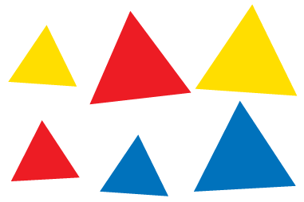  “I sorted the blocks by number of sides: 3.” | Identifies 2 attributes and uses them to sort (with and without overlap)  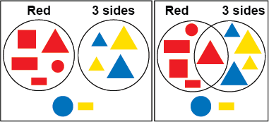 | Identifies 3 attributes and uses them to sort (without overlap)  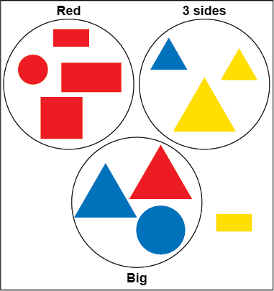  “I used the attributes red, 3 sides, and big.”
Observations/Documentation

Identifying and Sorting Attributes
Identifies 3 attributes and uses them to sort (with overlap)  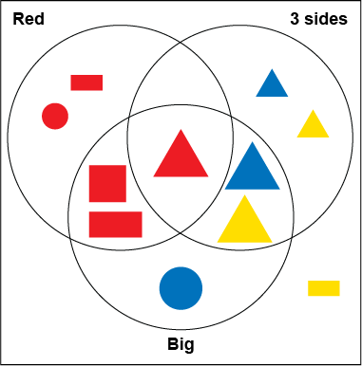  “One block has all three attributes:  red, 3 sides, and big.” | Identifies the sorting rule  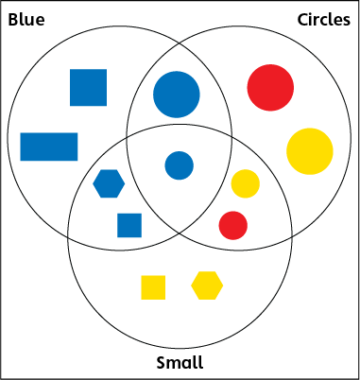  “The centre overlap has a small, blue circle. So, this category must be blue, this must be small, and this must be circles.” | Uses attributes flexibly to sort (concretely and mentally)  Attributes: small, blue, 6-sides  Centre overlap: small blue hexagon  Overlaps:  Small, blue blocks  Small hexagons  Blue hexagons
Observations/Documentation

