**Animal Sort**

**Master 66a**

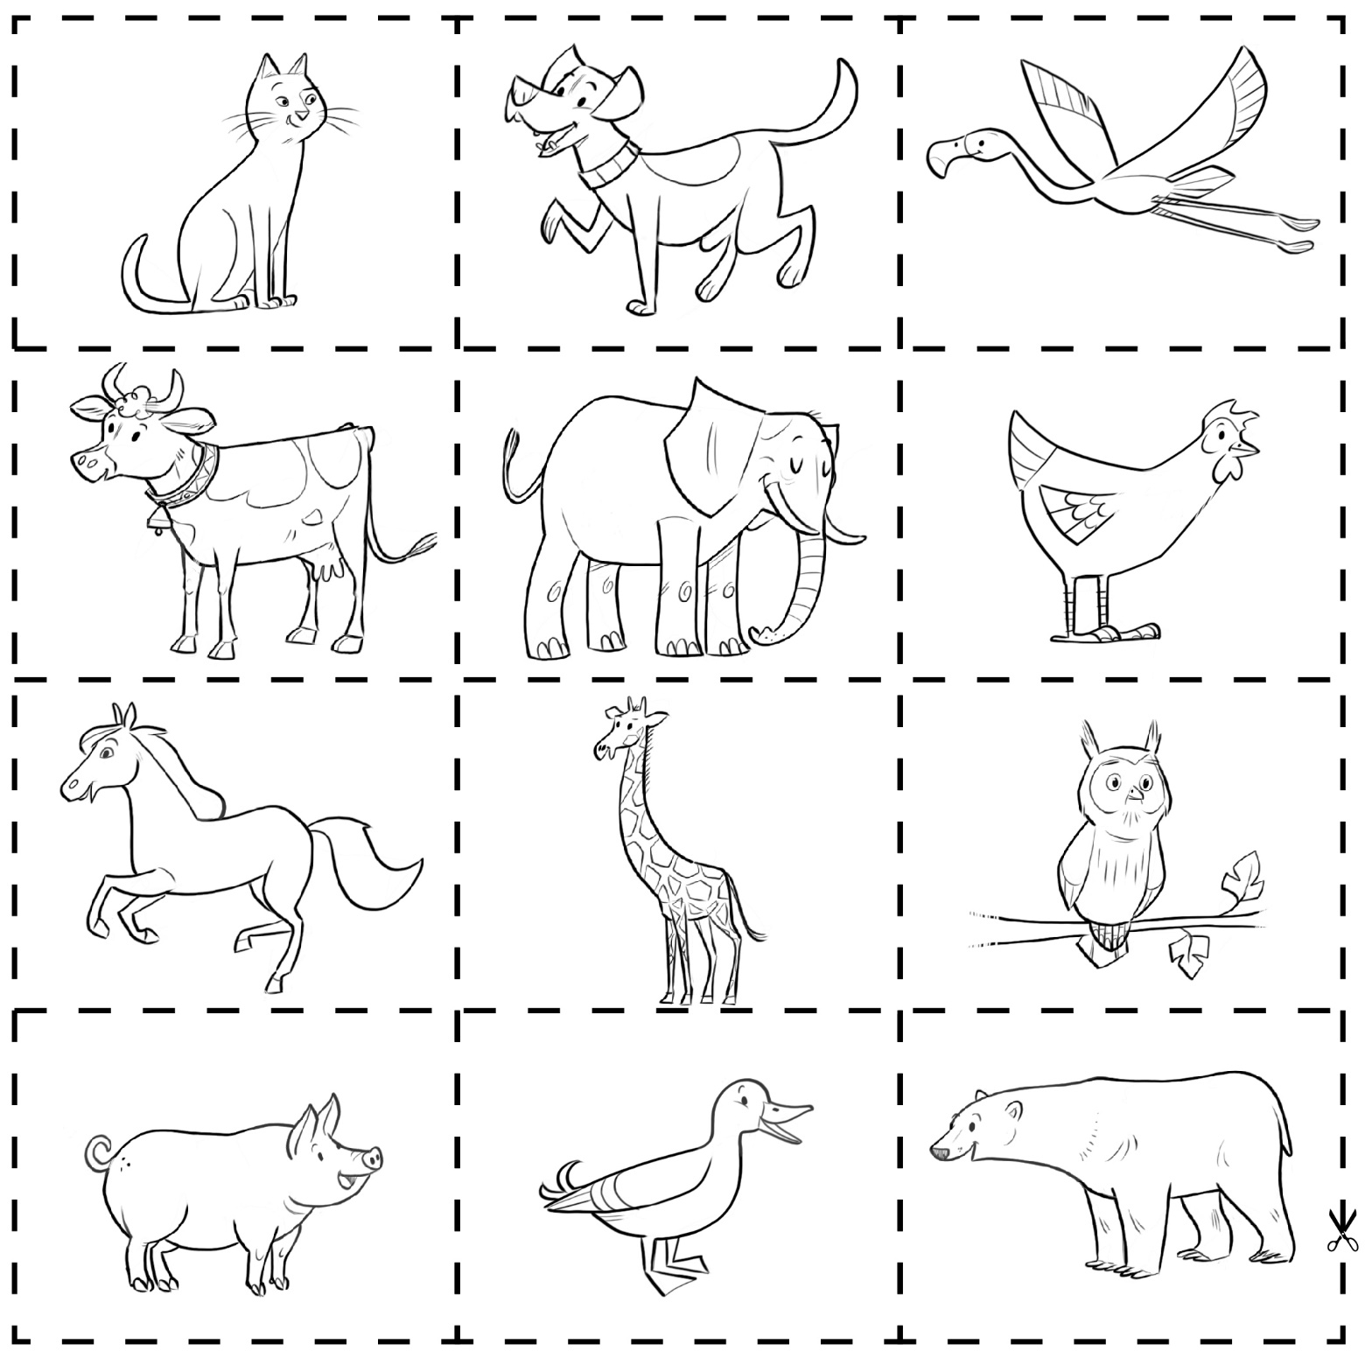

**Animal Sort** (cont’d)

**Master 66b**

