**Nets of Solids**

**Master 50a**

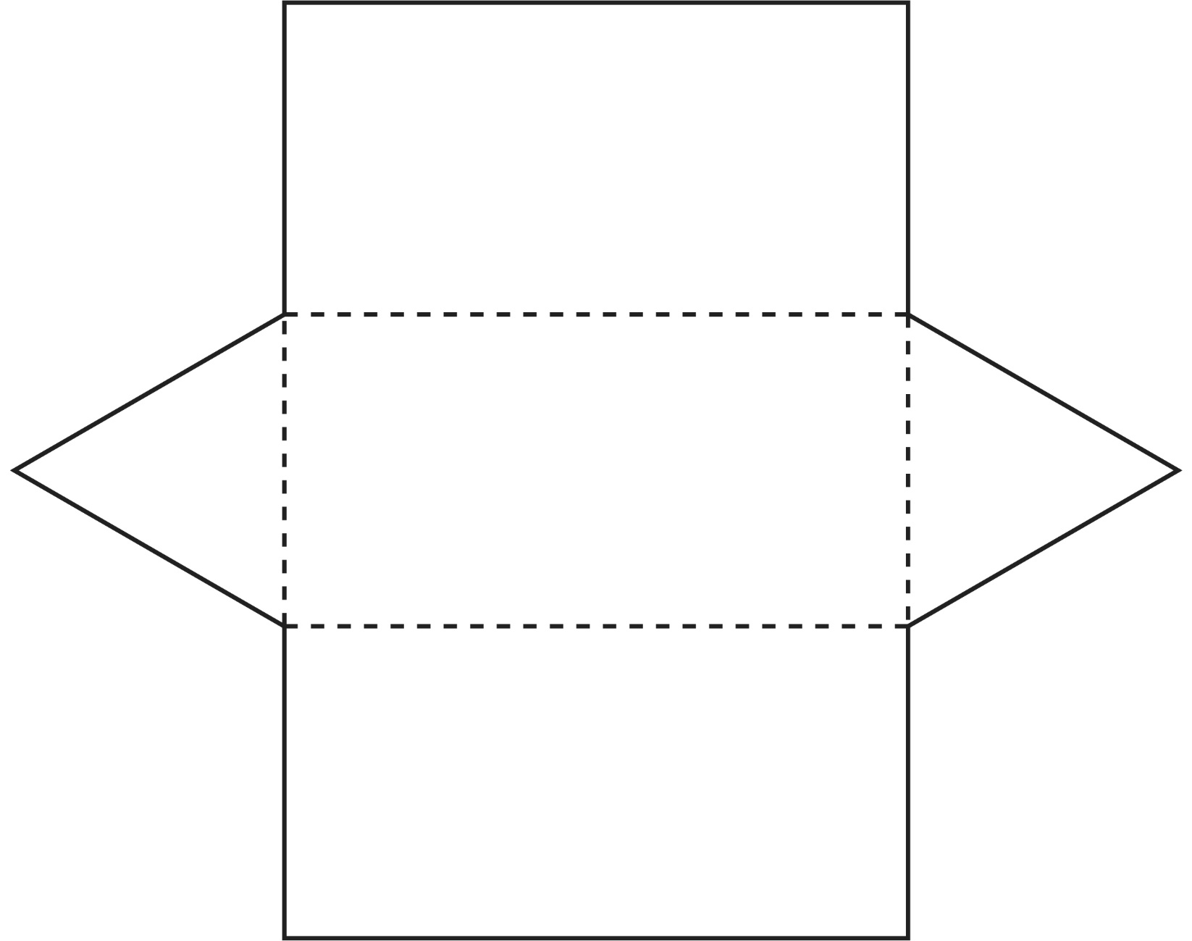

**Nets of Solids**

**Master 50b**

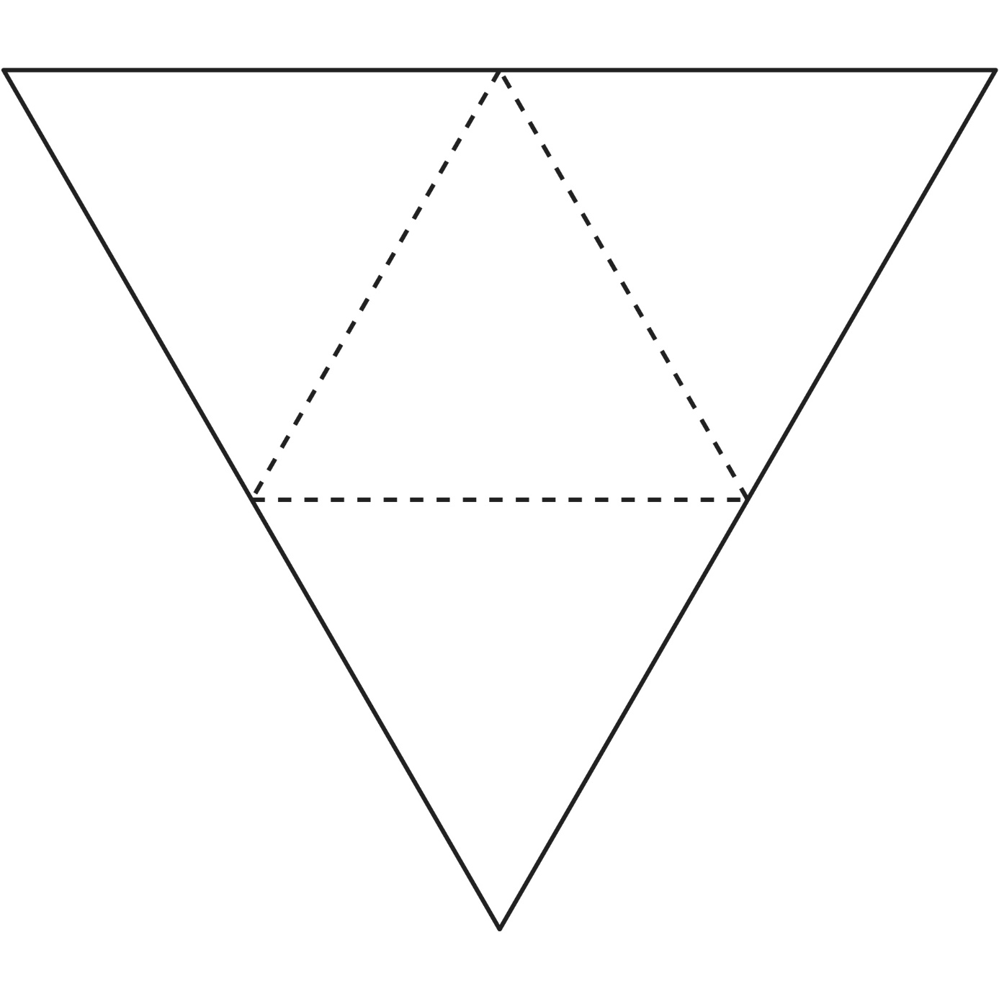

**Nets of Solids**

**Master 50c**

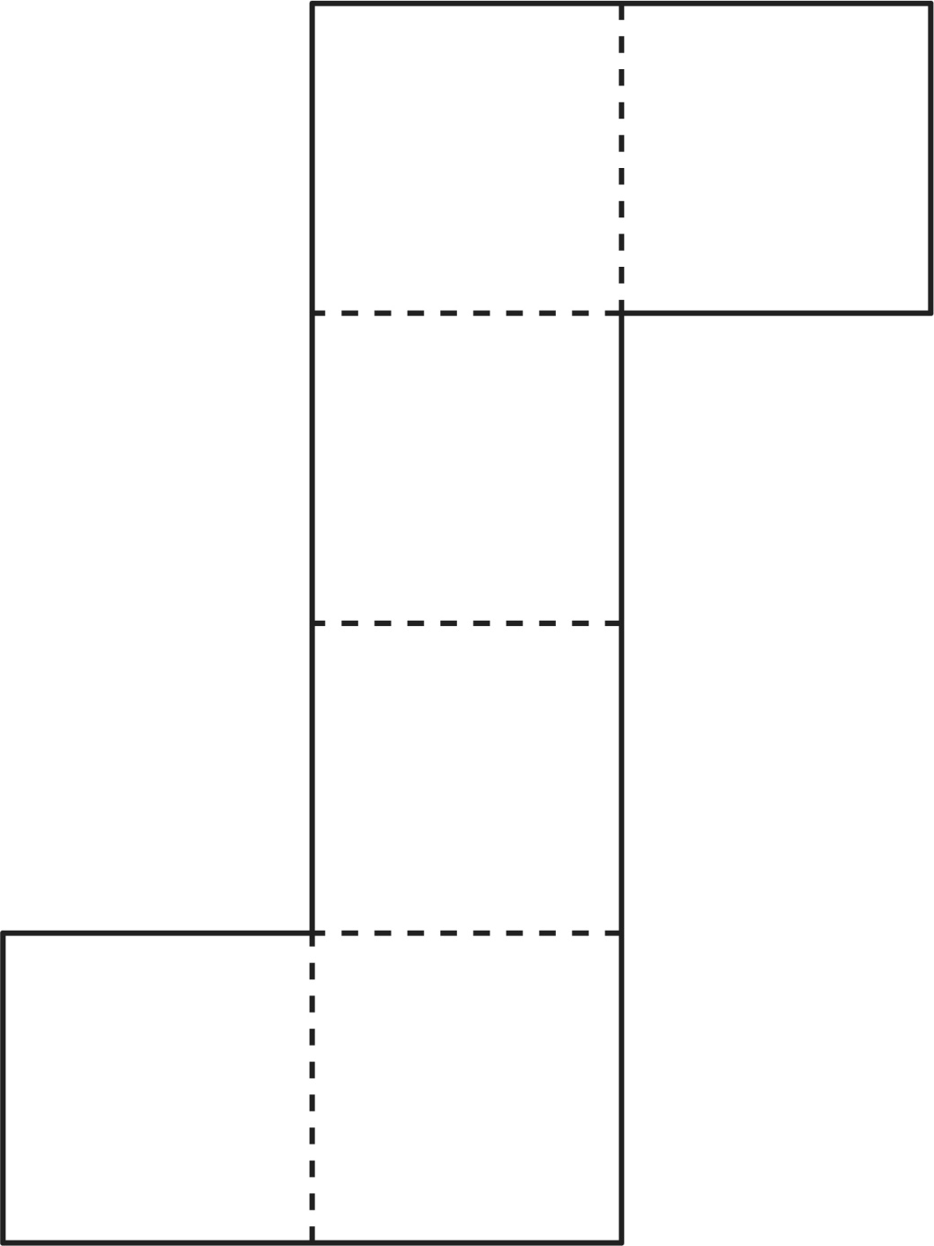

**Nets of Solids**

**Master 50d**

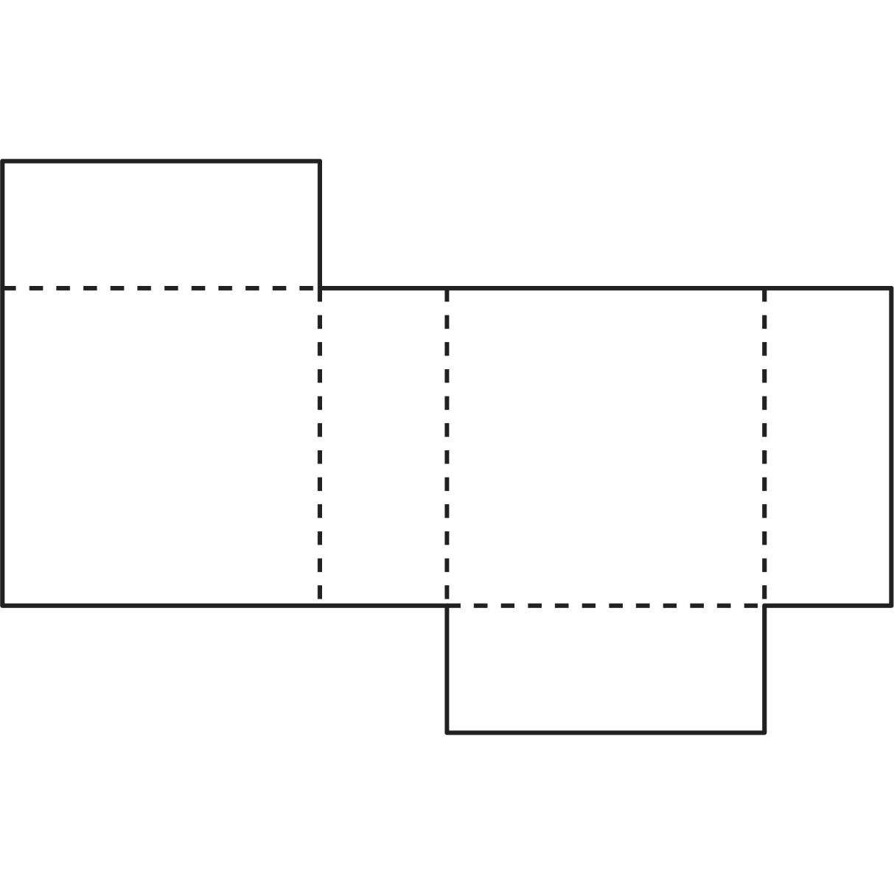

**Nets of Solids**

**Master 50e**

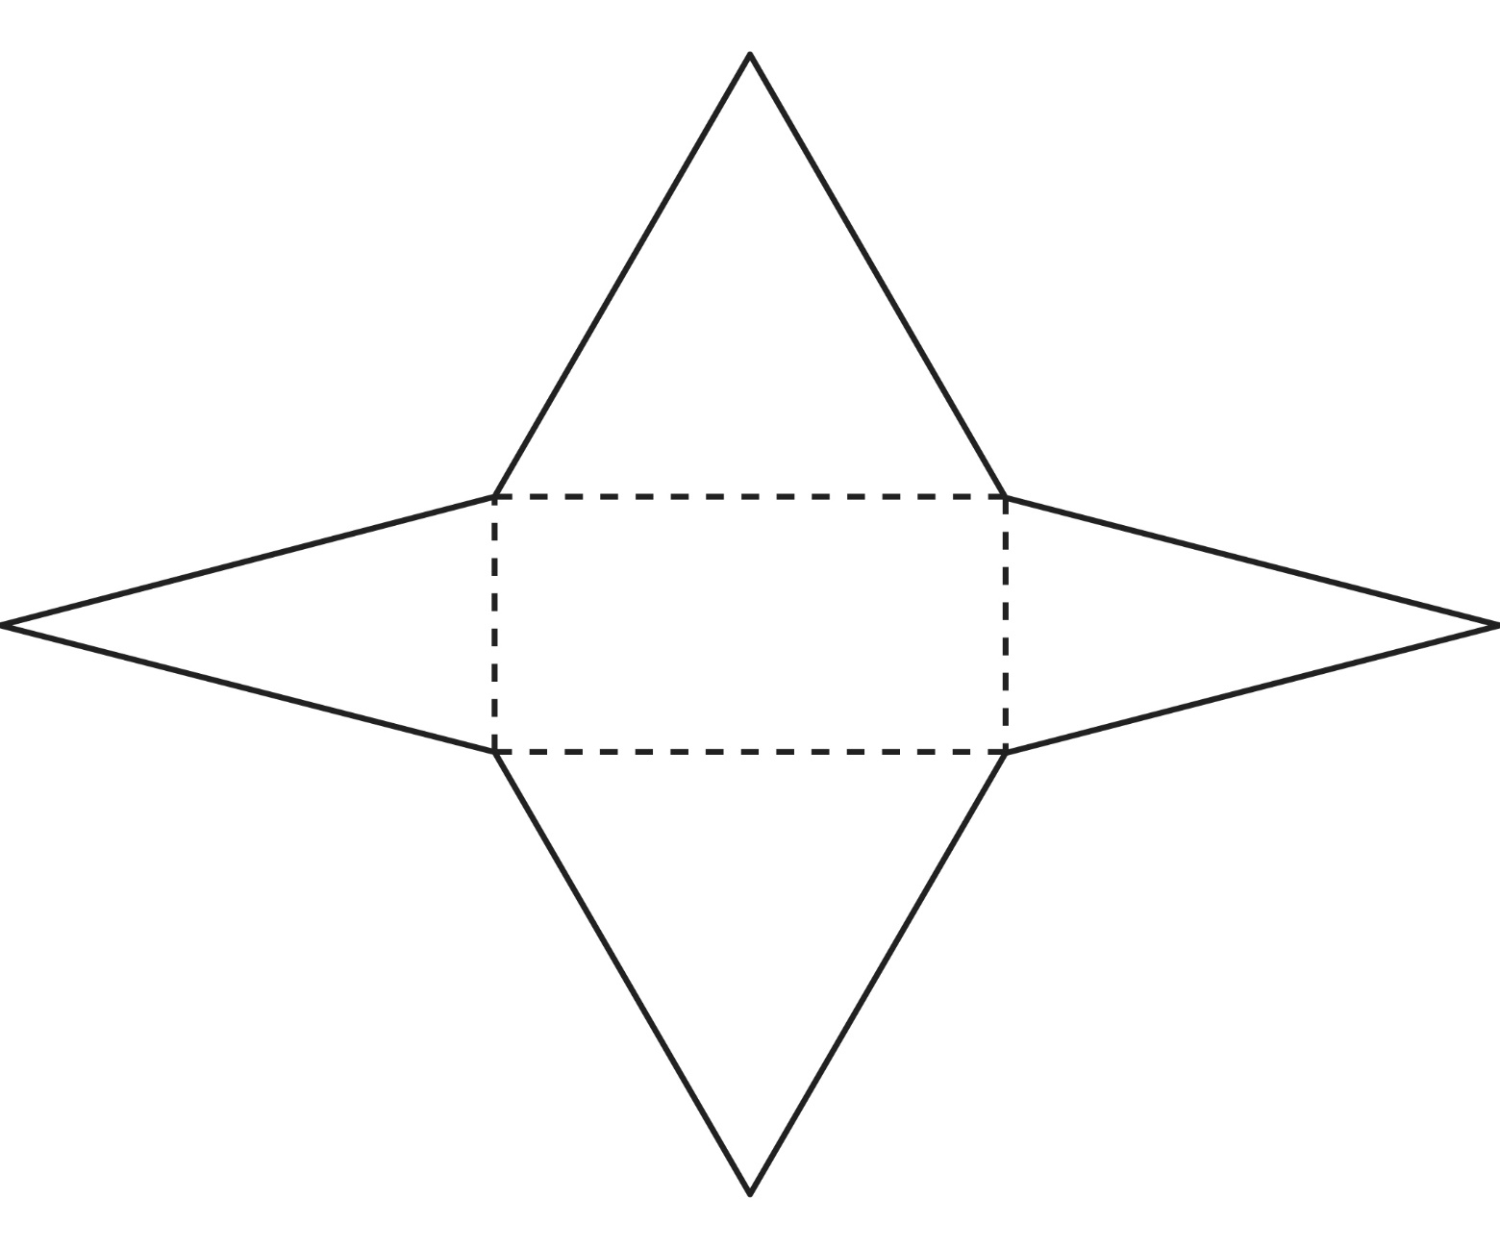

**Nets of Solids**

**Master 50f**

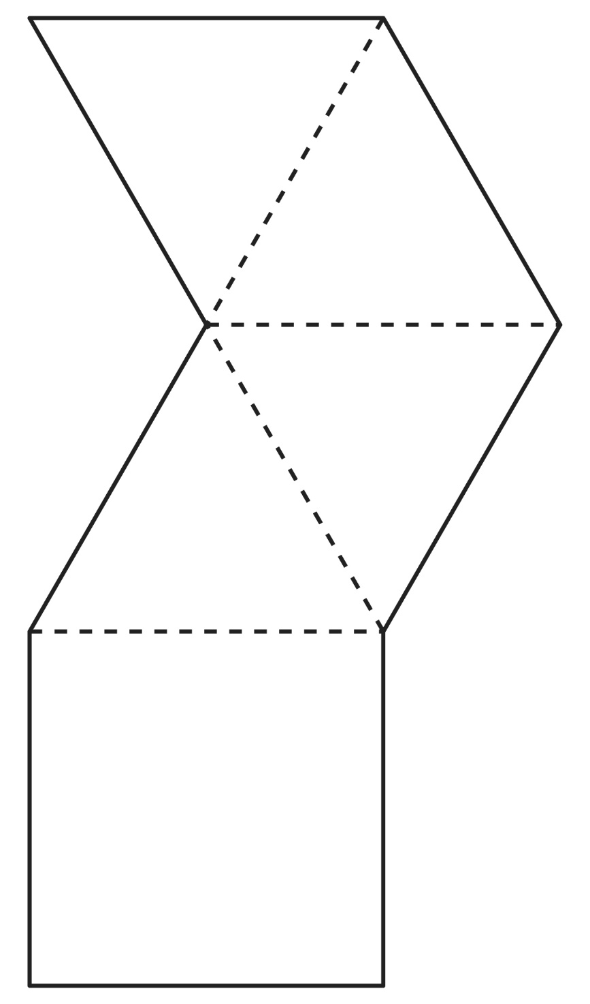

**Nets of Solids**

**Master 50g**

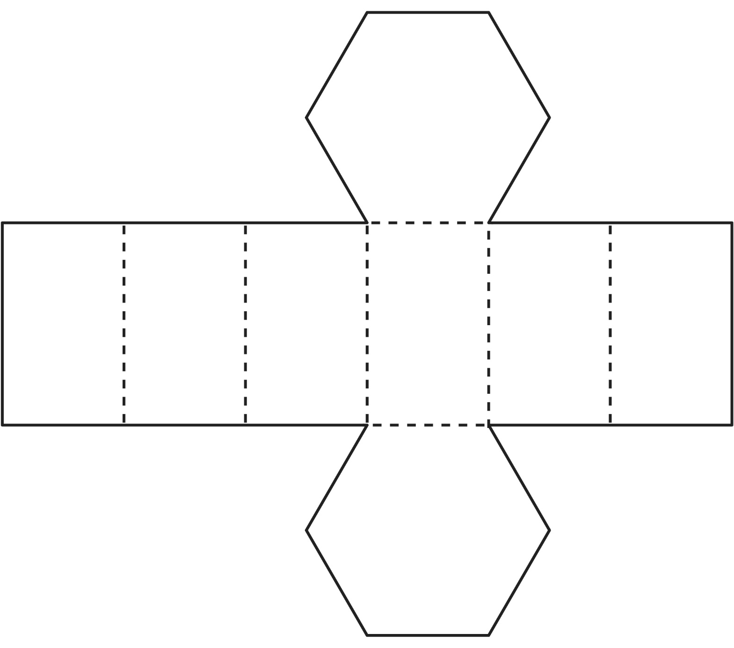

**Nets of Solids**

**Master 50h**

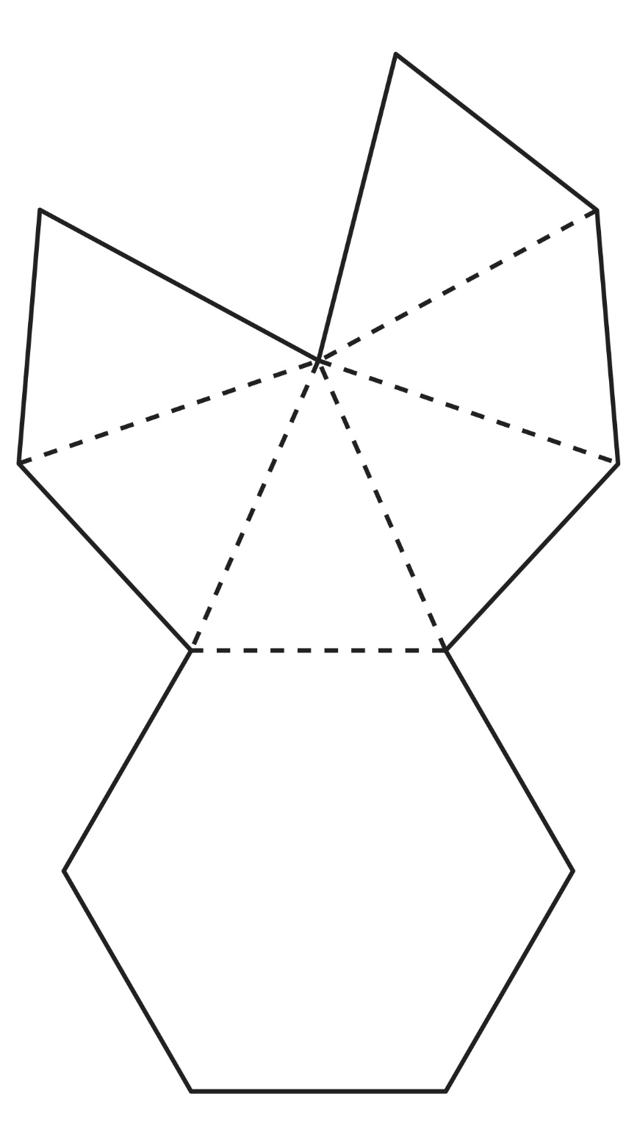

**Nets of Solids**

**Master 50i**

