Connections:
Neighbourhood Walk
Master 40

When you walk around the outside of a park, a building, or a neighbourhood, you are walking around its perimeter.
Tristan and his mom walk around their neighbourhood every night after dinner. Sometimes they walk to the end of the street and turn left. Sometimes they turn right.
The two paths are shown on this map. How far do they walk along each path? Which path is longer? How much longer is it?
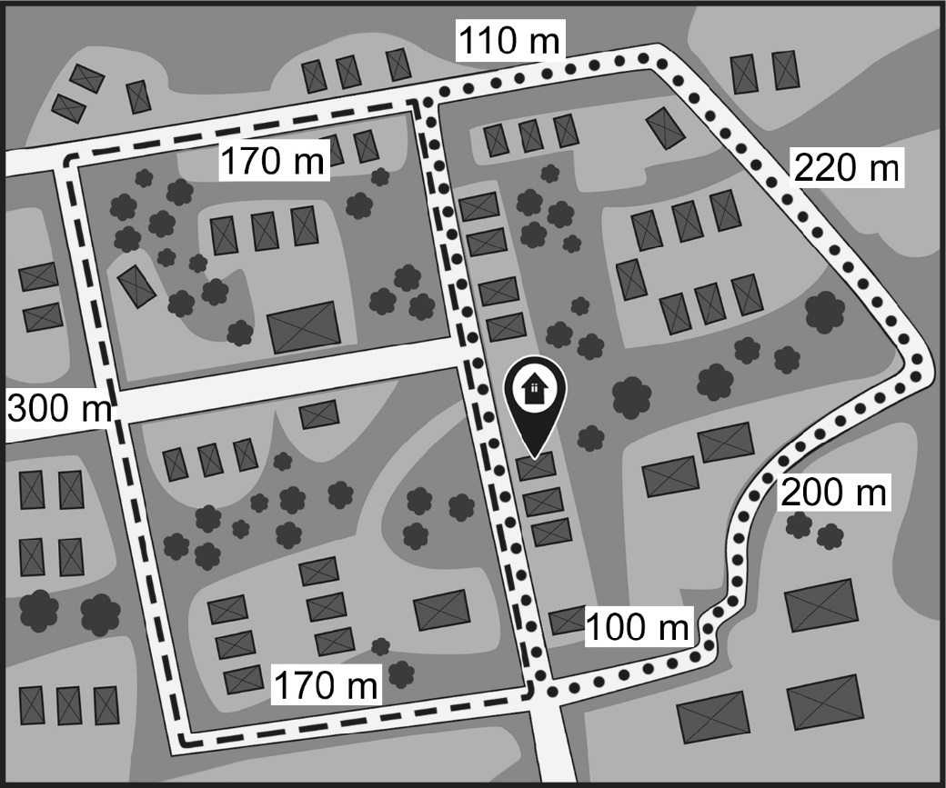

Go for a walk with a friend around the perimeter of your neighbourhood or school yard. Use a big step as a personal referent for 1 m. Count your steps.
About how long was the path you took in metres?
Is that longer or shorter than 1 kilometre? How do you know?

