Connections:
Fraction Frenzy
Master 10

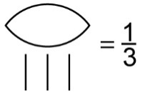
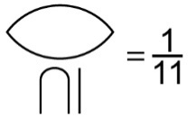
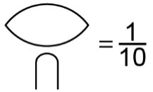
Many, many years ago,
Egyptian mathematicians
wrote fractions like this:

How do you think Egyptians would have written $\frac{1}{7}$? $\frac{1}{14}$?

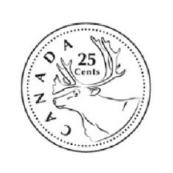
Have you ever wondered why we call 25¢ a quarter?
The word quarter comes from a Latin word that means “four.”
In French, the word for four is quatre!
So, quarter means one-fourth of something.
Since 25 cents is one-fourth of a dollar,
we call this coin “a quarter.”

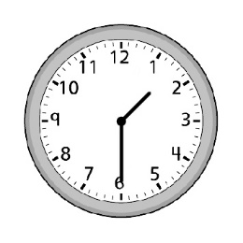
How many times do you hear fraction words in one day?
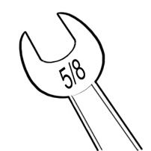
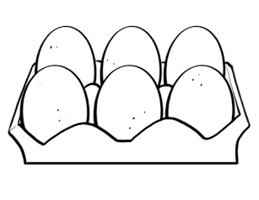

“Please pass me the five-eighths wrench.”
“I bought half a dozen eggs!”
“It’s half past one!”

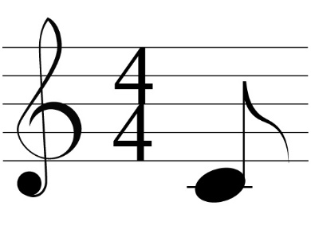

“The store is having a half-price sale!”
“This is an eighth note C.”

Listen carefully for the rest of the day.
What fraction words do you hear?

