Connections:
Canadian Coins–Did You Know?
Master 23

Toonie (2 dollars)  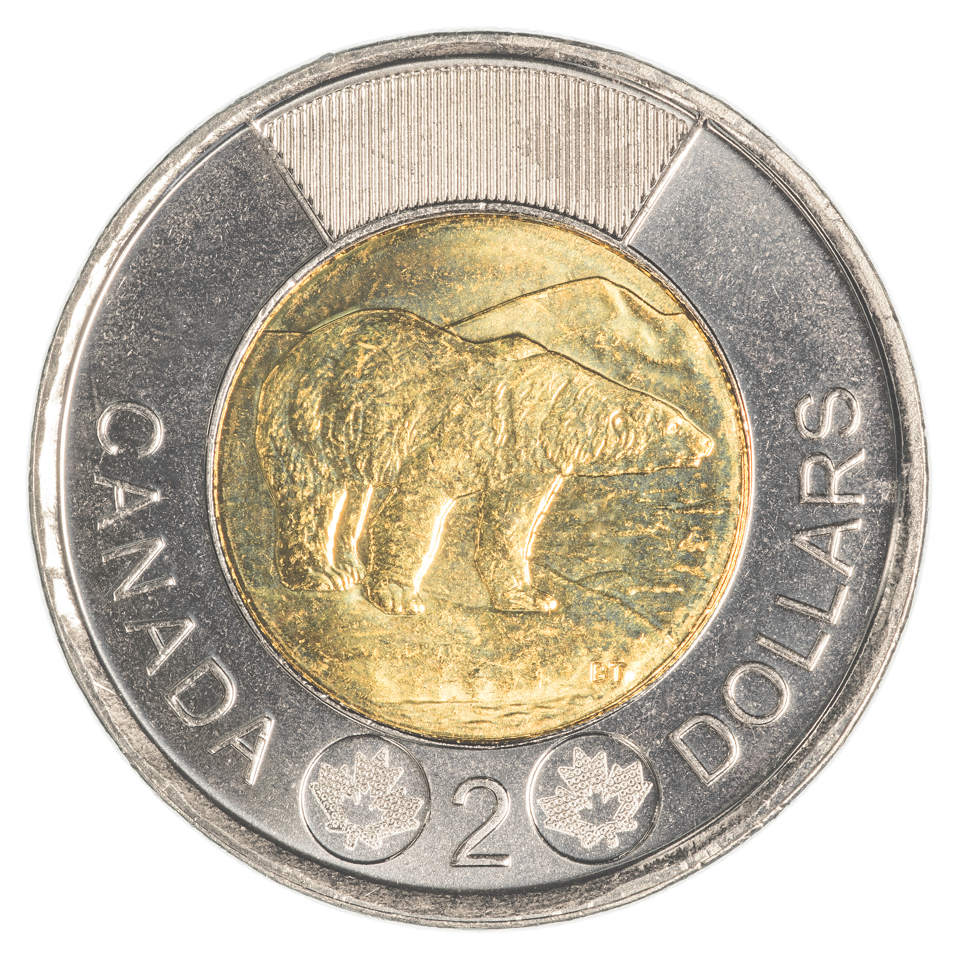  − replaced paper $2 bill in 1996  − a two-colour coin  − picture of polar bear  − issued special toonie in 2008 to recognize the 400th anniversary of Quebec City | Loonie (1 dollar)  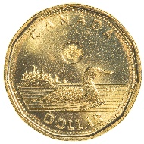  − replaced paper $1 bill  in 1987  − picture of a loon, the national bird of Canada  − issued special loonie in 2005 to honour Terry Fox | Quarter (25 cents)  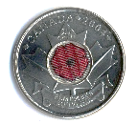  − worth one quarter of a dollar  − picture of a caribou, one of Canada’s most recognizable animals  − issued poppy quarter in  2004 in honour of Remembrance Day
Dime (10 cents)  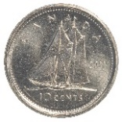  − smallest coin by size  − has picture of a famous Canadian sailboat, the Bluenose  − issued special dime in 2001 to honour the millions of Canadians who volunteer to help others | 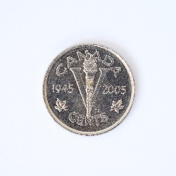  Nickel (5 cents)  − was originally made from nickel  − has picture of a beaver, an official symbol of Canada  − issued Victory nickel in 2005 to remember 60 years since end of World War II | Penny (1 cent)  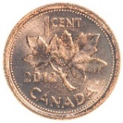  − stopped being used in 2013  − cost more than 1 cent to make  − picture of maple leaves  − until 1996, the penny had  12 sides so it was easier for people with vision problems to identify it

Look for examples of some of these coins in your piggy bank.
Did you find any of the special coins?
Design a coin of your choice to honour or celebrate a special event.
Explain why you chose the design you did.

