Fun Day! Patterning Cards (M)
Master 28a

M  What is the pattern rule?  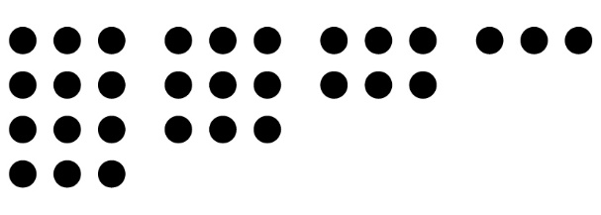 | M  What is the pattern rule?  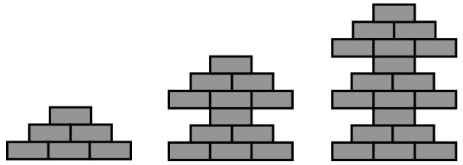
M  What is the pattern rule?  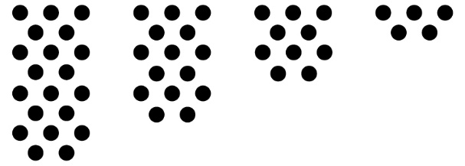 | M  What is the pattern rule?  100, 98, 96, 94, …
M  Use this rule to create  a pattern.  Start at 27 and  add 5 each time. | M  Use this rule to create  a pattern.  Start at 31 and take away  3 each time.

Fun Day! Patterning Cards (M)
Master 28b

M  Use this rule to create  a pattern.  Start at 1 and  add 6 each time. | M  Use this rule to create  a pattern.  Start at 335 and take away  9 each time.
M  Show this pattern  another way.  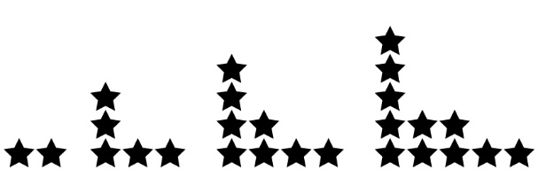 | M  Show this pattern  another way.  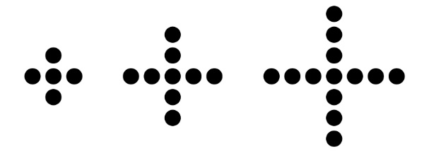
M  Show this pattern  another way.  545, 547, 549, 551, … | M  Show this pattern  another way.  87, 83, 79, 75, …

Fun Day! Patterning Cards (P)
Master 28c

P  Extend the pattern  by 2 more terms.  200, 196, 192, 188, … | P  Extend the pattern  by 2 more terms.  113, 116, 119, 122, …
P  Extend the pattern  by 2 more terms.  35, 29, 23, 17, … | P  Extend the pattern  by 2 more terms.  5, 10, 15, 20, …
P  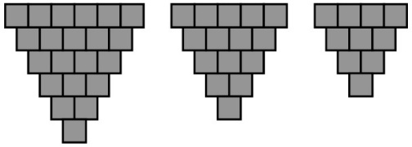  Extend the pattern.  Draw one term before and after these terms. | P  Extend the pattern  by 2 more terms.  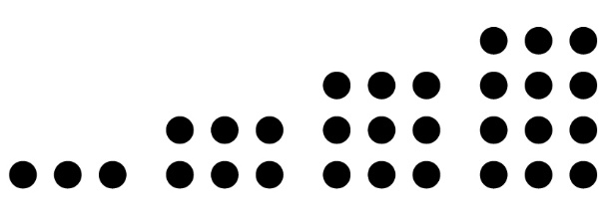

Fun Day! Patterning Cards (P)
Master 28d

P  Extend the pattern  by 2 more terms.  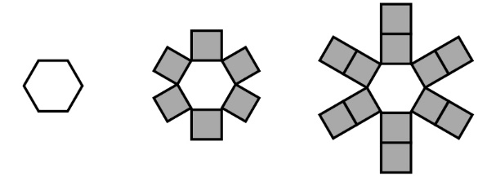 | P  Extend the pattern  by 2 more terms.  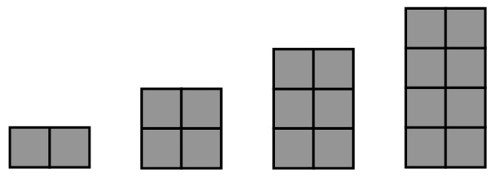
P  Find the term  represents.  6, 11, 16, 21, , 31, 36, … | P  Find the term  represents.  303, 300, 297, ,  291, 288, …
P  Find and correct the error.  120, 129, 138, 146, 156, … | P  Find and correct the error.  48, 40, 32, 25, 16, 8, …

Fun Day! Patterning Cards (P)
Master 28e

P  Find the terms B and A represent in the pattern.  B, 6, 12, 18, 24, A, … | P  Extend the pattern  by 2 more terms.  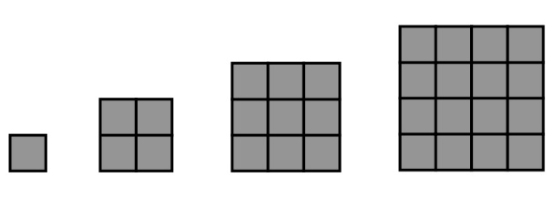
P  Are these expressions equivalent?  52 + 48 35 + 65 | P  Are these expressions equivalent?  31 + 56 42 + 47
P  Are these expressions equivalent?  73 – 46 81 – 57 | P  Are these expressions equivalent?  64 – 29 89 – 54
P  Are these expressions equivalent?  23 + 26 89 – 40 | P  Are these expressions equivalent?  51 – 38 9 + 4

