Formulating Questions
Makes statements that don’t generate answers  “I like to go swimming when it is hot outside.” | Formulates questions to learn about people (no response options)  “What do you do most often when it is very hot outside?” | Formulates questions to learn about people (incomplete response options)  “What do you do most often when it is very hot outside: swim, find shade, turn up AC, drink water?” | Formulates clear questions with complete response options to collect relevant data  “What do you do most often when it is very hot outside: swim, find shade, turn up AC, drink water, other?”
Observations/Documentation

Interpreting Data and Making Informed Decisions
No organization of data  shade, water, AC, swim, water, water, shade, swim, water, water | Uses class list; no interpretation  ✓ Juin Find shade  Tommy  ✓ Tai Swim  ✓ Ioana Find Shade  ✓ Mark Drink water  ✓ Alex Swim  ✓ Kim Drink water  Jon  ✓ Sadia Turn up AC  ✓ Lise Drink water  ✓ Dimitri Drink water  Vicky  ✓ Ali Drink water  “I’m not sure which answer was chosen most often.” | Uses tally chart, table, or list  “I made a tally chart so I can easily see how many chose each answer.”  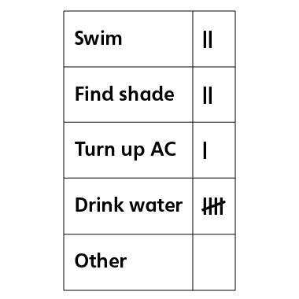 | Uses collected data to answer question  “Most students drink water.”  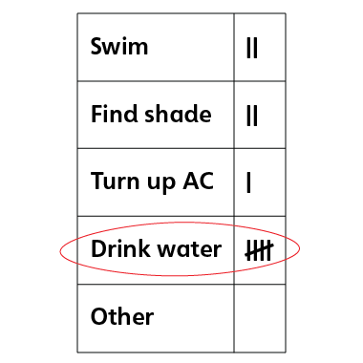
Observations/Documentation

