Describing Events Using the Language of Chance
Thinks outcomes of an experiment are always equally likely to happen  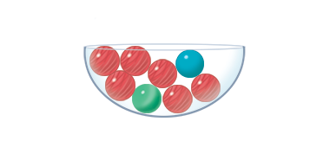  “I choose green. The chance of getting any colour is always the same.” | Describes the likelihood of an event or outcome (e.g., impossible, likely, certain)  “It is likely that I will get red.” | Makes predictions based on likelihoods  “If I draw a marble 8 times and put it back each time, I predict I will get red 6 times.”
Observations/Documentation

Describing Events Using the Language of Chance (con’t)
Lists all possible outcomes for an experiment  “I could get green, blue, or red,  but not yellow or purple.” | Compares the likelihoods of two outcomes  “It is more likely that I will get blue than green.” | Identifies flexibly the likelihoods of outcomes in a simple probability experiment  “Blue is most likely, red is least likely, green is unlikely, and yellow is impossible.”
Observations/Documentation

