Composing and Decomposing 2-D Shapes
Constructs composite shape using copies of the same Pattern Block  “I can use 4 triangles to make  a parallelogram.” | Constructs composite shape from Pattern Blocks in more than one way  “I can also use 2 triangles and a rhombus to make a parallelogram.” | Completes a picture outline with Pattern Blocks  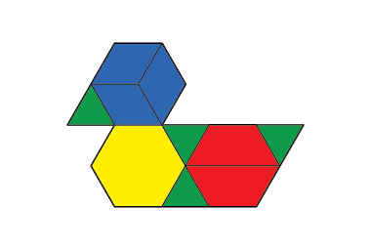  “I used 10 blocks to cover the outline. I tried to use a variety  of blocks.” | Constructs composite shapes in many ways by decomposing shapes and rearranging parts  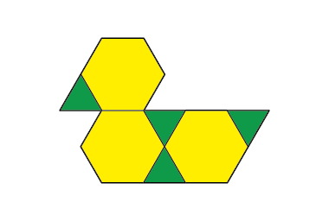  “I traded 3 blue blocks for a yellow block, and 2 red blocks for a yellow block. I was able to cover the outline using only 7 blocks. When I use only green blocks, it takes 22 blocks.”
Observations/Documentation

