Exploring Symmetry with 2-D Shapes
Identifies a line of symmetry in a design  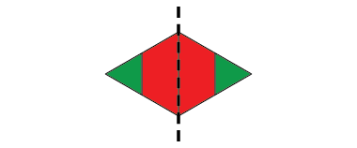  “I see one line of symmetry. If I fold the design on the line,  the 2 sides match exactly.” | Completes a symmetrical design, placing most shapes correctly  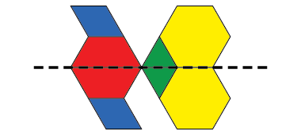  “I’m not sure about the blue block, but it looks right to me.” | Successfully completes a symmetrical design and uses math language to describe it  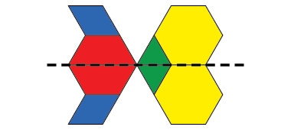  “This design is symmetrical because all the blocks below the line are reflections of the blocks above the line. I used a Mira to check.” | Constructs symmetrical designs and identifies all lines of symmetry  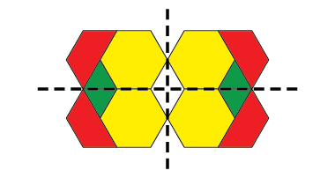  “I made my own design. It has  2 lines of symmetry.”
Observations/Documentation

