Locating and Mapping Objects
Uses positional language to describe location  “The green triangle is above the orange square. The orange square is below the green triangle.” | Uses positional and directional language to locate objects on a grid map  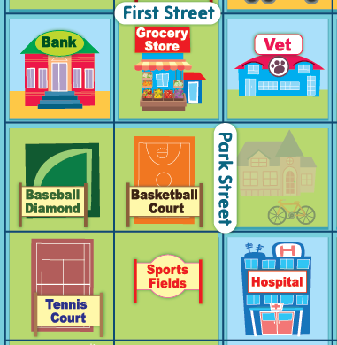  “The Grocery Store is 1 square up from the Basketball Court. The Bank is 1 square to the left of the Grocery Store.” | Describes the movement of an object from one location to another on a grid map  “To get from the Hospital to the Bank, I walk forward 2 squares to the Vet, then turn left and walk forward 2 squares.”
Observations/Documentation

Locating and Mapping Objects (con’t)
Writes code to move from Start to Finish on a grid  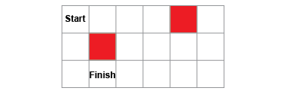  “From Start, move 2 squares right, 2 squares down, and 1 square left.” | Considers perspective to give directions and code efficiently and flexibly  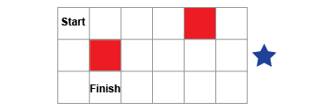  “My partner is looking at the grid from the right. So, from Start, move 2 squares down, 2 squares left, and 1 square up.” | Uses loops to show repeated steps in a code  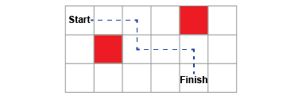  “Repeat 2 times: Move right 2 steps,  then 1 step down.”
Observations/Documentation

