Measuring Length and Perimeter
Uses non-standard units to measure  “The rectangle is 5 paper clips long. Its perimeter is 16 paper clips.” | Uses standard-sized items to measure  “The rectangle is 17 centicubes long. Its perimeter is 54 centicubes.” | Uses benchmarks to estimate in standard units (m, cm)  “I used a big step as a referent for one metre. The classroom is about  7 big steps, or 7 m wide.  Its perimeter is about 30 big steps, or 30 m.” | Measures using standard units (m, cm)  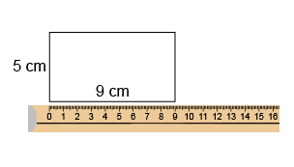  “The perimeter is 28 cm.”
Observations/Documentation

Measuring Length and Perimeter (con’t)
Selects and uses appropriate standard units  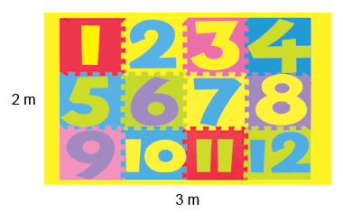  “I would use m because cm are too small. The perimeter is 10 m because 3 + 2 + 3 + 2 = 10.” | Relates standard units of length  (1 m = 100 cm)  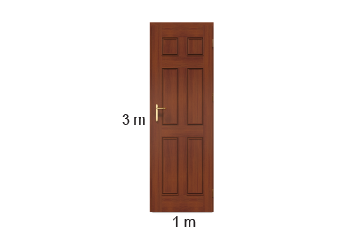  “The door has a perimeter of 8 m. Since 1 m = 100 cm, 8 m = 800 cm.” | Uses smaller units to give more accurate measures  “The rug is between 2 m and 3 m long. If I use cm, I can be more accurate: 285 cm.” | Compares using standard units  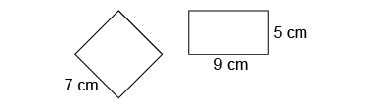  “Rectangle: 5 + 9 + 5 + 9 = 28 cm Square: 7 × 4 = 28 cm. The perimeters are the same.”
Observations/Documentation

