Multiplying 1-Digit Numbers
Groups objects and counts by 1s  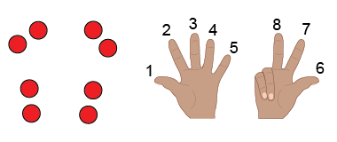 | Groups objects and skip-counts  “2, 4, 6, 8” | Uses repeated addition  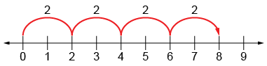  “2 + 2 + 2 + 2 = 8.” | Models using multiplicative thinking  “4 rows of 2 is 8.”
Observations/Documentation

Understands relationship between operations  “I can think of 2 + 2 + 2 + 2 = 8  as 4 groups of 2.” | Uses multiplication symbol  “4 × 2 = 8” | Multiplies fluently (e.g., uses properties of multiplication)  “4 × 2 = 8  2 × 4 = 8” | Creates and solves problems involving equal groups  4 × 2 = 8  “There are 4 bicycles in the shed. How many wheels  are there altogether?”
Observations/Documentation

