Meeting a Financial Goal
Identifies ways to earn and spend money (thinks strictly in cash transactions)  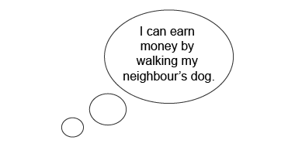  “I can think of lots of ways to earn money to buy something I want.” | Identifies ways to earn, spend, and receive money  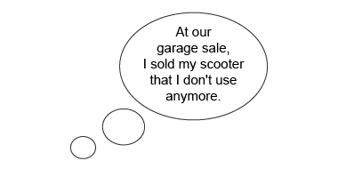  “I can sell things that I don’t use anymore to make extra money.” | Identifies ways to earn money and make payments  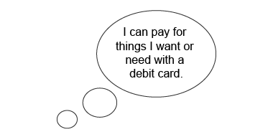  “After I earn money, I can deposit it and make payments in lots of ways.” | Creates a reasonable financial plan considering all components (earning, spending, and saving)  “There are so many things to think about when you set a financial goal.”
Observations/Documentation

Comparing Money Amounts and Making Change
Compares money amounts using part-part-whole relationship  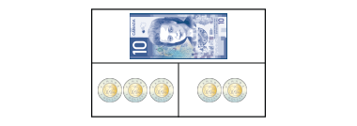  “The total cost is the whole. That’s $10. The cost of each item is a part. The items cost $6 and $4.” | Uses part-part-whole relationship to find a missing part  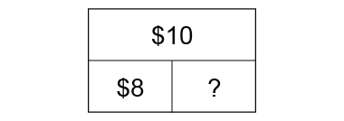  “Part + Part = whole so, 8 + ? = 10 or 10 – 8 = ? I model $10 with coins, then take away $8. I am left with $2, the missing part.” | Makes change using skip-counting  I had a $5 bill.  I bought:  Change:  “I skip-counted on from $3.50 by 25s, adding a quarter each time. 6 quarters is the same as $1.50.” | Uses different strategies to make change efficiently (e.g., counting on, counting back)  I had a $10 bill.  I bought:  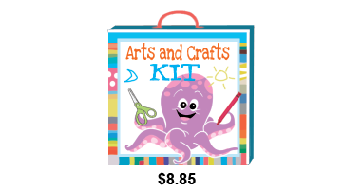  Change:  “I counted on from $8.85  and needed only 3 coins to  get to $10.”
Observations/Documentation

