Our Solid Recording Sheet
Master 54

Our Solid: _________________________________________

Attributes | Number of…
Faces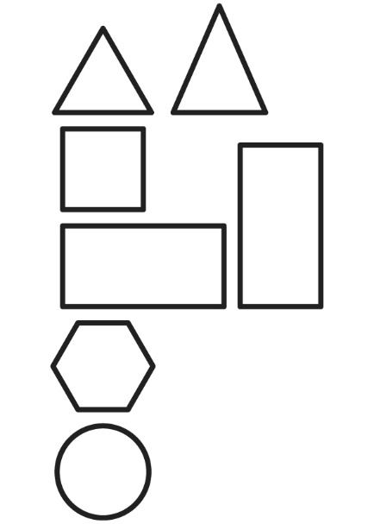 | Shape of Base: __________________________________
Edges
Vertices
Curved Surfaces

