**Is It a Net?**

**Master 55a**

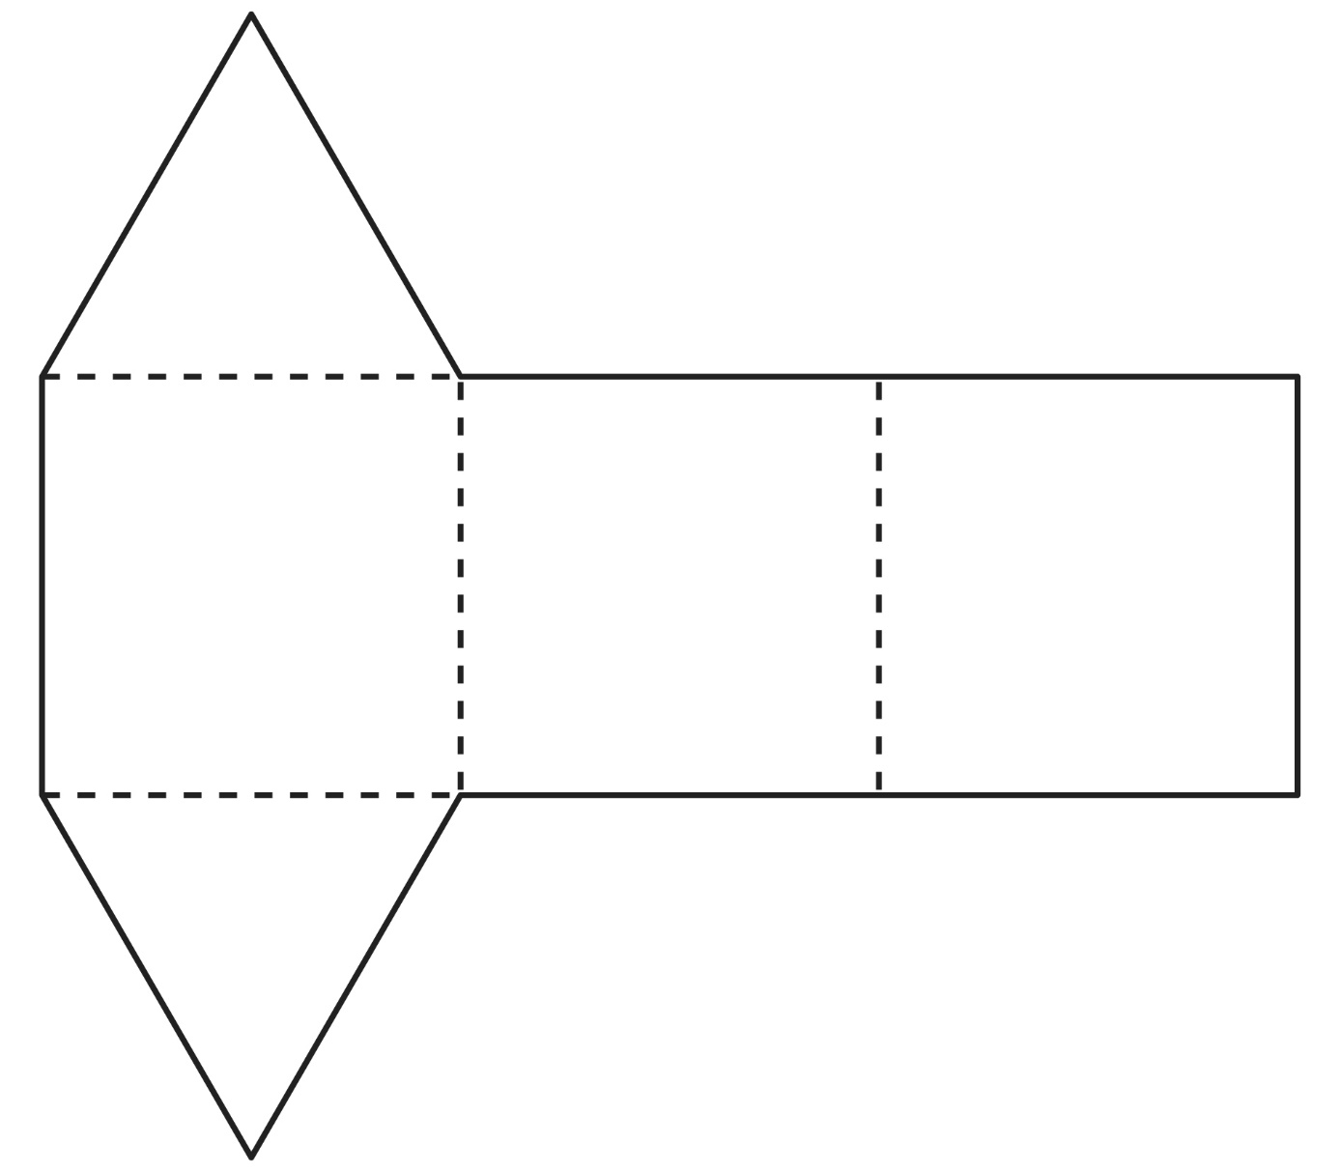

**Is It a Net?**

**Master 55b**

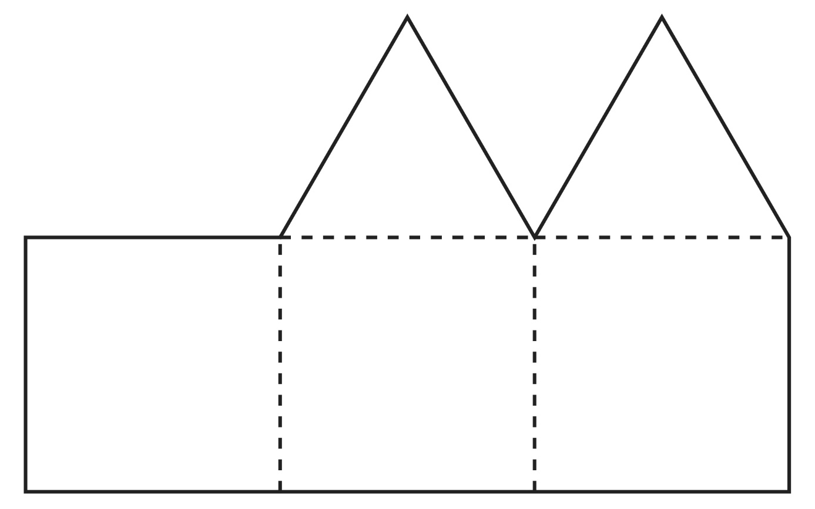

**Is It a Net?**

**Master 55c**

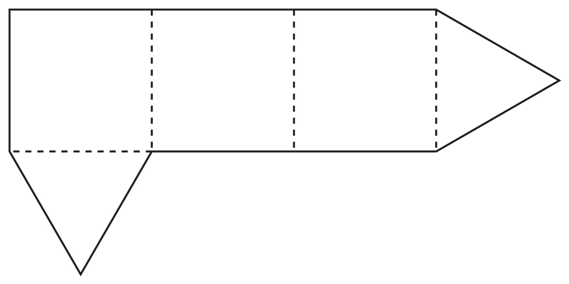

**Is It a Net?**

**Master 55d**

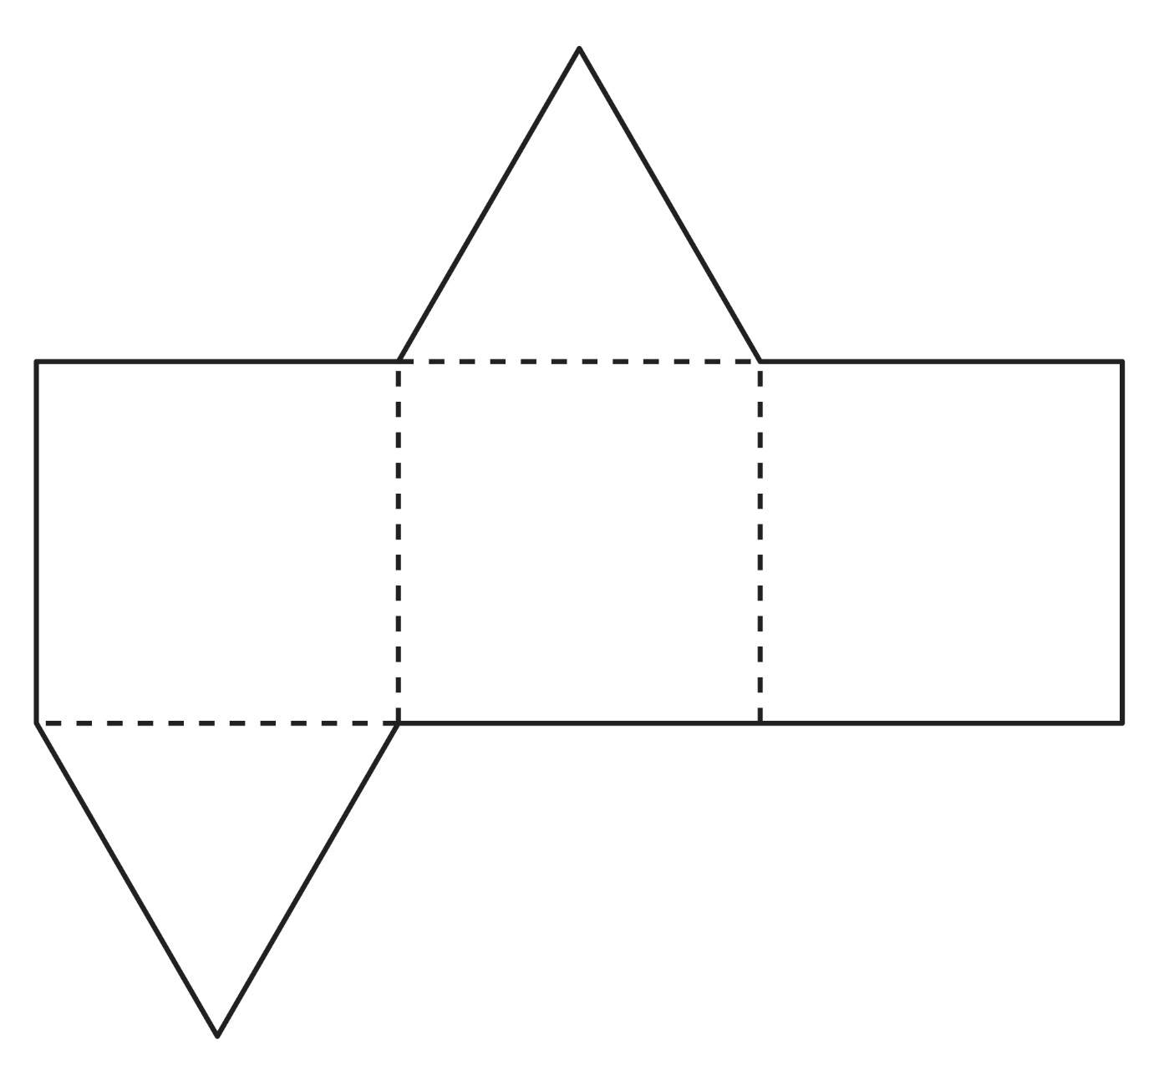

**Is It a Net?**

**Master 55e**

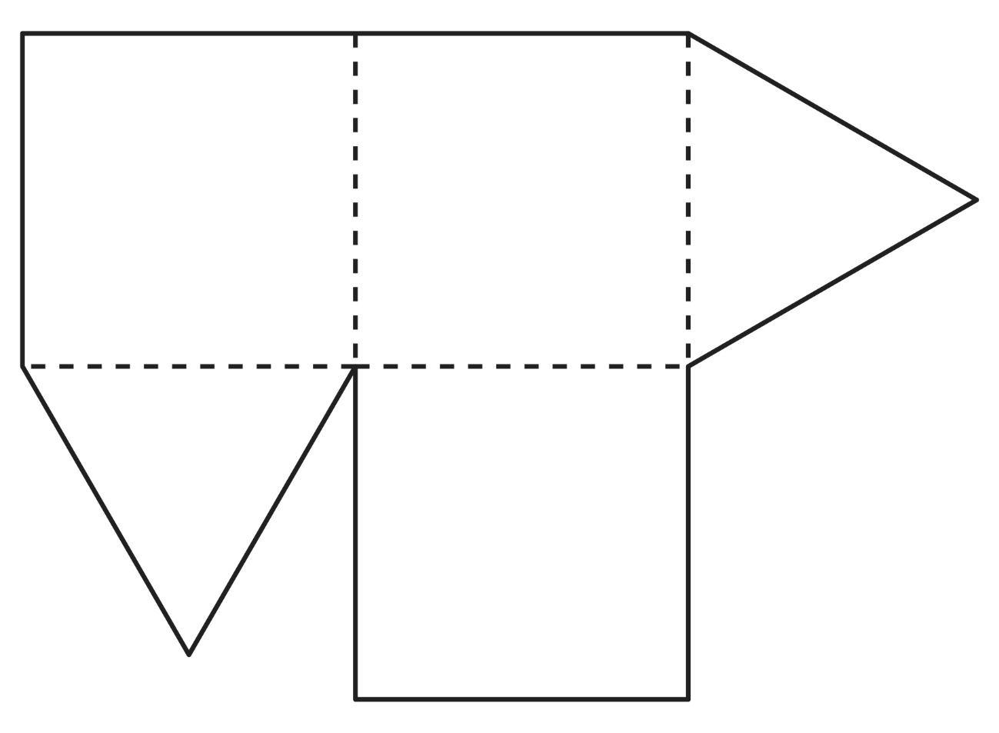

**Is It a Net?**

**Master 55f**

