**Tile Symmetry**

**Master 59a**

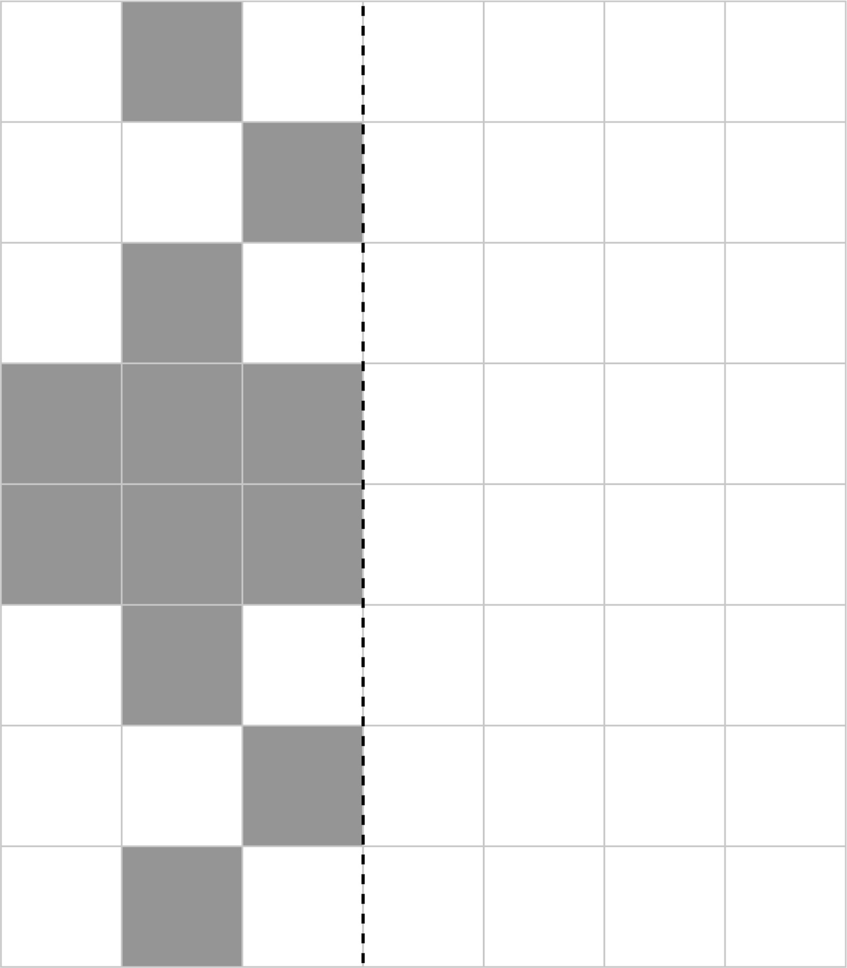

**Tile Symmetry**

**Master 59b**

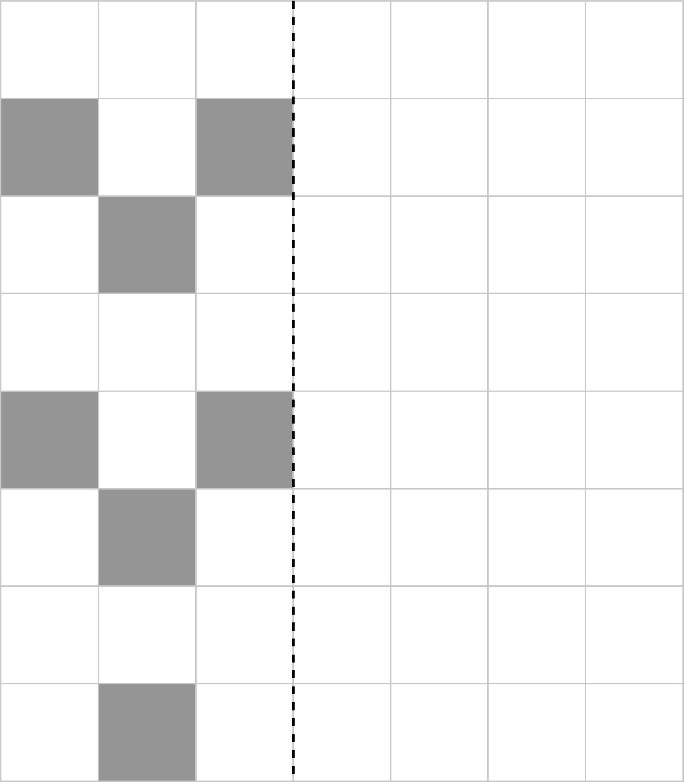

**Tile Symmetry**

**Master 59c**

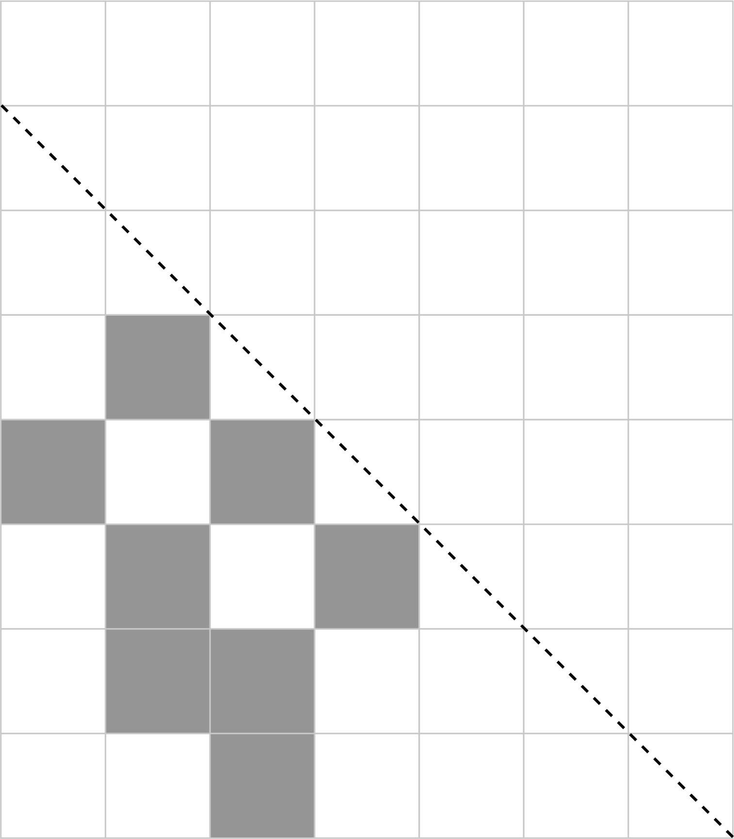

**Tile Symmetry**

**Master 59d**

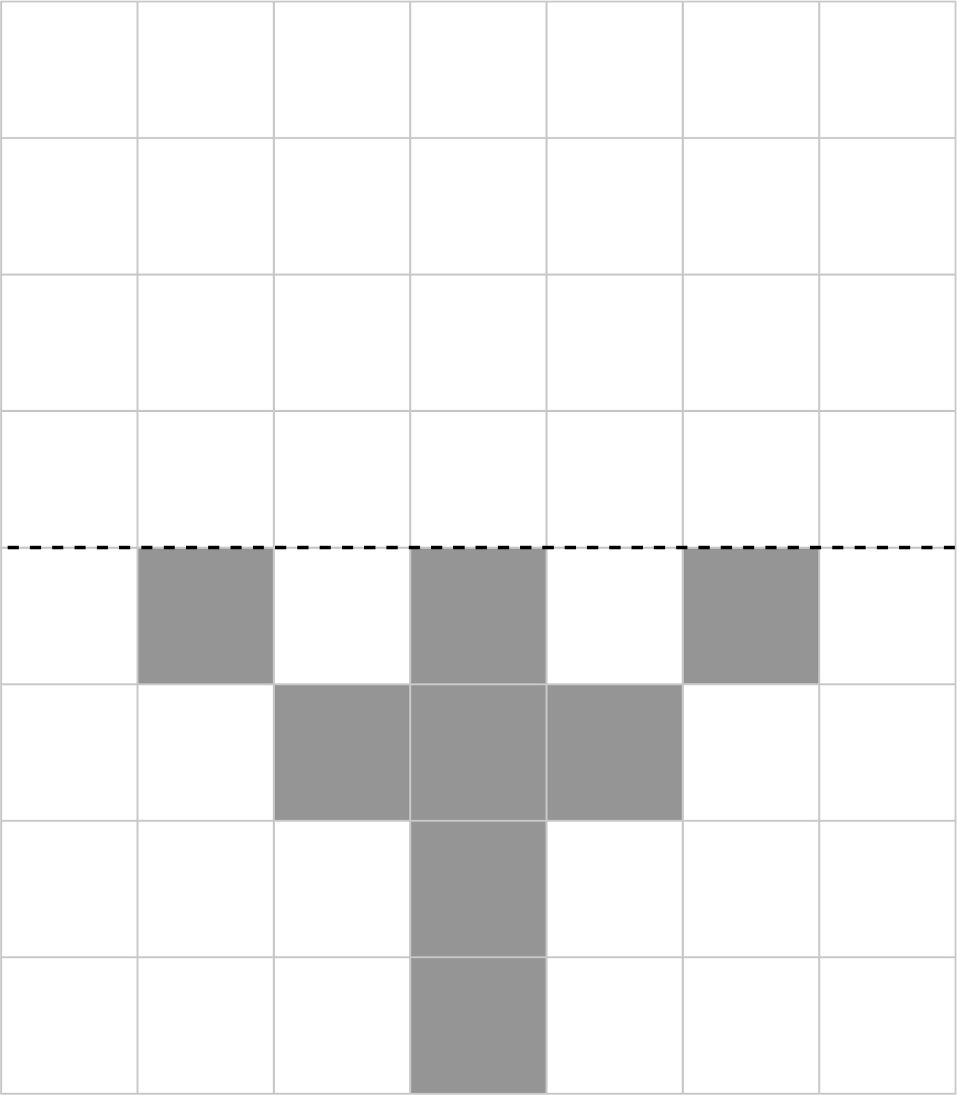

**Tile Symmetry** (Accommodation)

**Master 59e**

