Connections:
Take a Closer Look at Nature
Master 60

Can you find symmetry in these objects from nature?
Where else might you find symmetry in nature?
This is a leaf of the Sugar Maple.  It is on the Canadian flag. | Have you ever looked closely at  a snowflake?  No two snowflakes are alike.  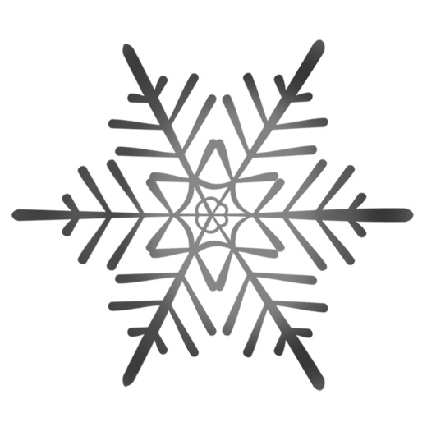
Many Monarch butterflies migrate 5000 km to Mexico for the winter. | The spots on a ladybug, along with its colourful body, are meant to warn predators to stay away.  