Dance Move Cards
Master 68a

Hop on 2 Feet | Step Touch Left
Step Touch Right | Slide Left
Slide Right | Grapevine Left
Grapevine Right | Clap Hands  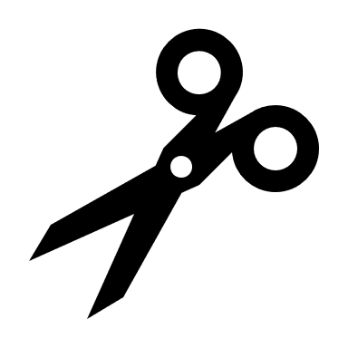

Dance Move Cards
Master 68b

Spin Around | Touch Right Knee to Elbow
Touch Left Knee to Elbow | Dig Left Heel
Dig Right Heel | Cross Over Left
Cross Over Right | Snap Fingers

Dance Move Cards
Master 68c

Turn Right | Turn Left

