Connections:
Master 46

Life as a Tree!

As a tree grows, it adds one growth ring each year.
Some trees live to be hundreds of years old.

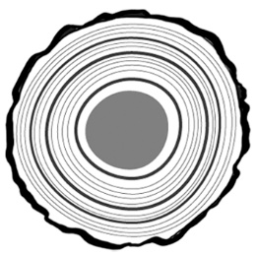
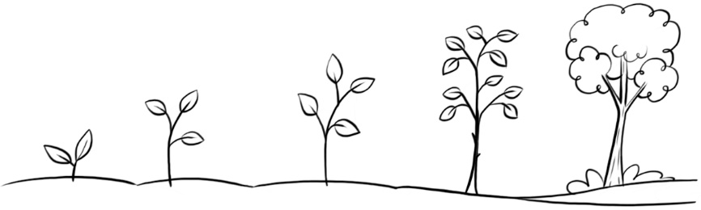

The older rings are at the centre of the tree.
The newer rings are at the outside, near the bark.

Thicker rings tell us growing conditions were good.
Thinner rings tell us growing conditions were poor.

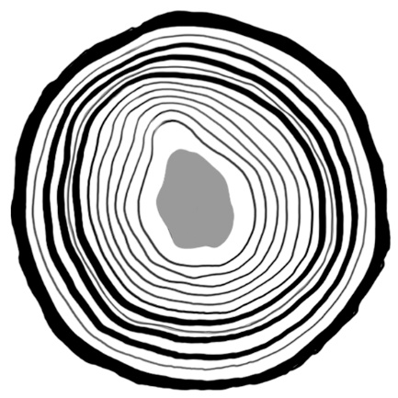
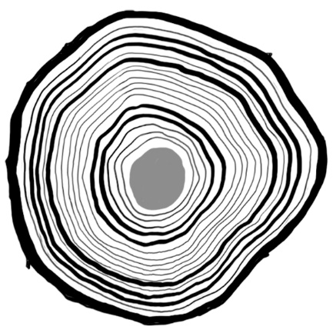
Look at these tree trunks.
- Which tree is older?
How much older?
- Which rings show good growing years?
Which rings show years that were not so good?
- Do you think these trees grew in the same area? Explain.

