**Connections: Park News**

**Master 49**

A hummingbird and robin are spotted.  
The hummingbird has a mass of 4 g.

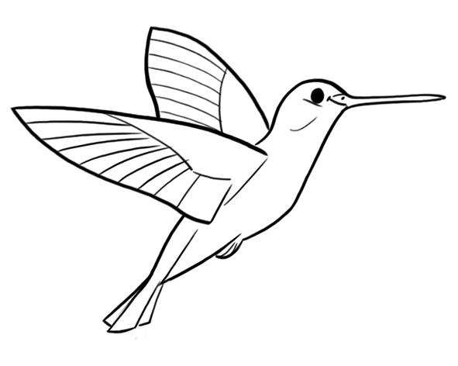

What might the mass of the robin be?

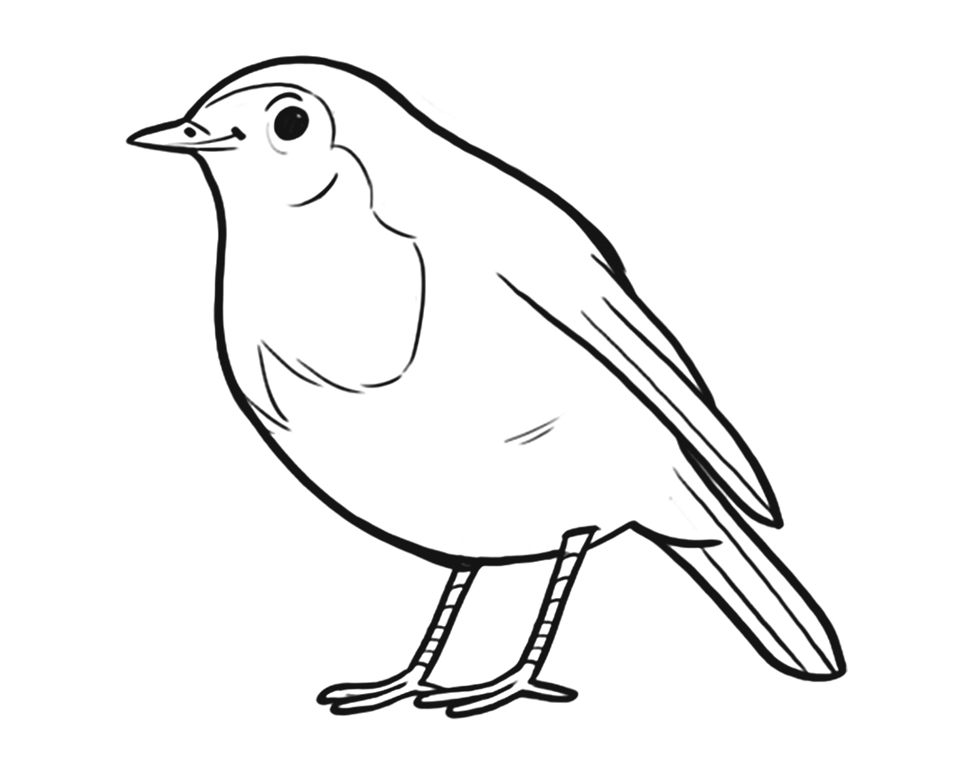

**Lost and Found**

Water bottles are left behind in a picnic area.

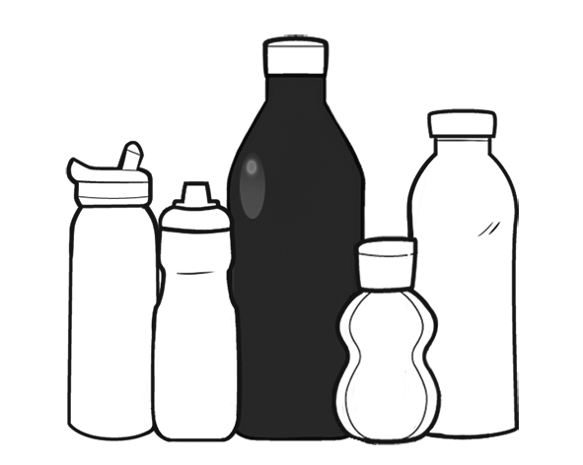

The black bottle has a capacity of 2 L.   
  
How much might each of the other bottles hold?

**Fun Fact**

An African elephant has about 450 L of blood.

Research how much blood other animals have, including you!

Annie returns from an African safari and  
shares this image.

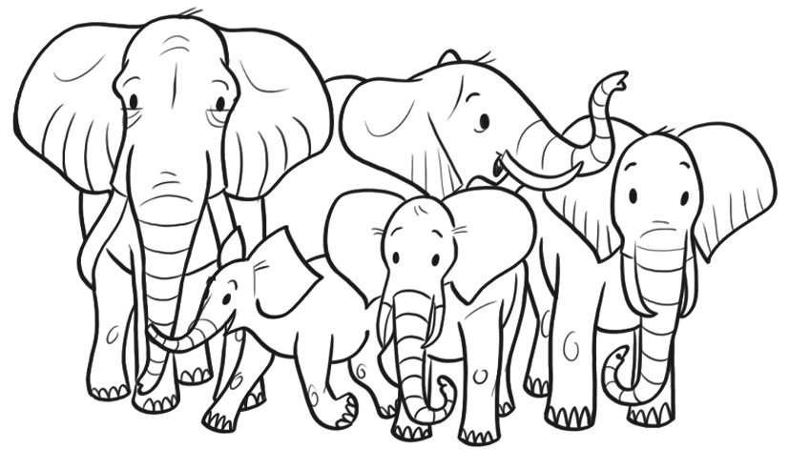

The largest elephant has a mass of 6000 kg.  
What might the mass of each of the other elephants be?