Connections:
How Many Minutes? Seconds?
Master 13

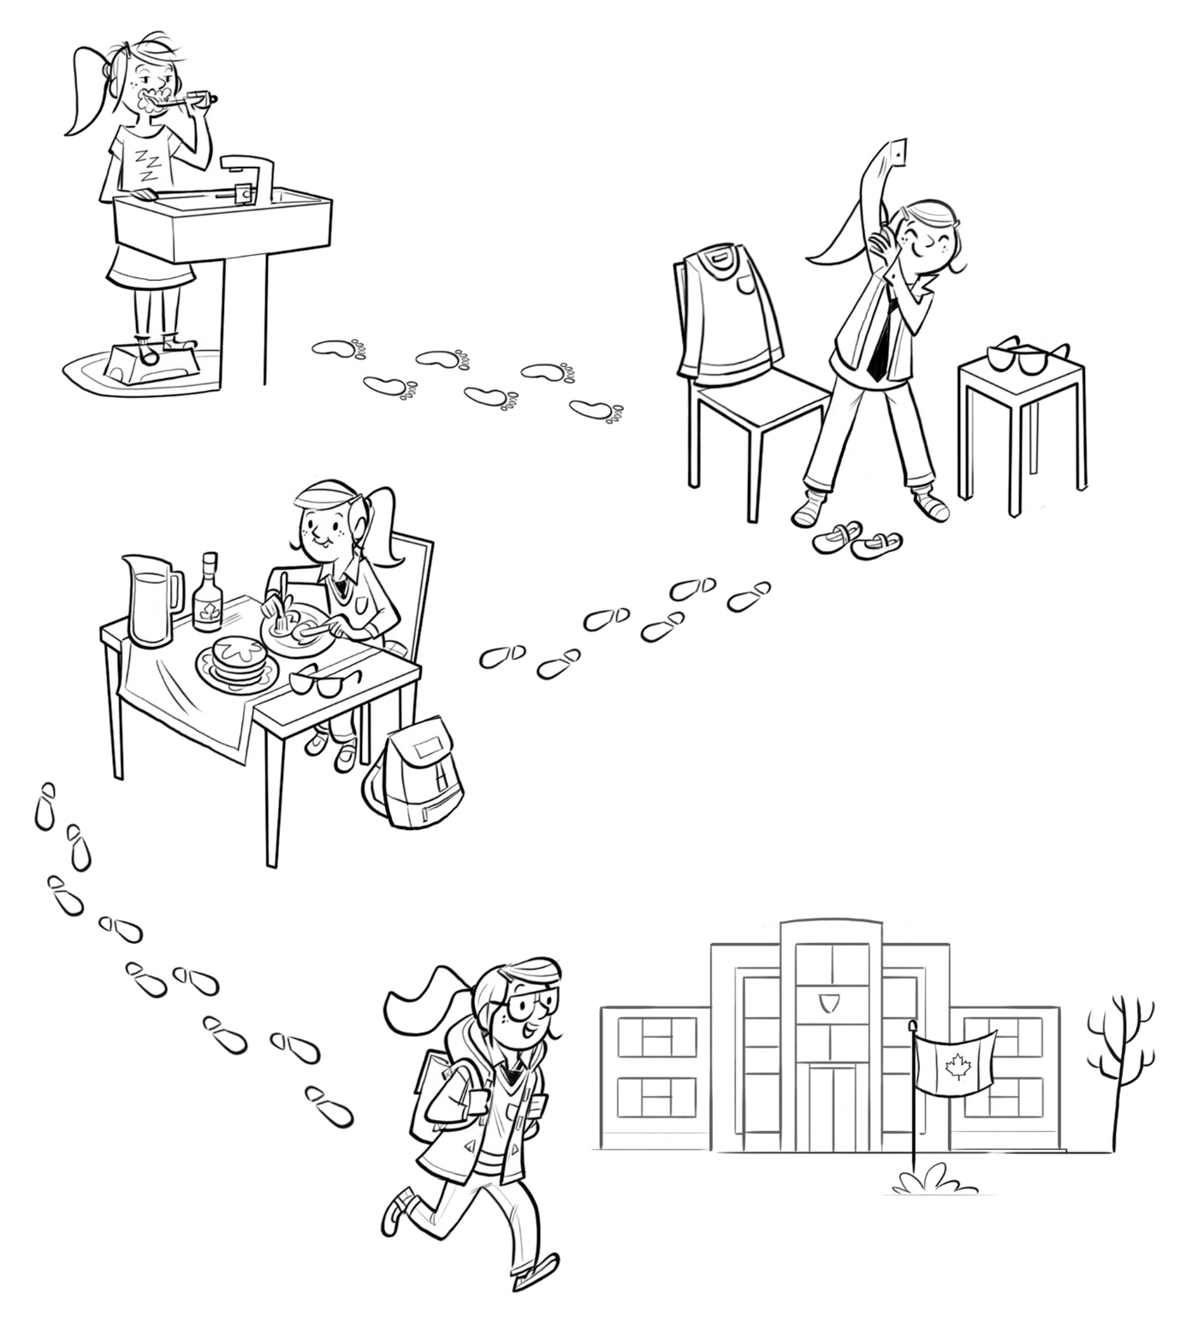
To get ready for school…
She takes 6 minutes to walk
from her house to school.
That is 360 seconds.
She takes 5 minutes
to eat her breakfast. That is 300 seconds.
She takes 3 minutes
to get dressed.
That is 180 seconds.

Grace brushes her teeth for
2 minutes every morning.
That is 120 seconds.
How many minutes does Grace spend getting ready for school altogether? How many seconds?
How many minutes and seconds do you take?
$f(1,2)$

