Connections: Vyshyvanka
Master 26

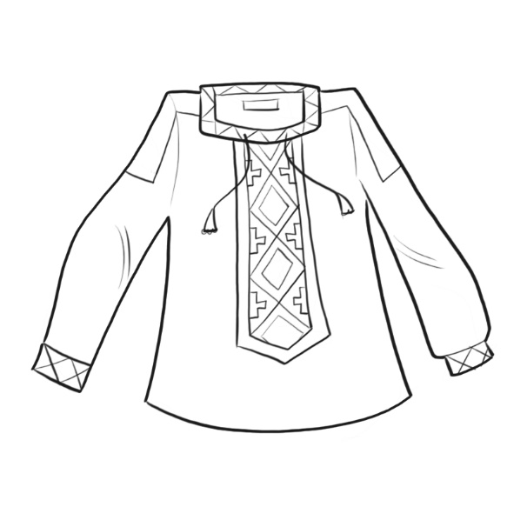
Vyshyvanka is the Ukranian name for embroidered shirt.

Ukrainian embroidery often contains hidden meanings.
When people embroider shirts or blouses for others, they include
symbols that are meant to protect them or bring good luck.

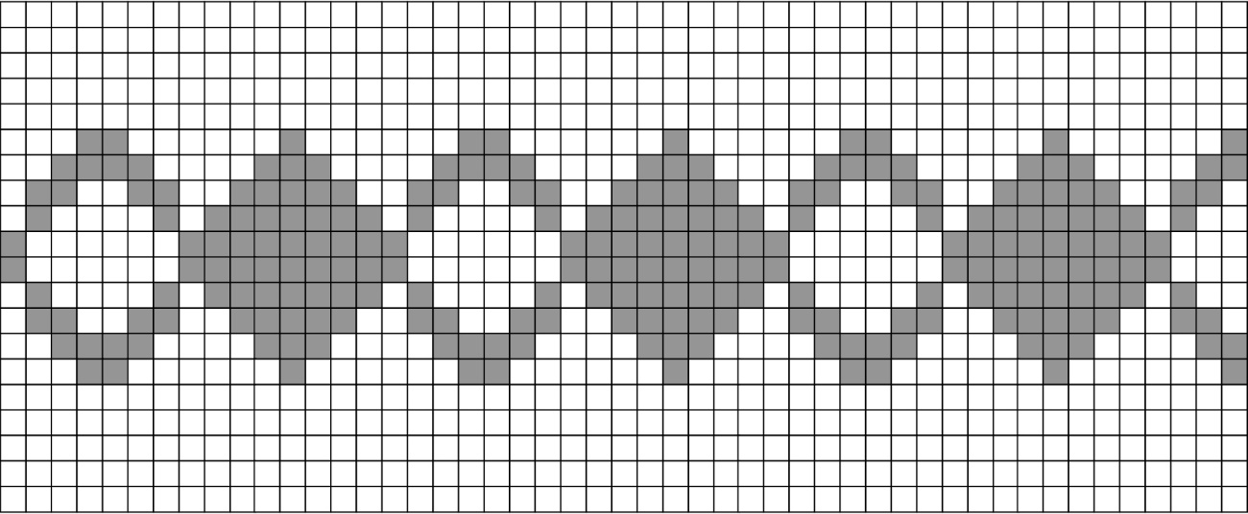
What increasing or decreasing pattern do you see in the stitches?

Copy the pattern on a grid.
What is the pattern rule?

Do some research to learn about the meaning of different symbols
in this type of embroidery.

