Hockey Homework Line Master 1
(Assessment Master)

Name: _____________________________

Split Wholes into Equal Parts to  Make Fractions | Not observed | Sometimes | Consistently
Uses fractions to describe contexts that are part of a whole or part of a set
Splits wholes (e.g., shapes, intervals, sets) into equal parts
Uses fraction symbols as labels (optional in some provinces)
Compare Fractions
Uses visual models (area model, set model, linear model) to compare fractional size
Determines the relationship between the number of parts of a whole and the size of the parts
Recognizes that the size of the whole matters when comparing fractions
Strengths:

Next Steps:

Connecting Home and School Line Master 2–1



NOTE TO THE TEACHER

You may wish to send families a Hockey Homework letter outlining a familiar activity or two they can do at home with their children.

Create a letter using this template and select one or two activities from the suggestions on the next page. Simply delete these instructions and cut and paste the activities you have selected, adapting them to fit your needs.

Connecting Home and School Line Master 2–2

Dear Family:

We have been working on Hockey Homework, which focuses on splitting wholes into equal parts to make fractions, and comparing fractions. Try this activity at home with your child.
 – – – – – – – – – – – – – – – – – – – – – – – – – – – – – – – – – – – – – – – – – –
Fraction Scavenger Hunt: Grab a smart phone, tablet, camera, or paper and markers, and go find fractions! Set a time limit and record as many fractions as you can. Stay in the house, or go for a walk in nature or around the neighbourhood.
 – – – – – – – – – – – – – – – – – – – – – – – – – – – – – – – – – – – – – – – – – –
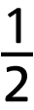
Bake with Fractions: Bake or cook with your child using non-metric measuring tools, such as measuring cups. Point out any fractions written on the items, such
as “ tsp.” Invite your child to see how many of one can fit into another.
It can be fun to estimate first, and then check how close the estimation was.
 – – – – – – – – – – – – – – – – – – – – – – – – – – – – – – – – – – – – – – – – – –
Build Fractions: Join your child in using toy building blocks to represent fractions. Build a structure together and then ask questions such as: What fraction of the blocks are red? Or, ask your child to build a structure or shape using specific fractions; for example, say: Let’s make a rectangle that is
one-fourth blue.
 – – – – – – – – – – – – – – – – – – – – – – – – – – – – – – – – – – – – – – – – – –
Practise fair sharing: Gather up items that can be shared, such as food (e.g., grapes or crackers), or a non-food item that can be divided, such as a “pizza” made of modelling clay or ribbons that can be cut. Invite your child to share the items equally among the people in a group. The “people” could be a collection of dolls stuffed animals, or toys. Repeat with different numbers of things to be shared for as long as your child remains interested. You might also vary the number of people to be shared with. Discuss why some are more difficult to share fairly than others (e.g., making thirds or fifths).
 – – – – – – – – – – – – – – – – – – – – – – – – – – – – – – – – – – – – – – – – – –
Sincerely,

___________________________
Grid Paper Line Master 3
Name: _____________________________

Equal Parts Mat Line Master 4
 – – – – – – – – – – – – – – – – – – – – – – – – – – – – – – – – – – – – – – – – – –
Name: _____________________________

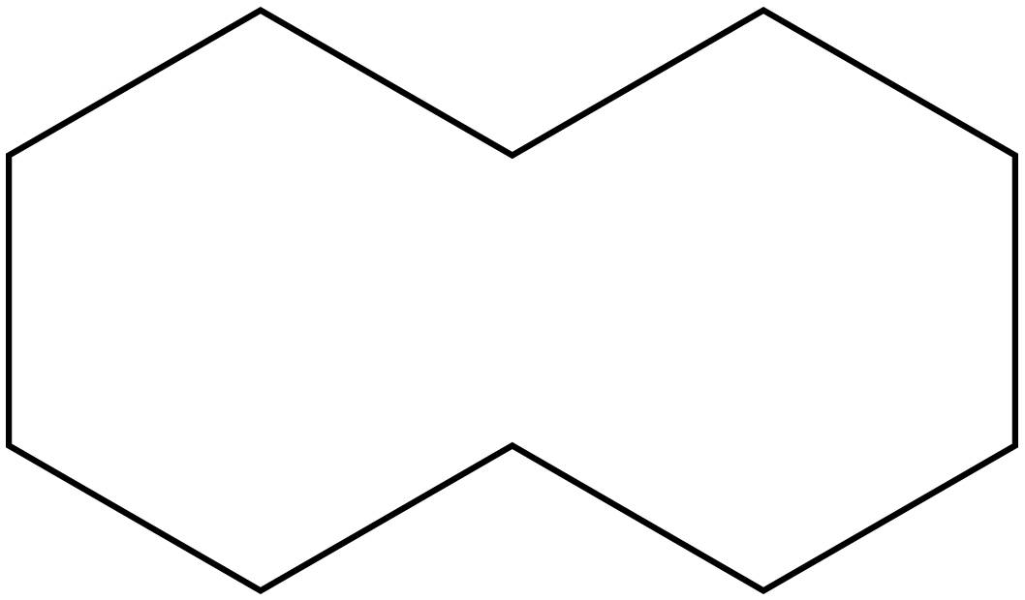
 – – – – – – – – – – – – – – – – – – – – – – – – – – – – – – – – – – – – – – – – – –
Name: _____________________________

 – – – – – – – – – – – – – – – – – – – – – – – – – – – – – – – – – – – – – – – – – –

Equal Parts Recording Sheet Line Master 5
Name: _____________________________

Picture | Number of Pattern Blocks | Name of the Equal Parts

My Logo Line Master 6–1
Name: _____________________________

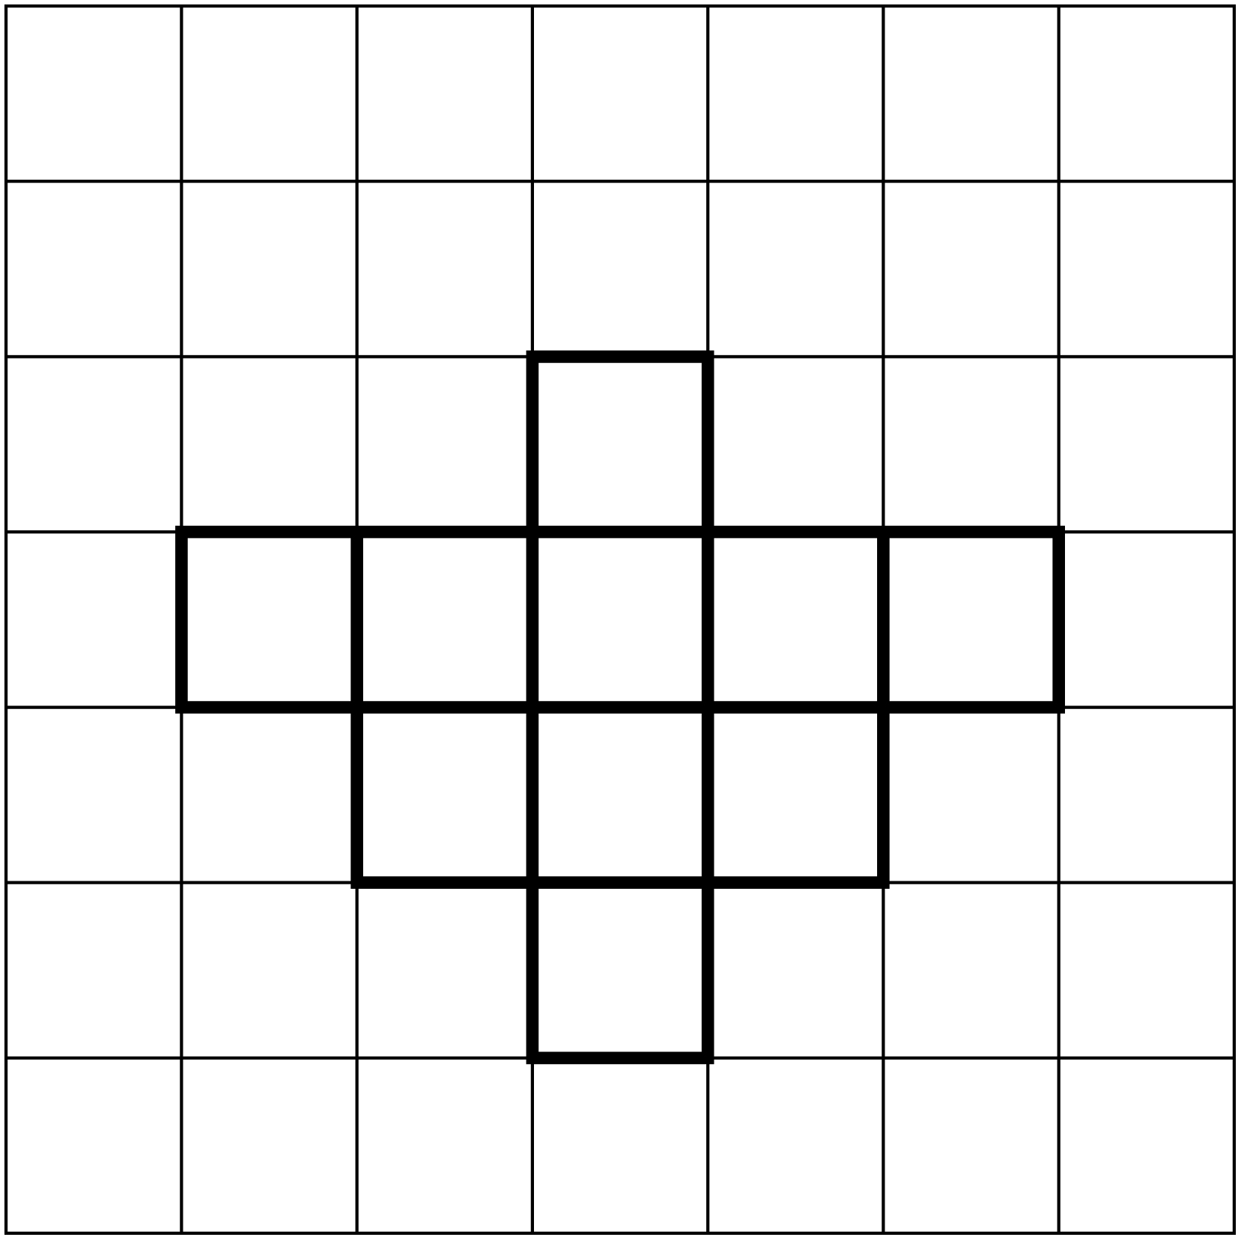
My Logo Line Master 6–2
Name: _____________________________

Colour | How many are this colour? | How can you represent this number as a fraction of the whole?

Pick any two fractions. Write the lesser fraction first and then
the greater fraction.

Sorting Cards Line Master 7

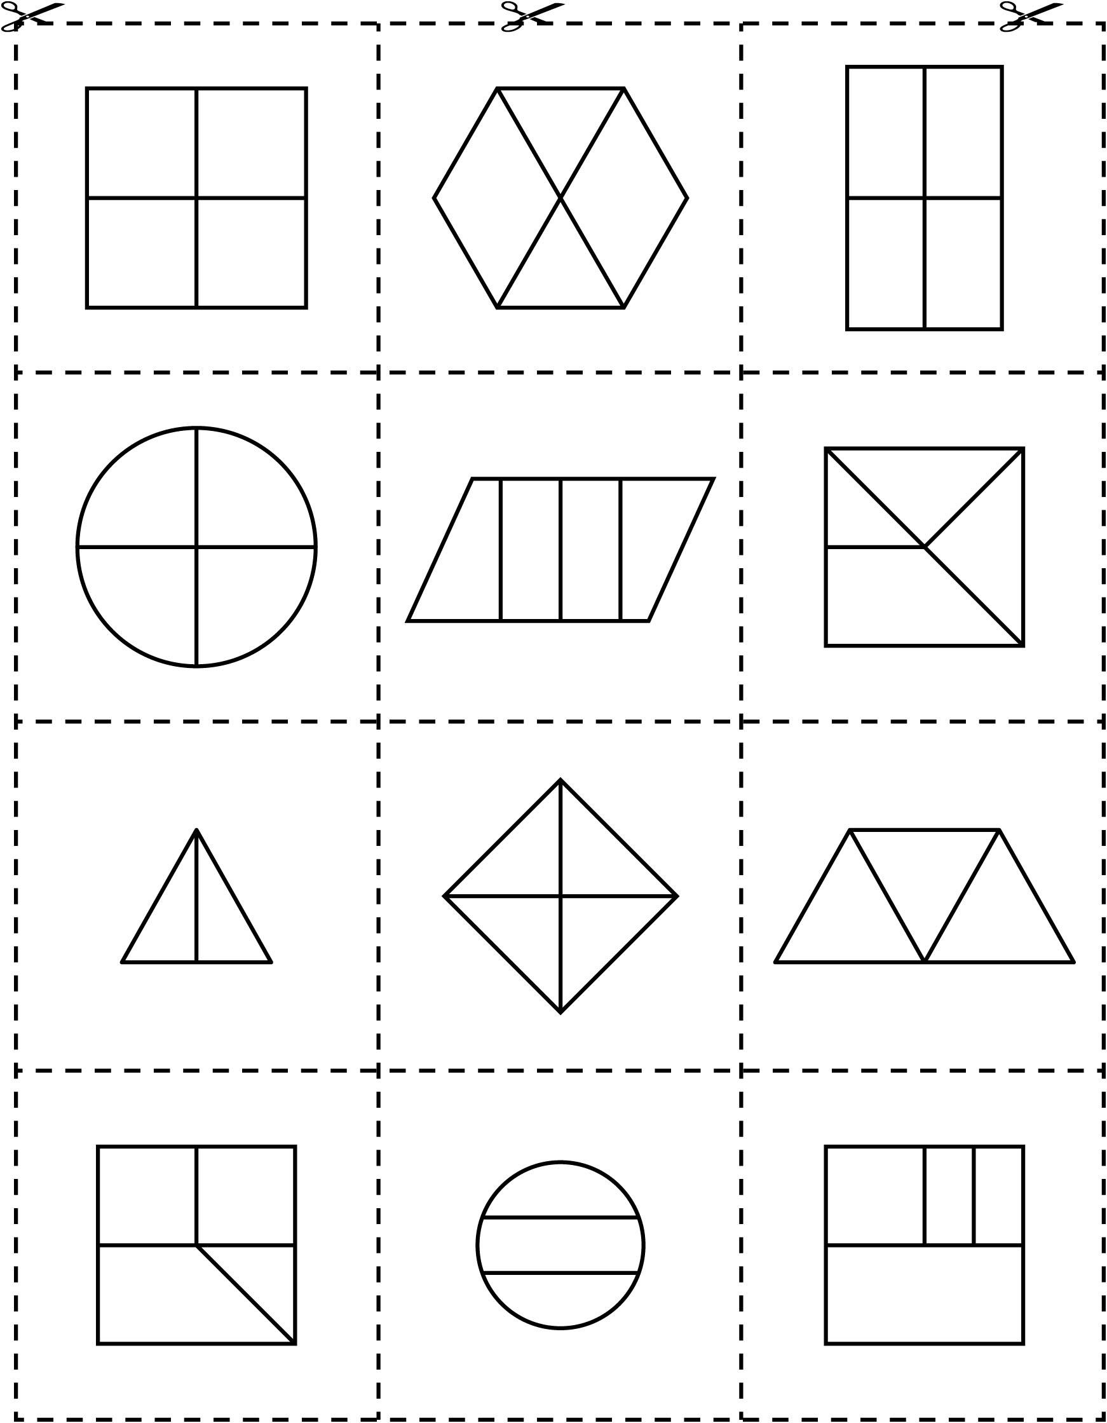
Sorting Mat Line Master 8
Name: _____________________________

Fractional Parts | Examples
halves
thirds
quarters

Fraction Match Cards Line Master 9–1

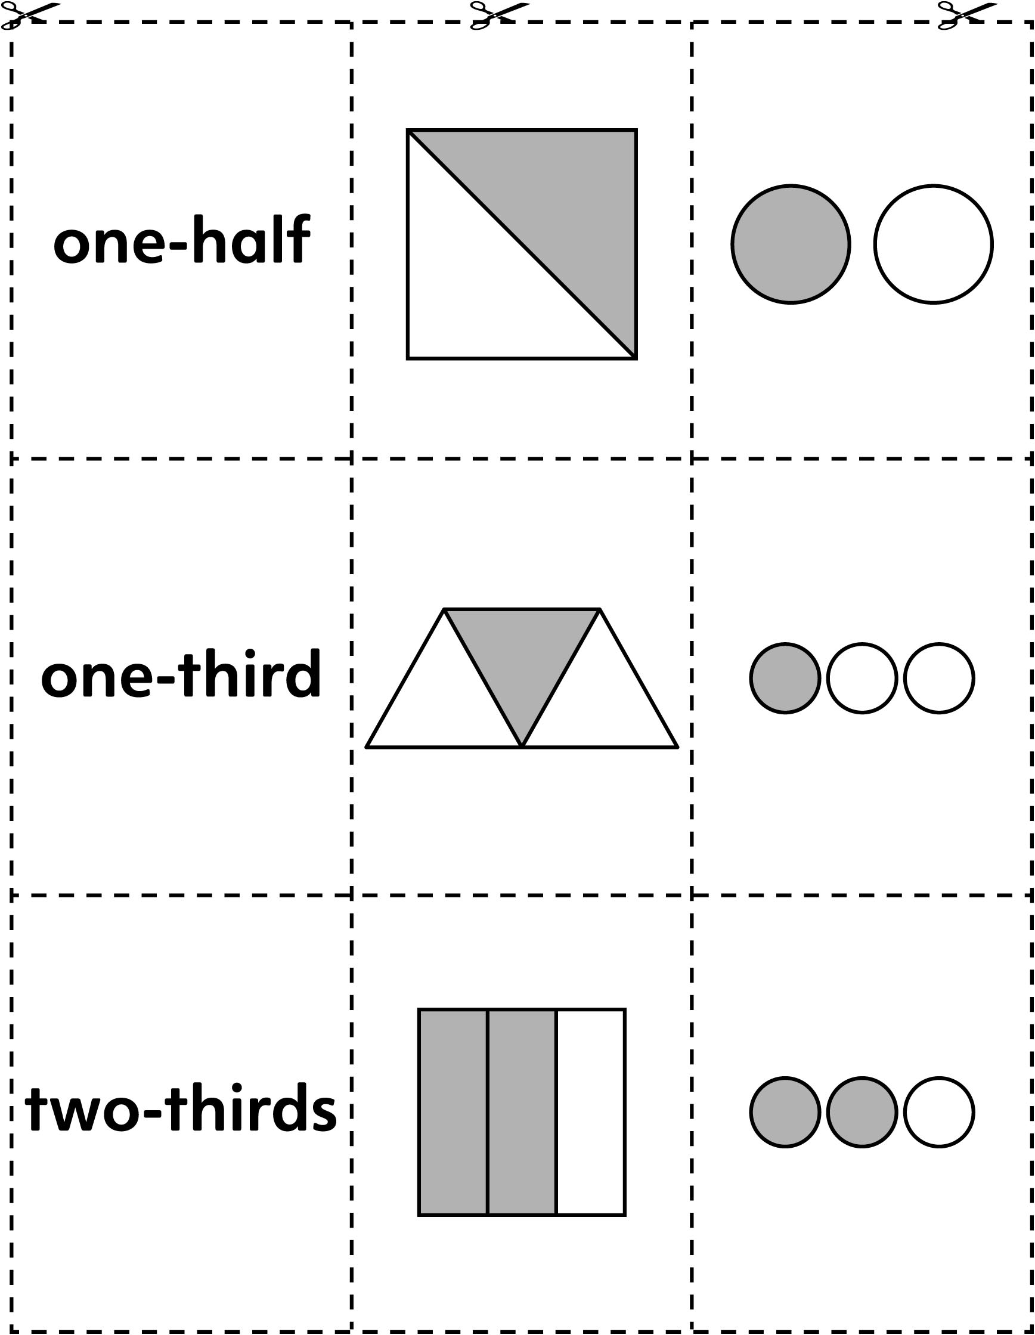

Fraction Match Cards Line Master 9–2

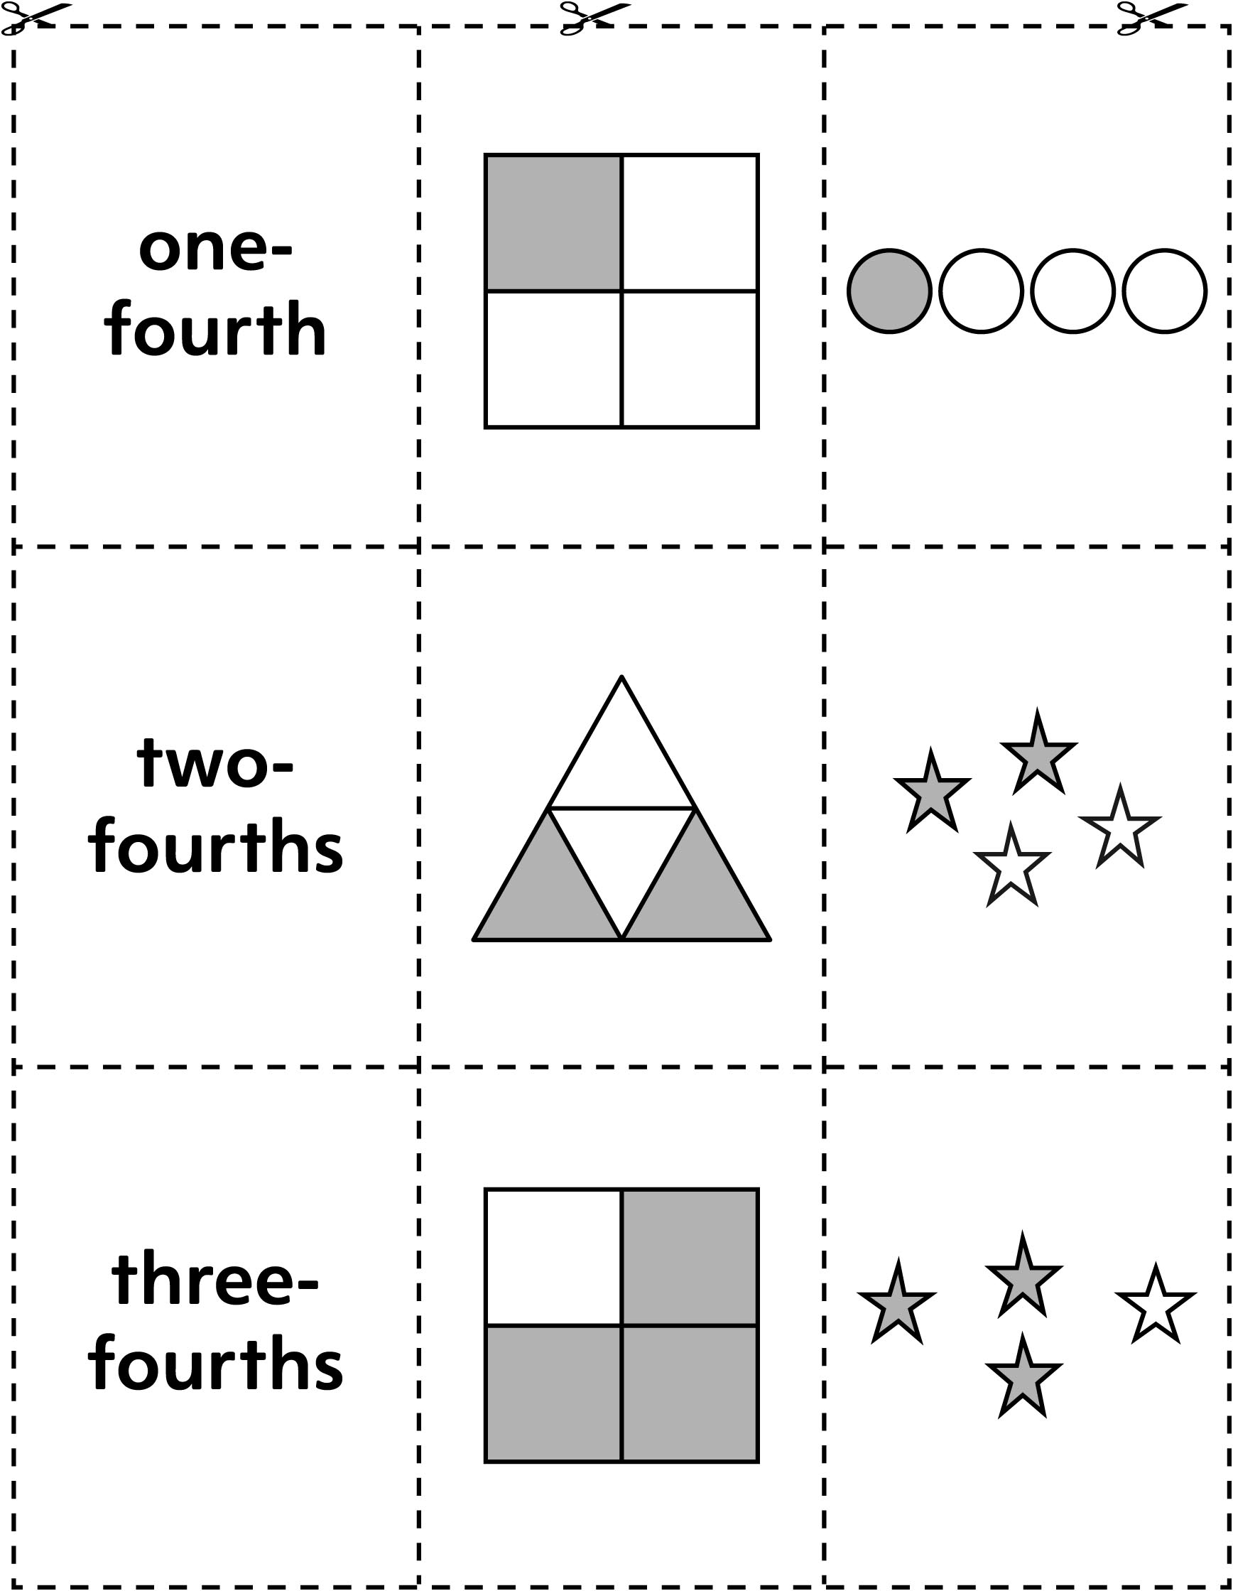

Discover Fractions Line Master 10–1
Name: _____________________________

Find rods that show the fractions. Then, draw the rods.

Fraction | My Drawing
one-half | The ______________________ rod is ______________________  of the ______________________ rod.
one-third | The ______________________ rod is ______________________  of the ______________________ rod.
one-fourth | The ______________________ rod is ______________________  of the ______________________ rod.

Discover Fractions Line Master 10–2
Name: _____________________________

Find rods that show the fractions. Then, draw the rods.

Fraction | My Drawing
one-fifth | The ______________________ rod is ______________________  of the ______________________ rod.
one-tenth | The ______________________ rod is ______________________  of the ______________________ rod.

Writing About Fractions Line Master 11

 – – – – – – – – – – – – – – – – – – – – – – – – – – – – – – – – – – – – – – – – – –

Where do we use fractions? List as many places as you can.

 – – – – – – – – – – – – – – – – – – – – – – – – – – – – – – – – – – – – – – – – – –

Suppose you were sharing a chocolate bar with 2 friends. How would you share it fairly?

 – – – – – – – – – – – – – – – – – – – – – – – – – – – – – – – – – – – – – – – – – –

Imagine sharing a treat. Your share is one-fifth. Is your share more than or less than a one-fourth share? Use words and drawings to explain.

 – – – – – – – – – – – – – – – – – – – – – – – – – – – – – – – – – – – – – – – – – –

Could one-third ever be greater than one-half? Use drawings and words to show your ideas.

 – – – – – – – – – – – – – – – – – – – – – – – – – – – – – – – – – – – – – – – – – –

Write 2 important things you have learned about fractions. Explain why it is important to know these things.

 – – – – – – – – – – – – – – – – – – – – – – – – – – – – – – – – – – – – – – – – – –

Fraction Problems Line Master 12–1
 – – – – – – – – – – – – – – – – – – – – – – – – – – – – – – – – – – – – – – – – – –
Draw a flag that fits the fractions.

two-thirds yellow
one-third blue

 – – – – – – – – – – – – – – – – – – – – – – – – – – – – – – – – – – – – – – – – – –
Draw a flag that fits the fractions.

one-fourth green
one-fourth orange
two-fourths white

 – – – – – – – – – – – – – – – – – – – – – – – – – – – – – – – – – – – – – – – – – –
This shape is one-half of a larger shape. Using grid paper, draw as many different shapes as you can that might be the larger shape.

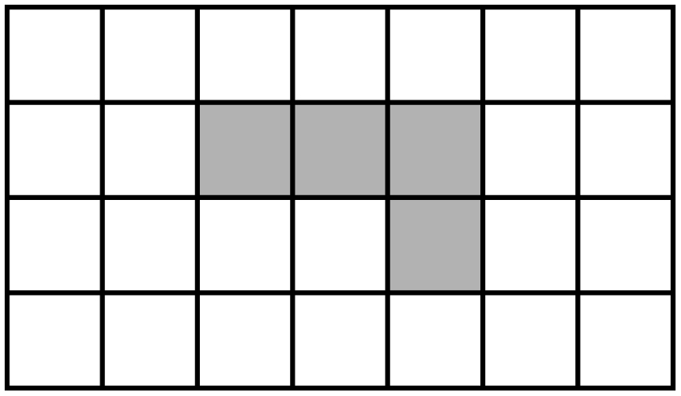
 – – – – – – – – – – – – – – – – – – – – – – – – – – – – – – – – – – – – – – – – – –
Fraction Problems Line Master 12–2
 – – – – – – – – – – – – – – – – – – – – – – – – – – – – – – – – – – – – – – – – – –
Imagine sharing a treat. Do you get a bigger piece when you share with many friends or a few friends? Use pictures to explain why your answer makes sense.
 – – – – – – – – – – – – – – – – – – – – – – – – – – – – – – – – – – – – – – – – – –
On Friday, the Bearcats hockey team practised for seven-twelfths of an hour, and the Bulldogs practised for nine-twelfths of an hour. Which team spent more time practising? How do you know?
 – – – – – – – – – – – – – – – – – – – – – – – – – – – – – – – – – – – – – – – – – –
There are 4 red pucks and 2 black pucks left on the ice.
What fraction of the pucks are black?
Use counters if they help. Draw a picture to show your solution.
 – – – – – – – – – – – – – – – – – – – – – – – – – – – – – – – – – – – – – – – – – –
Use rods to find the answer to each question.

Which rod is one-half of the dark green rod?
Which rod is one-fourth of the brown rod?
Which rod is one-third of the blue rod?
Which rod is one-fifth of the orange rod?
Which rod is one-half of the orange rod?
 – – – – – – – – – – – – – – – – – – – – – – – – – – – – – – – – – – – – – – – – – –

