Finding Buster Line Master 1
(Assessment Master)

Name: _____________________________

Compose to 1000 Based on Place Value | Not observed | Sometimes | Consistently
Writes, reads, composes, and decomposes 3-digit numbers as hundreds, tens, and ones
Determines 10 or 100 more/less than the given numbers
Compare and Order Quantities and Numbers to 1000
Compares quantities and numbers to 1000
Estimates quantities and numbers to 1000
Orders quantities and numbers to 1000
Strengths:

Next Steps:

Connecting Home and School Line Master 2–1

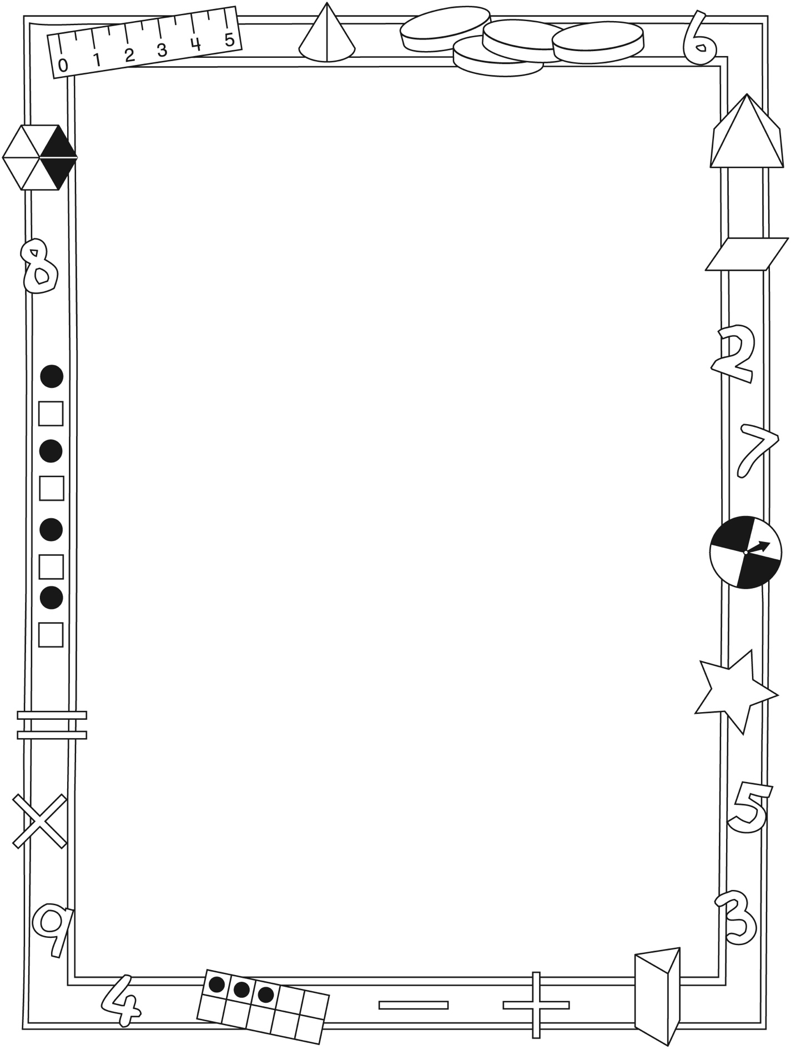

NOTE TO THE TEACHER

You may wish to send families a Finding Buster letter outlining a familiar activity or two they can do at home with their children.

Create a letter using this template and select one or two activities from the suggestions on the next page. Simply delete these instructions and cut and paste the activities you have selected, adapting them to fit your needs.

Connecting Home and School Line Master 2–2

Dear Family:

We have been working on Finding Buster, which engages children in conversations, investigations, and activities that help to develop their understanding of the big math idea that “Quantities and numbers can be grouped by units or split into units.” Particular focus is placed on composing numbers to 1000. Try this activity at home with your child.

– – – – – – – – – – – – – – – – – – – – – – – – – – – – – – – – – – – – – – – – – –

Reading the Story: As you read the story, enjoy estimating (guessing) how many items are in the scenes that show large collections. After you read, you might use collections of small objects such as buttons, coins, or beans to estimate and count numbers greater than 100. Grab large handfuls of the objects and spill them onto a surface. Estimate how many there are before grouping them into hundreds, tens, and ones on the inside back cover mat.

– – – – – – – – – – – – – – – – – – – – – – – – – – – – – – – – – – – – – – – – – –

I Spy Numbers: Search the book for 3-digit numbers and list the ones you find. Take turns asking each other questions such as the following: I spy a number that is 100 more than 400. Which number is it? I spy the number that is the greatest one on the list. What number is it? Create new lists of 3-digit numbers by searching your home, newspaper, or books.

– – – – – – – – – – – – – – – – – – – – – – – – – – – – – – – – – – – – – – – – – –

Make the Greatest or Least Number! Print the numbers 0–9 on 2 sets of separate cards, shuffle them, and place them face down. In turn, flip over 3 cards. Arrange the cards to make the greatest number you can. Then challenge the other to rearrange the same cards to make the least/smallest number possible. After several turns, shuffle the cards before continuing.

– – – – – – – – – – – – – – – – – – – – – – – – – – – – – – – – – – – – – – – – – –

Sincerely,

___________________________

Base Ten Cutouts Line Master 3–1

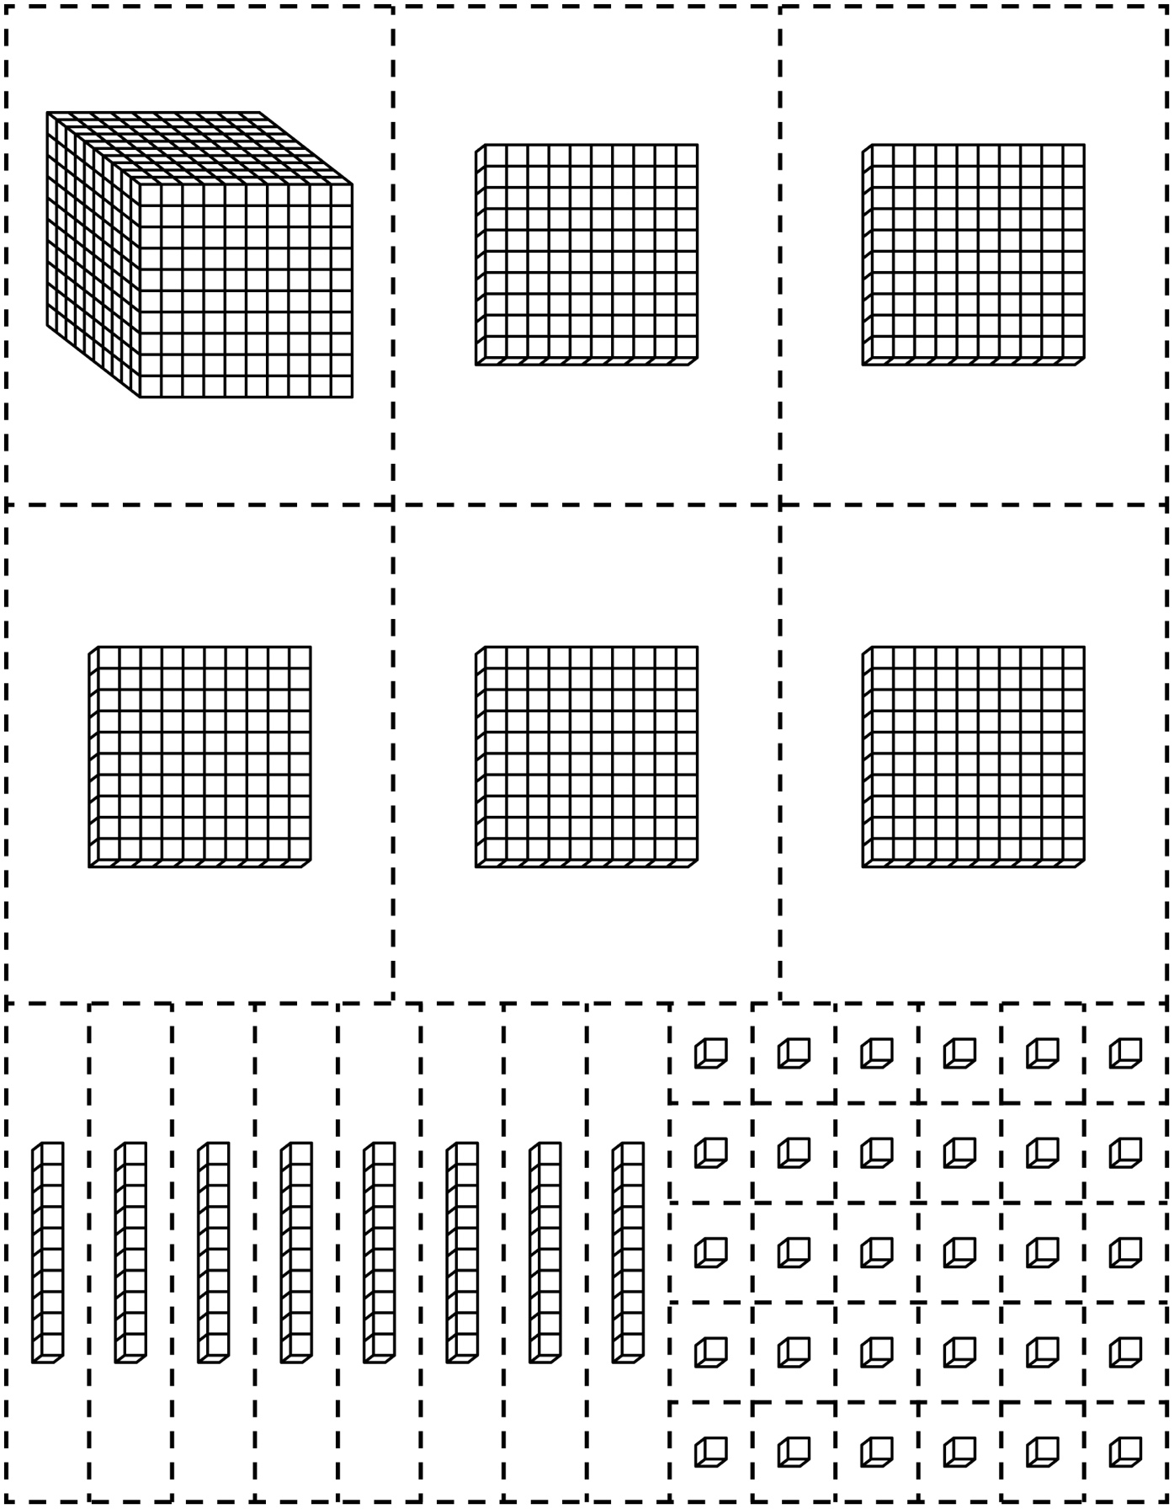

Base Ten Cutouts Line Master 3–2

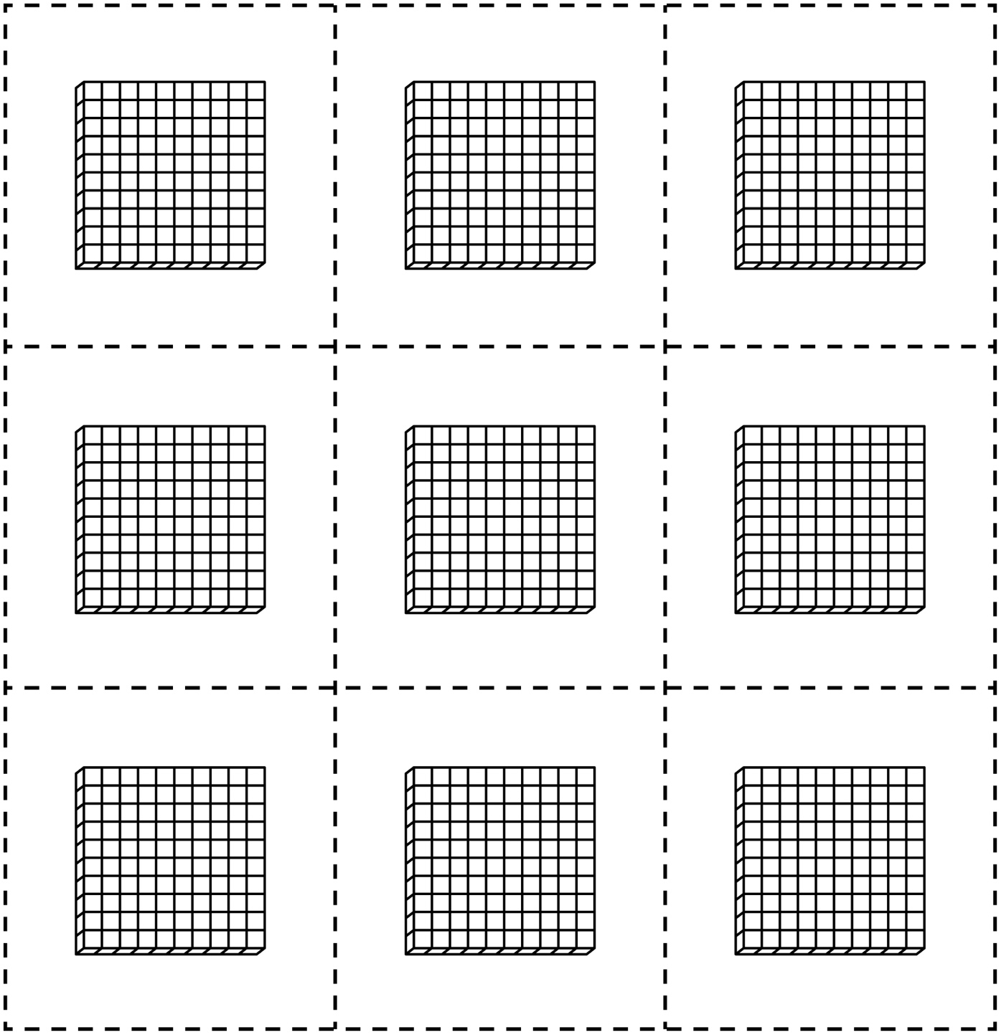

Base Ten Cutouts Line Master 3–3

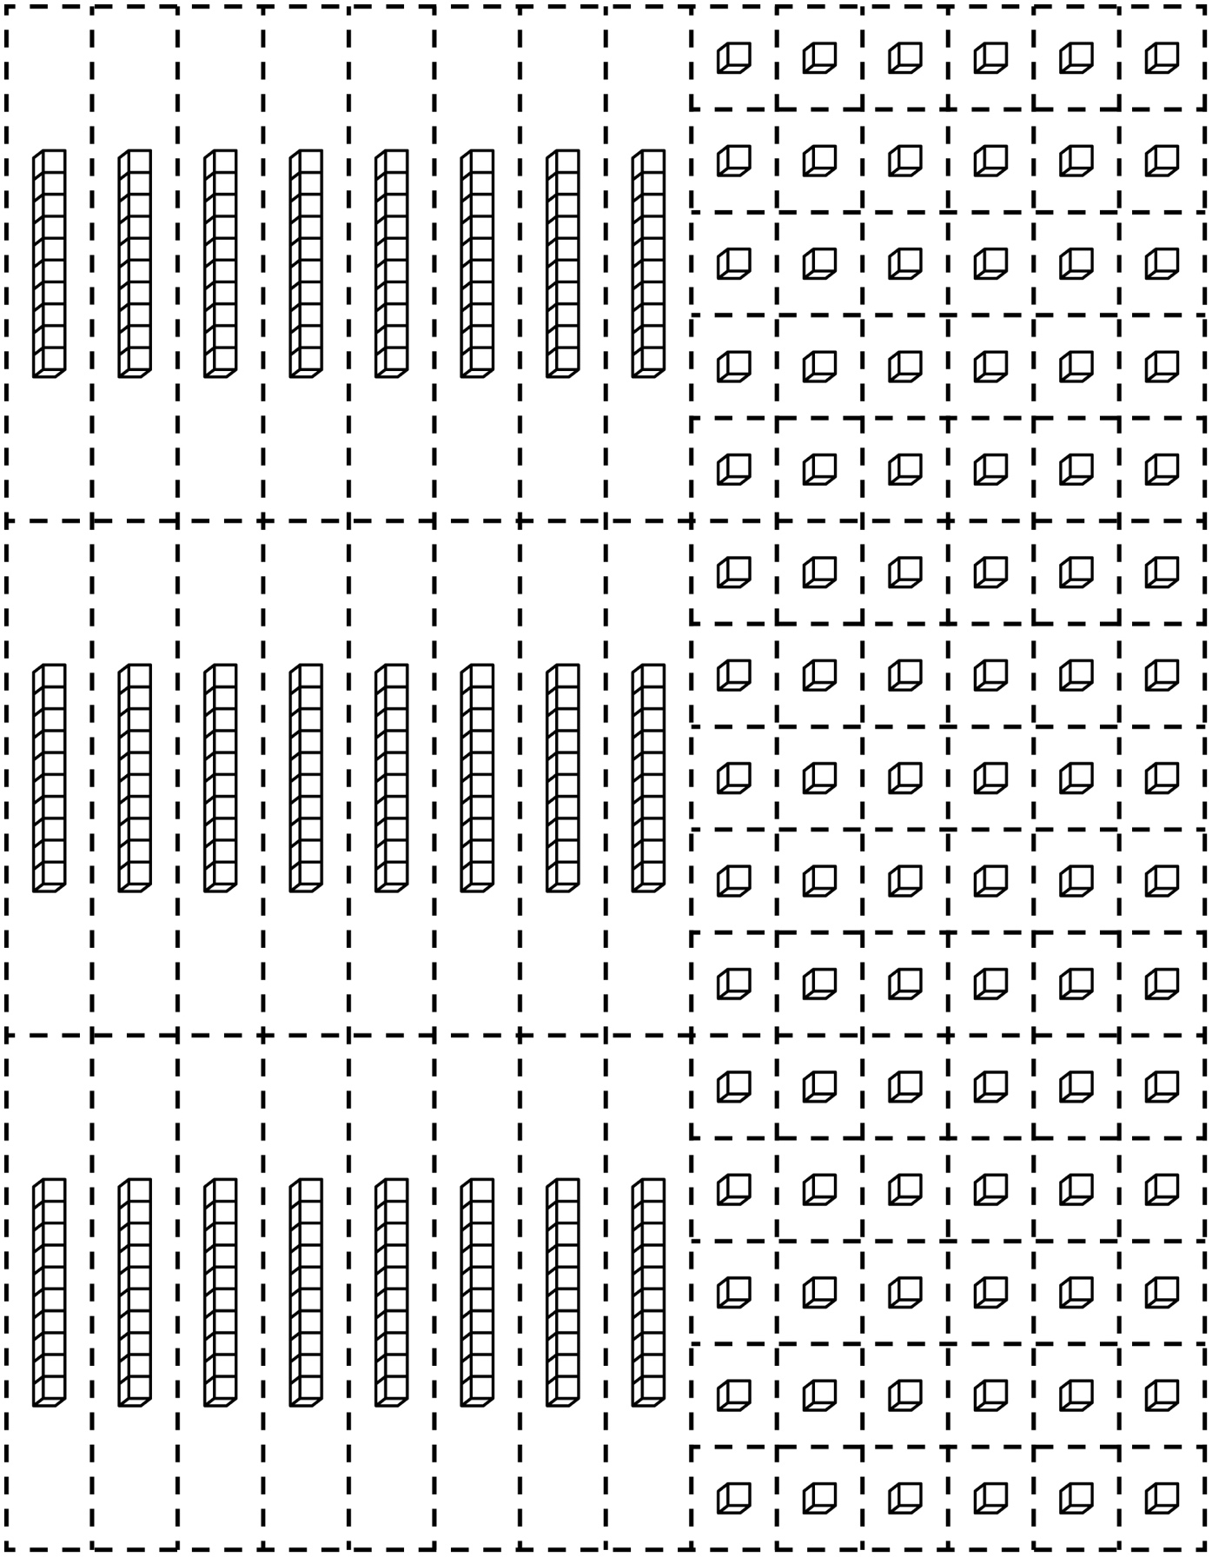

Hundred Charts Line Master 4–1

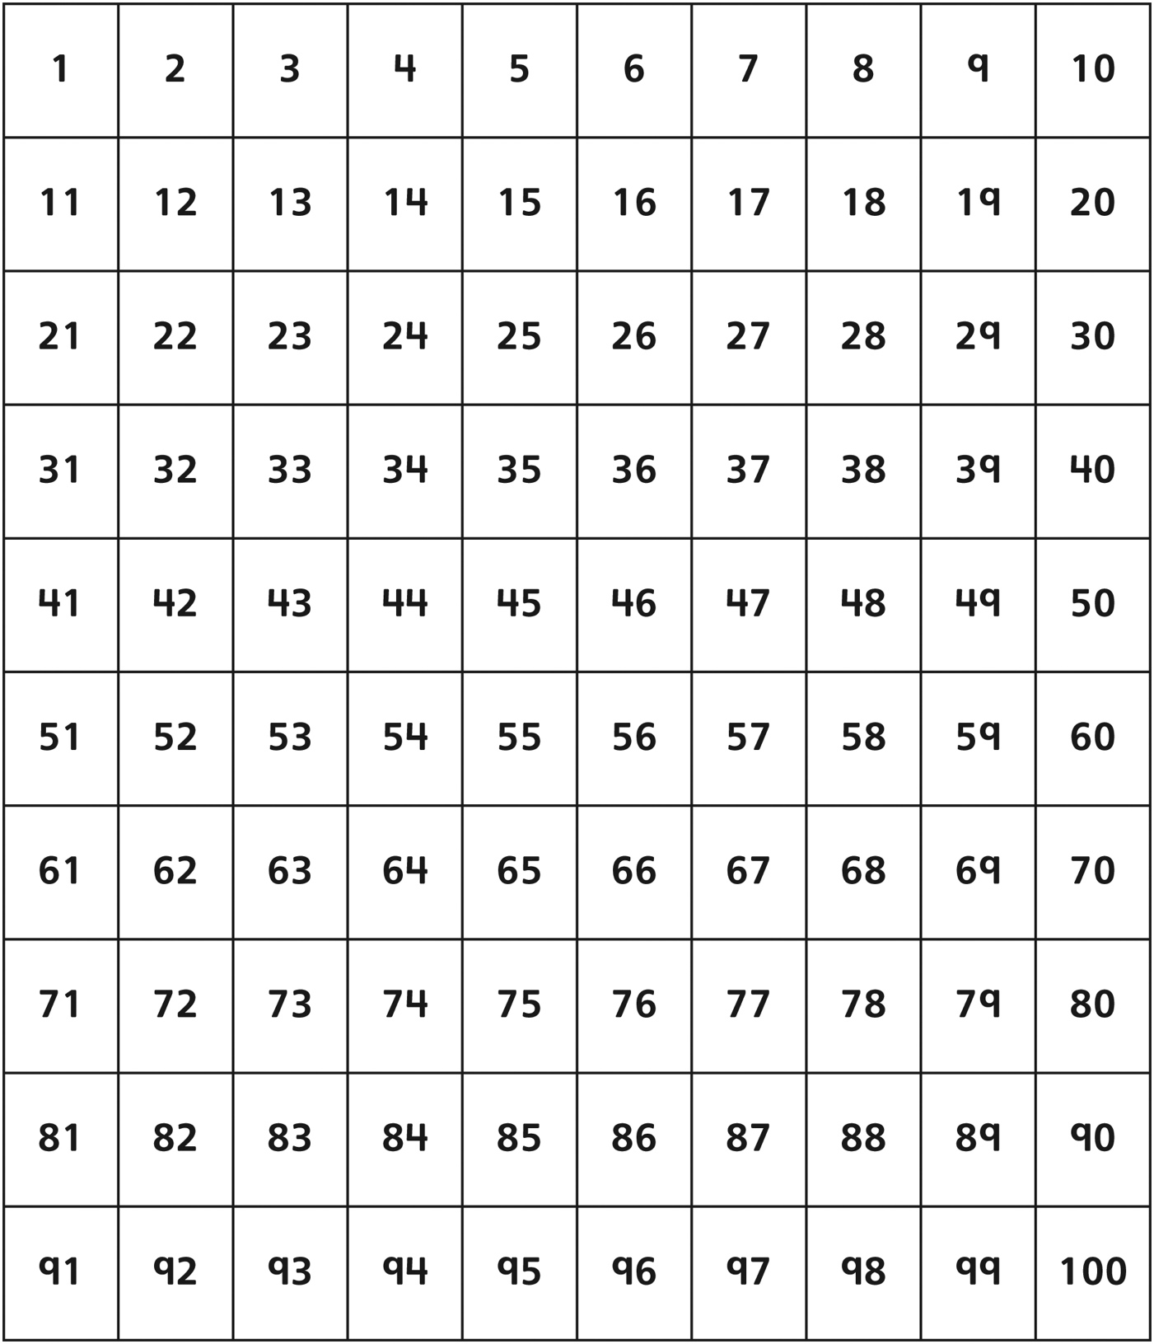

Hundred Charts Line Master 4–2

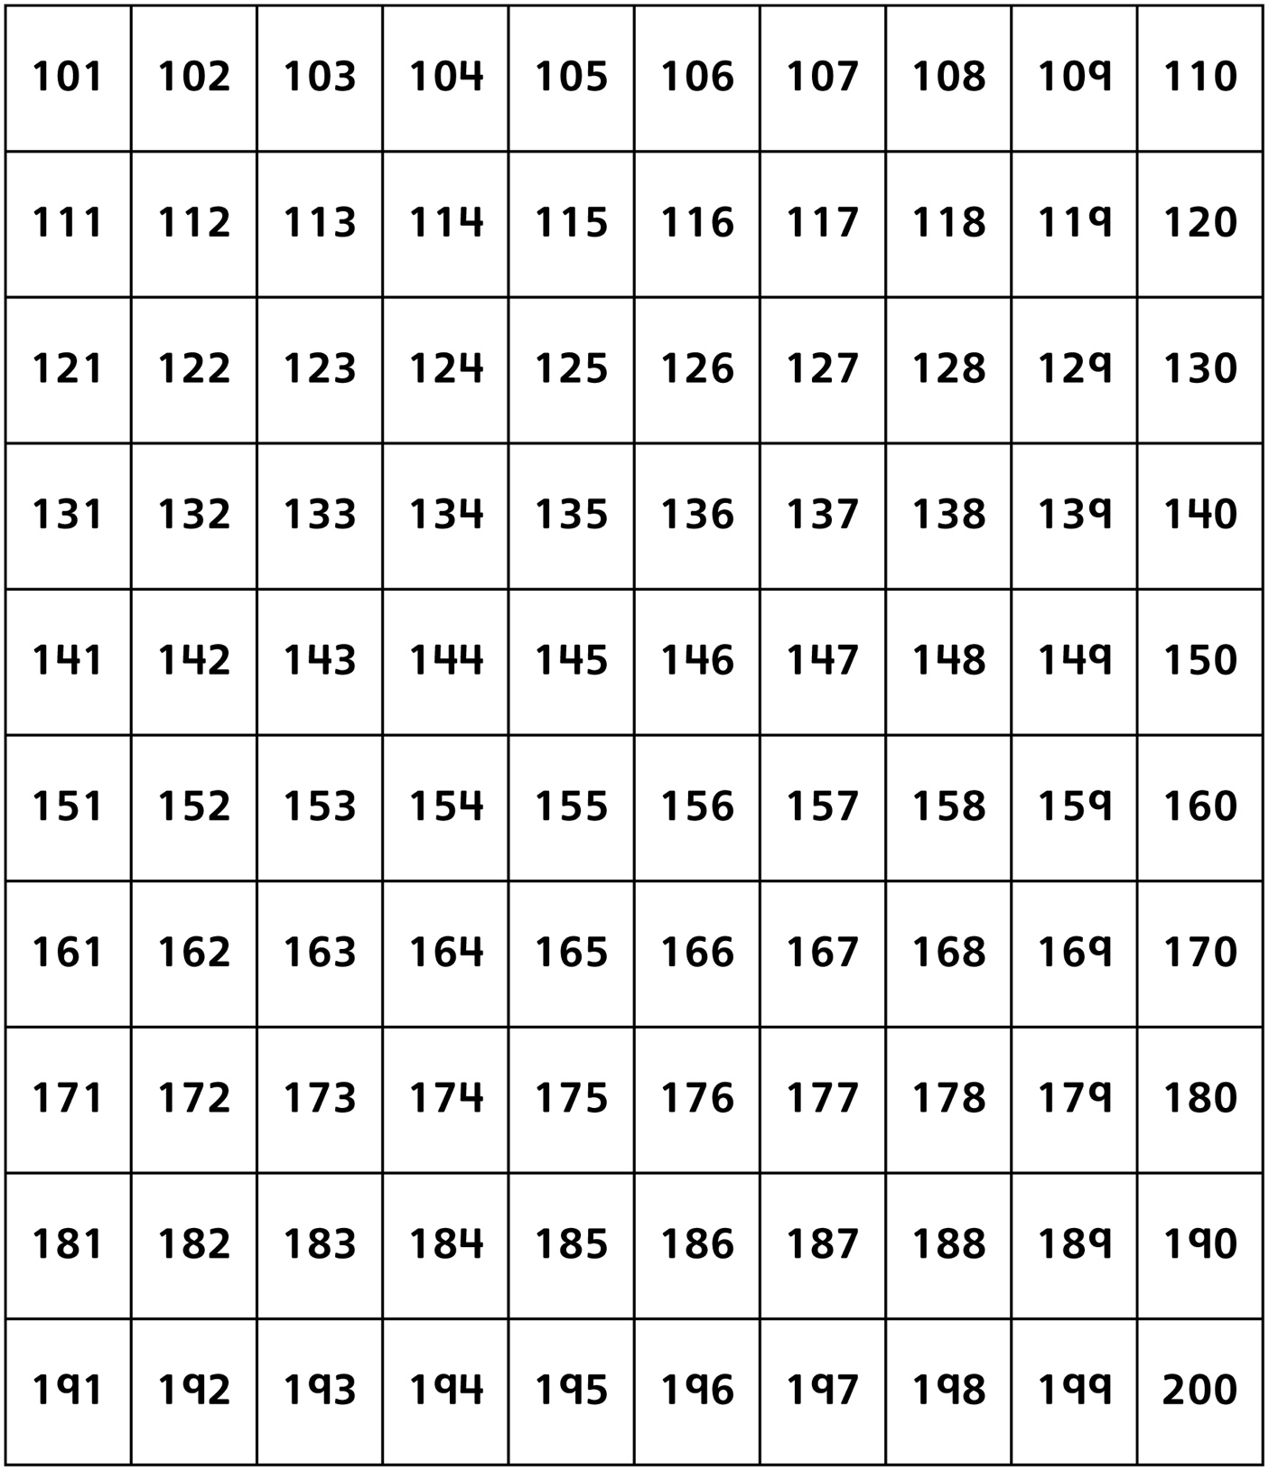

Hundred Charts Line Master 4–3

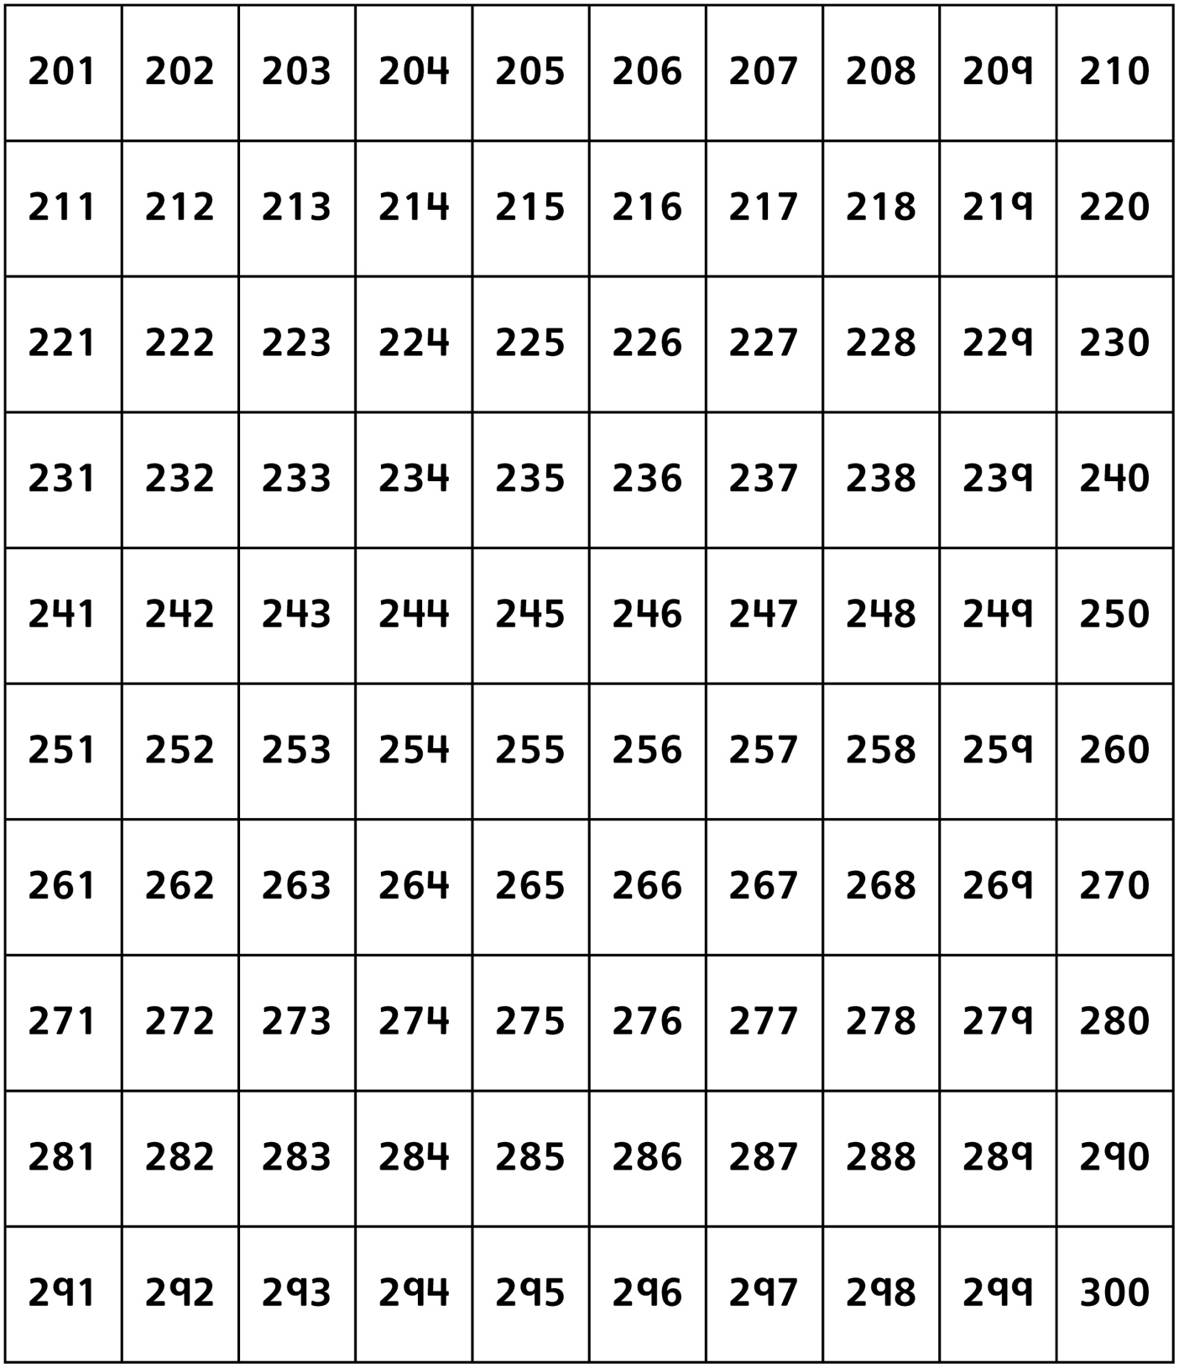

Hundred Charts Line Master 4–4

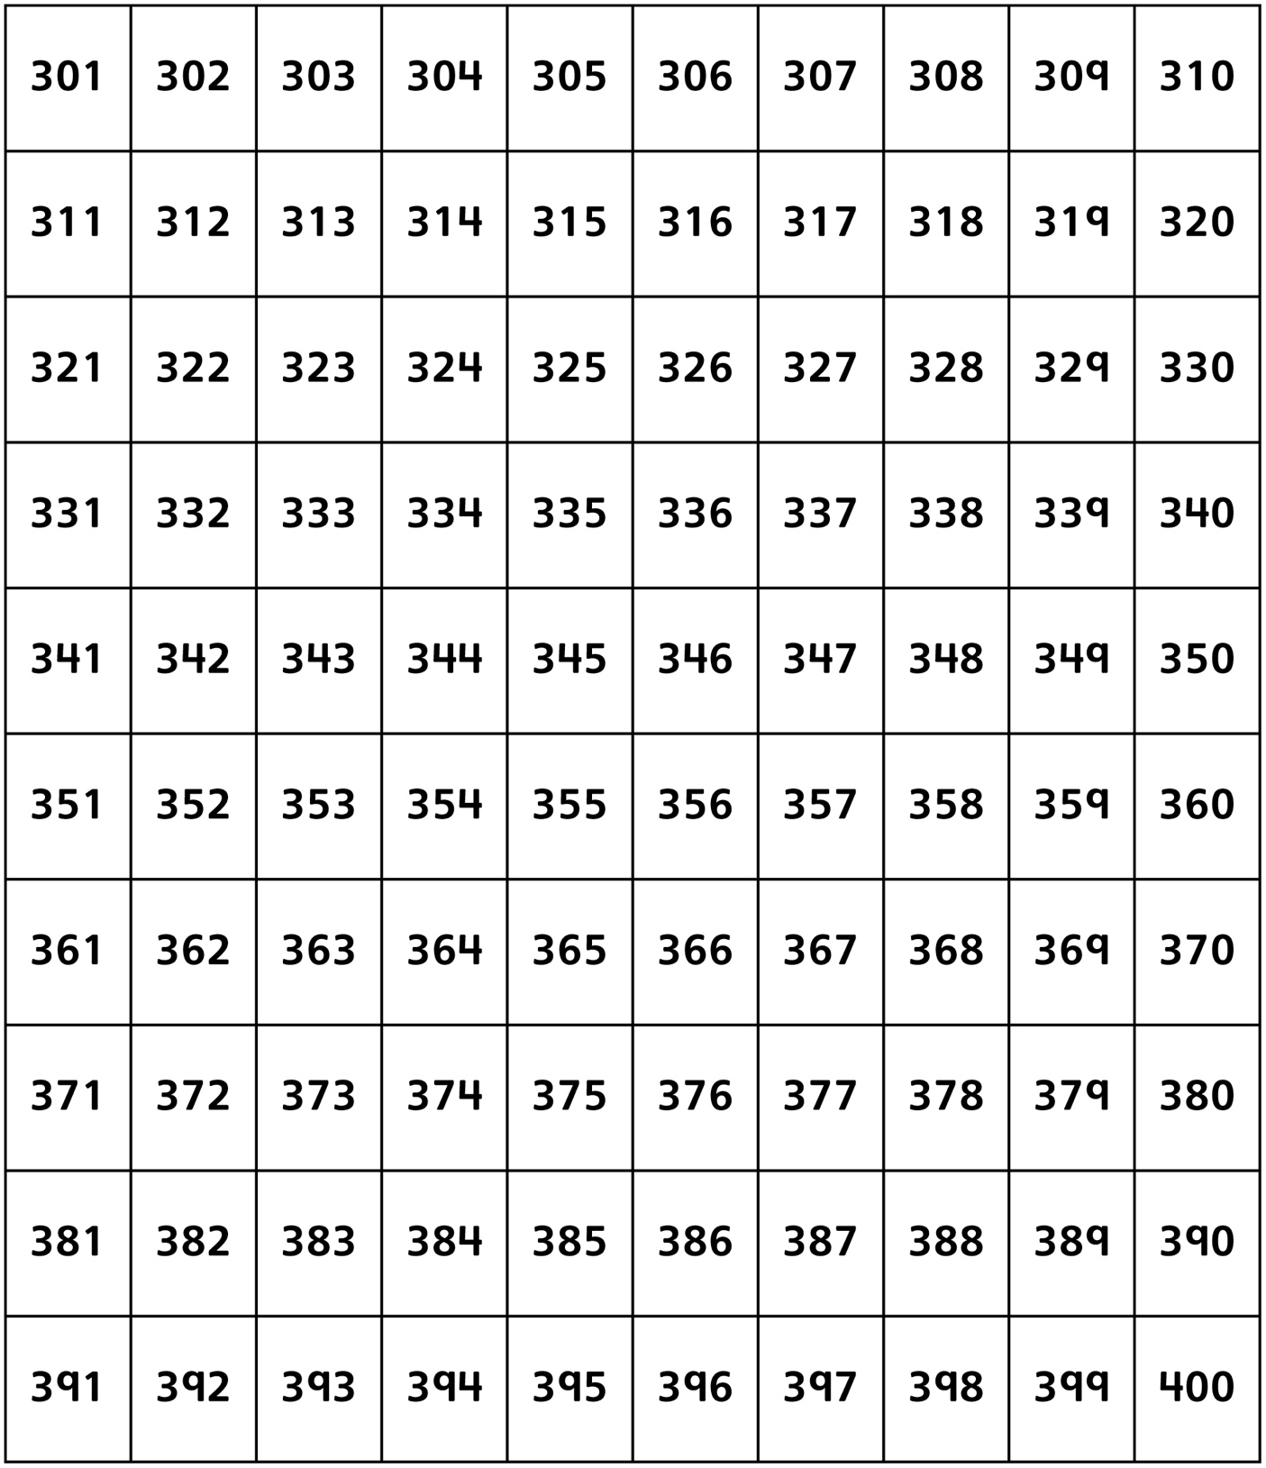

Hundred Charts Line Master 4–5

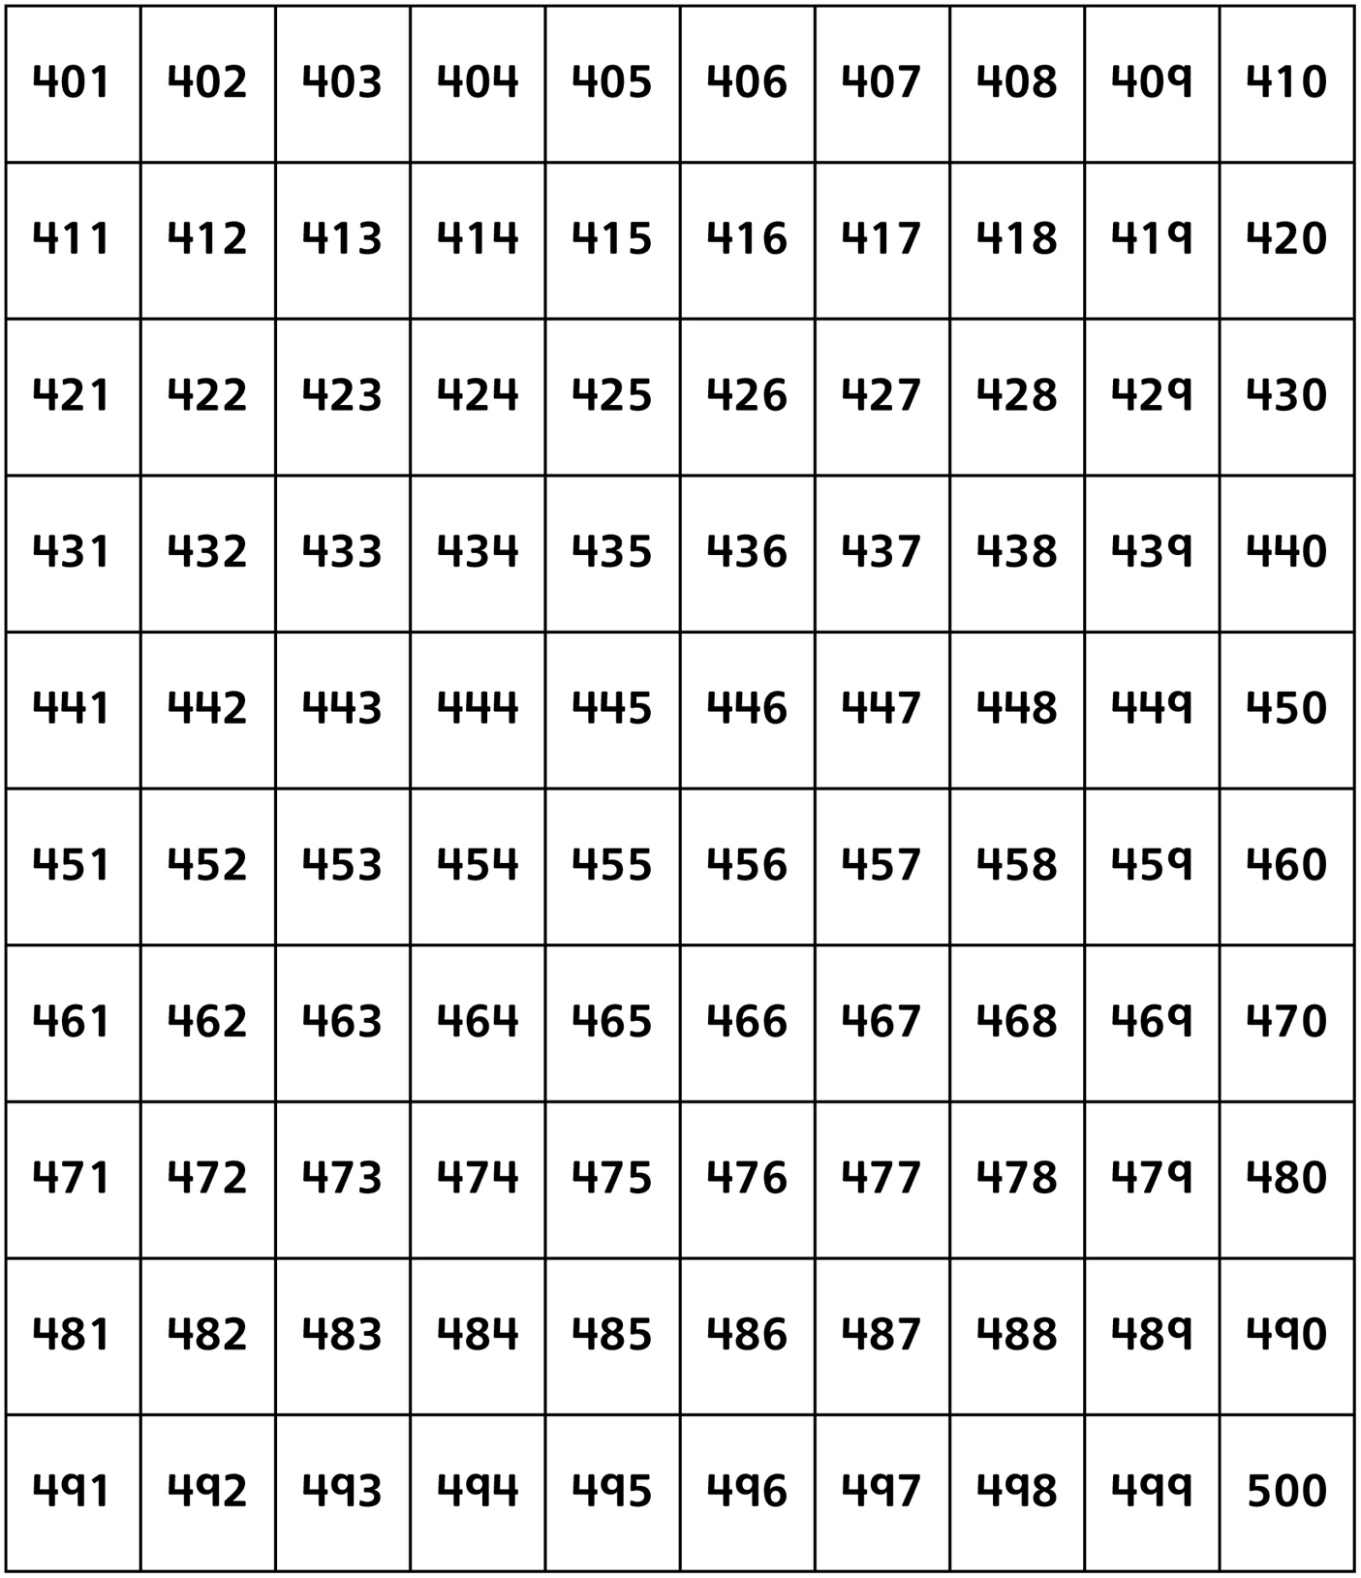

Hundred Charts Line Master 4–6

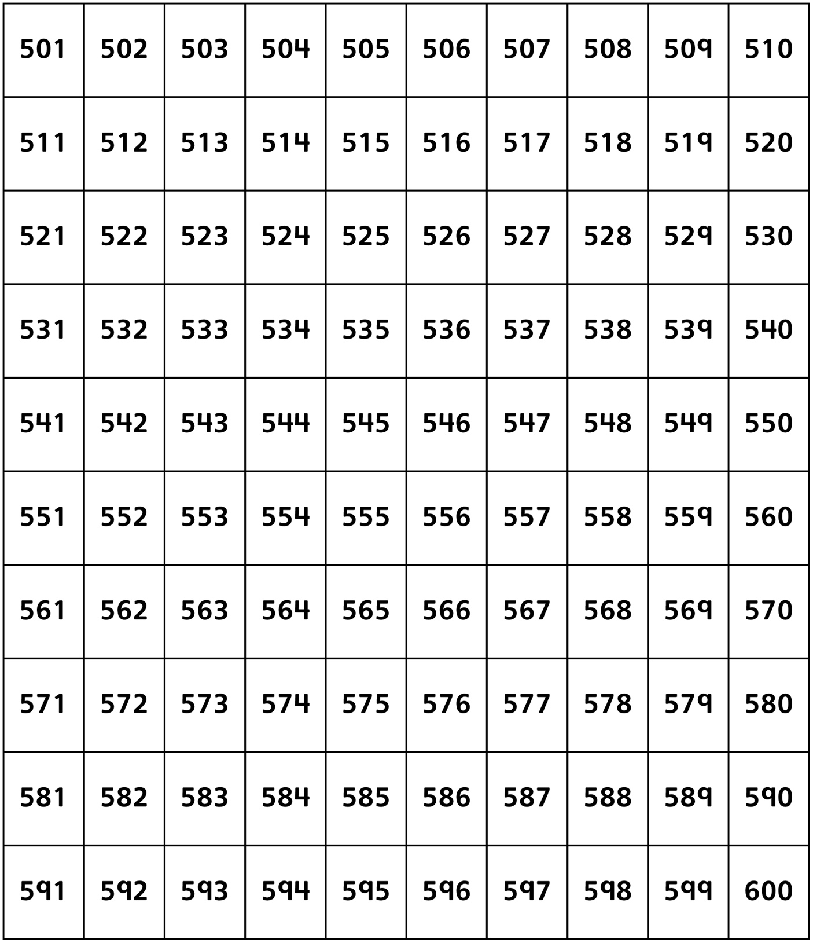

Hundred Charts Line Master 4–7

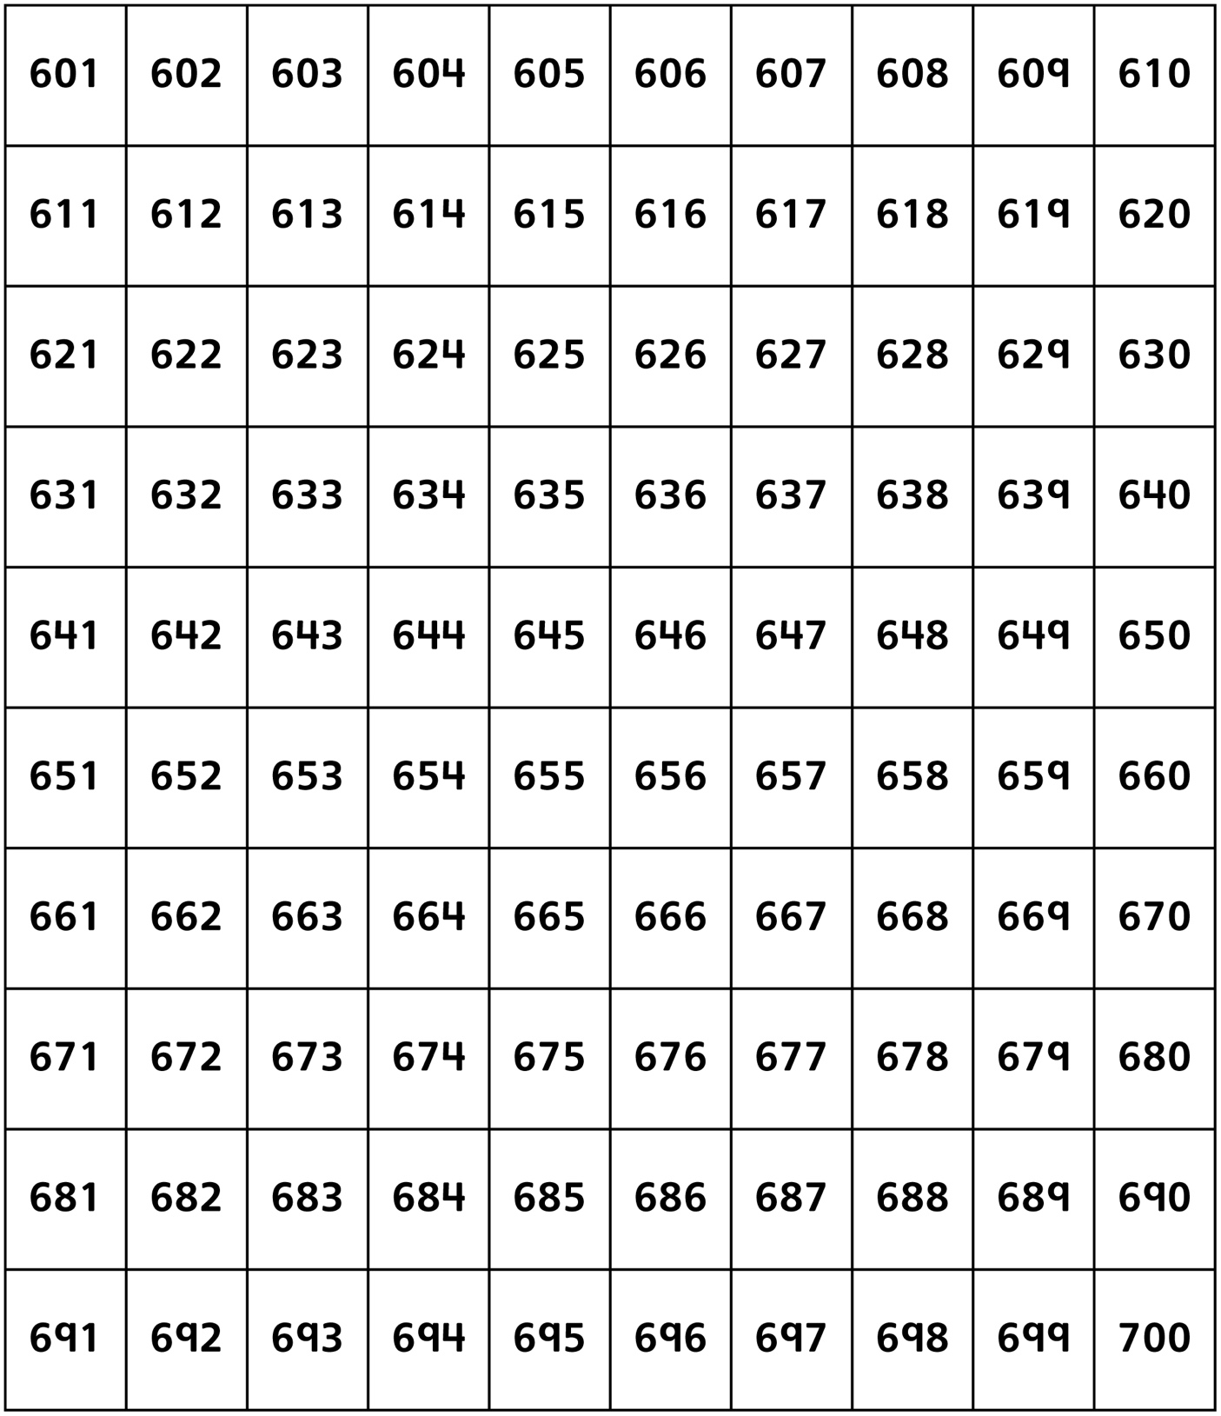

Hundred Charts Line Master 4–8

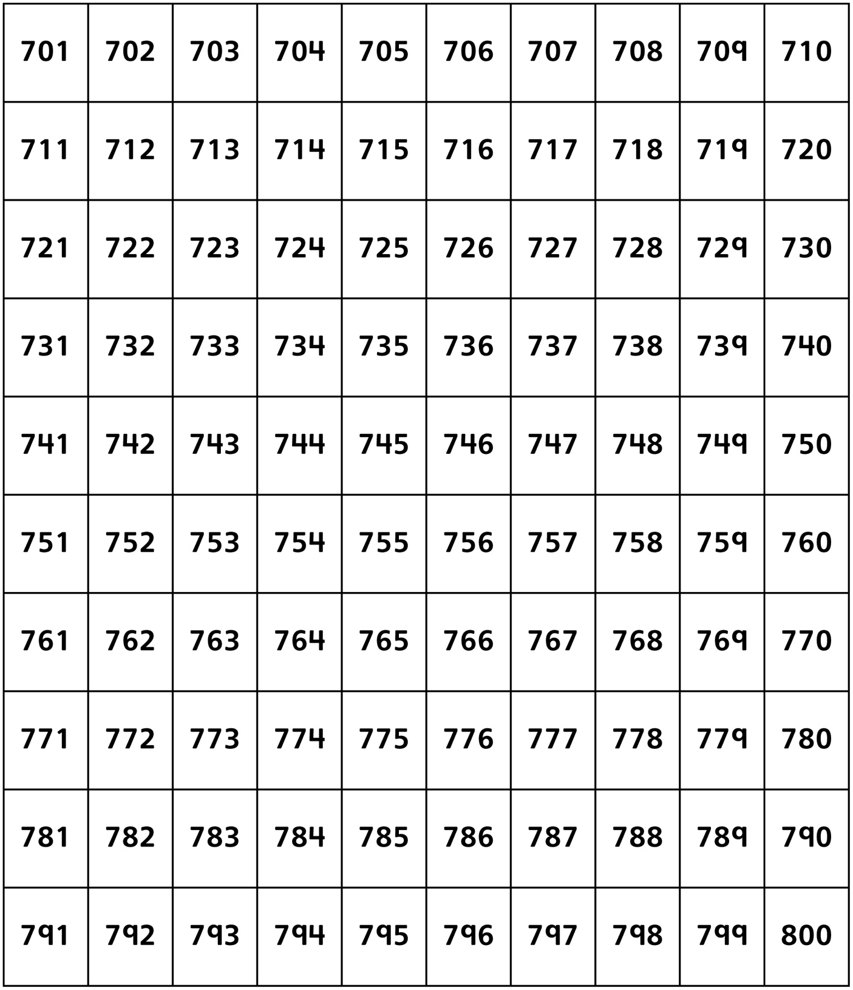

Hundred Charts Line Master 4–9

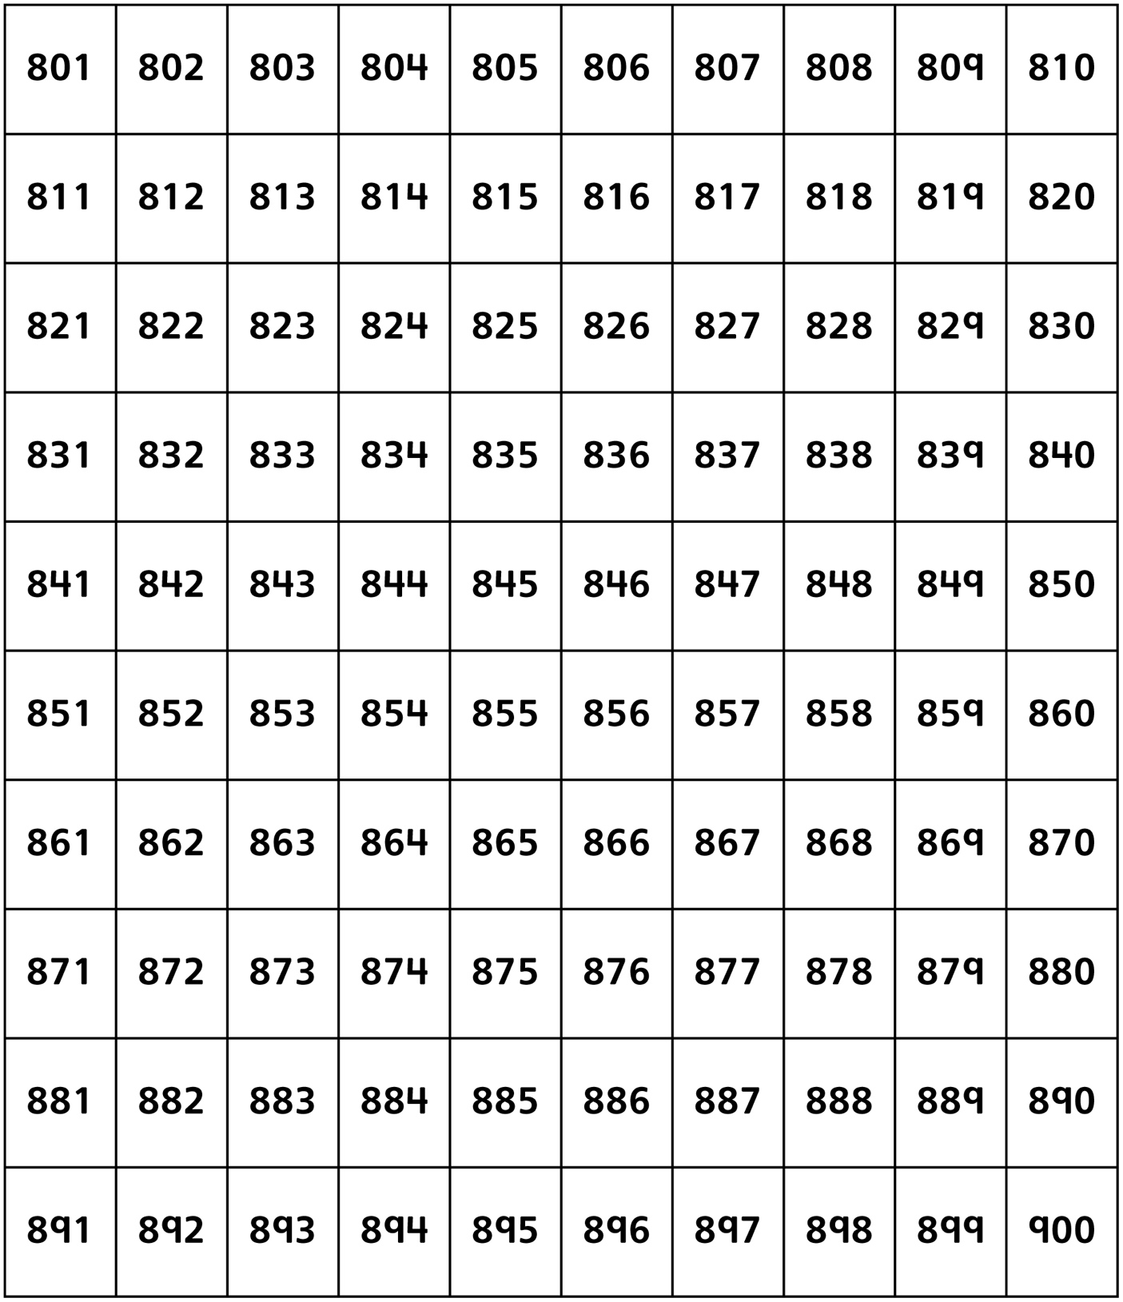

Hundred Charts Line Master 4–10

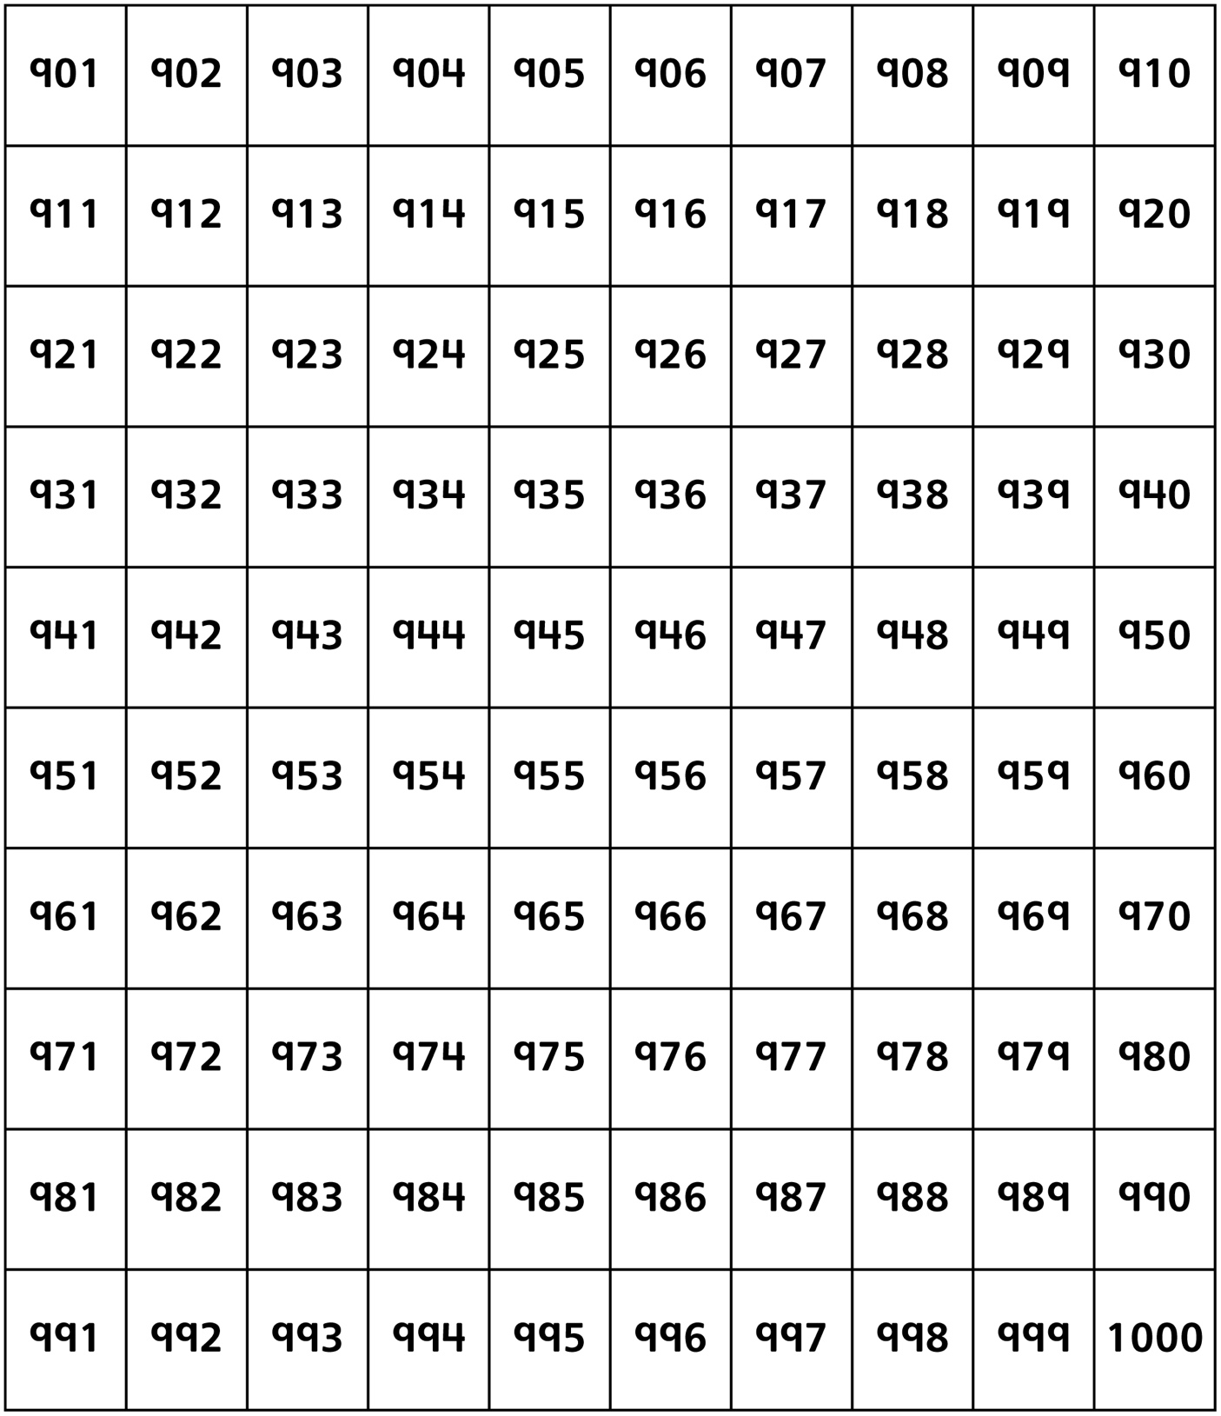

Ordering Books Line Master 5
Name: _____________________________ _____________________________

 | We estimate... | We discovered...
least  greatest | ____________________________  _____________________ pages | ____________________________  _____________________ pages
 | ____________________________  _____________________ pages | ____________________________  _____________________ pages
 | ____________________________  _____________________ pages | ____________________________  _____________________ pages
 | ____________________________  _____________________ pages | ____________________________  _____________________ pages
 | ____________________________  _____________________ pages | ____________________________  _____________________ pages
 | ____________________________  _____________________ pages | ____________________________  _____________________ pages
 | ____________________________  _____________________ pages | ____________________________  _____________________ pages
 | ____________________________  _____________________ pages | ____________________________  _____________________ pages
 | ____________________________  _____________________ pages | ____________________________  _____________________ pages
 | ____________________________  _____________________ pages | ____________________________  _____________________ pages

Finding Buster Math Mat Line Master 6

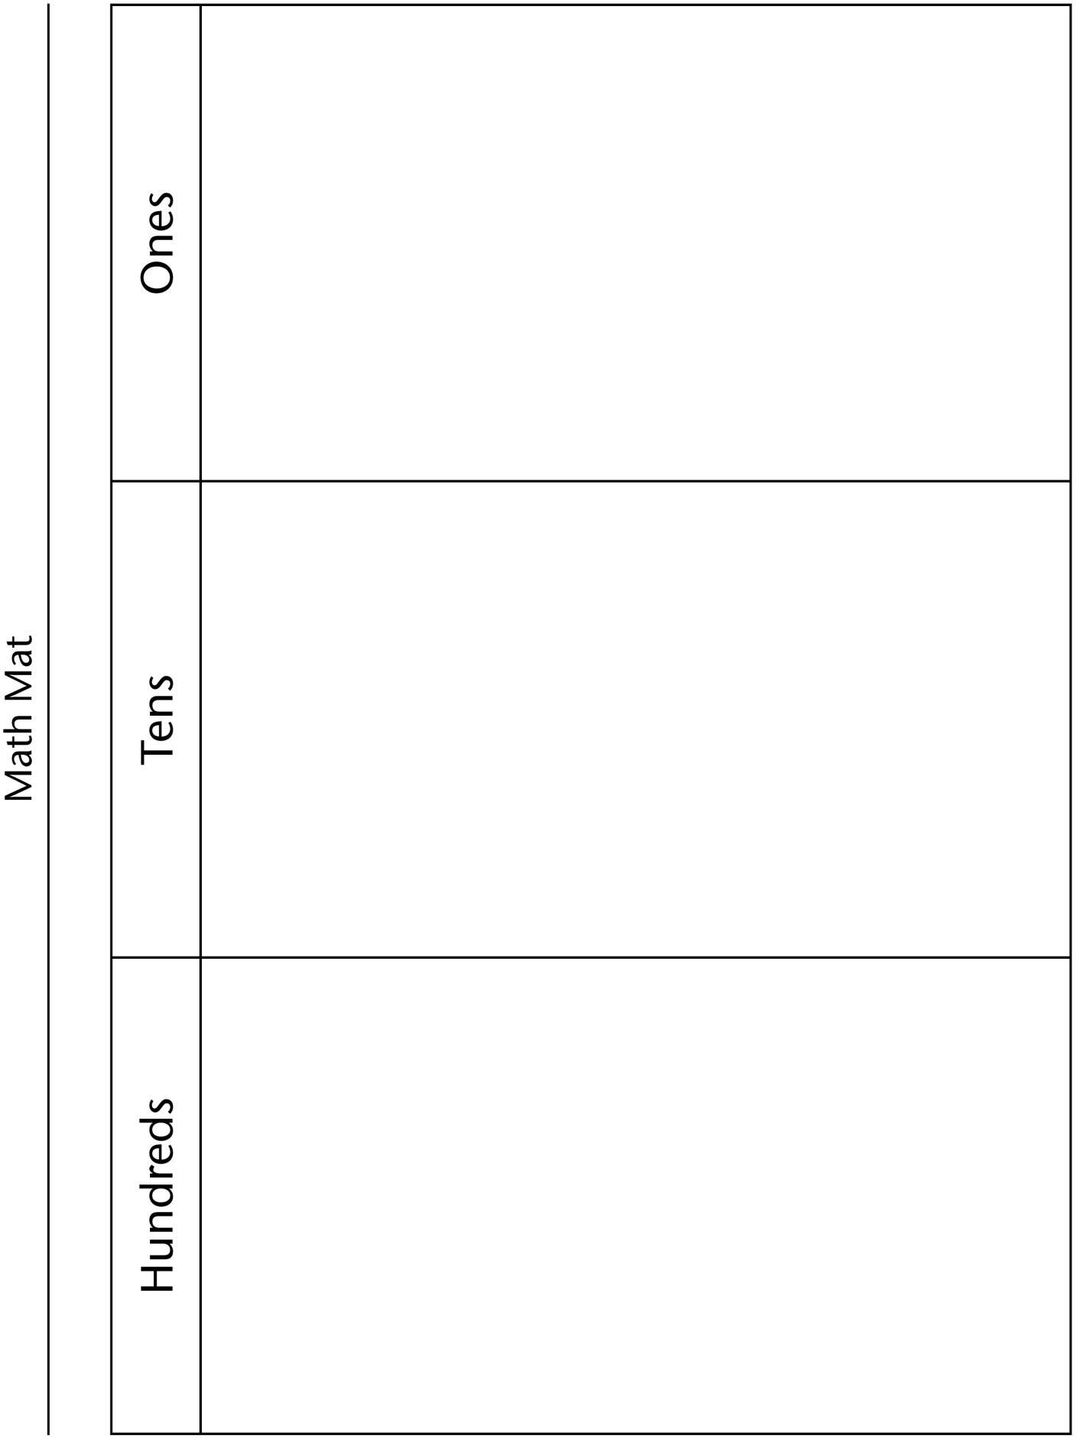

Modelling Numbers Line Master 7
Names: ______________________ _______________________

I see ________ hundreds, ________ tens, and ________ ones.

I see ________________ altogether.

I see ________ hundreds, ________ tens, and ________ ones.

I see ________________ altogether.

I see ________ hundreds, ________ tens, and ________ ones.

I see ________________ altogether.

I see ________ hundreds, ________ tens, and ________ ones.

I see ________________ altogether.

I see ________ hundreds, ________ tens, and ________ ones.

I see ________________ altogether.

Order the numbers you both modelled.

___________ __________ __________ __________ ___________
least greatest

Finding Buster Map Line Master 8

Blank Hundred Chart Line Master 9

Numbers Recording Sheet Line Master 10

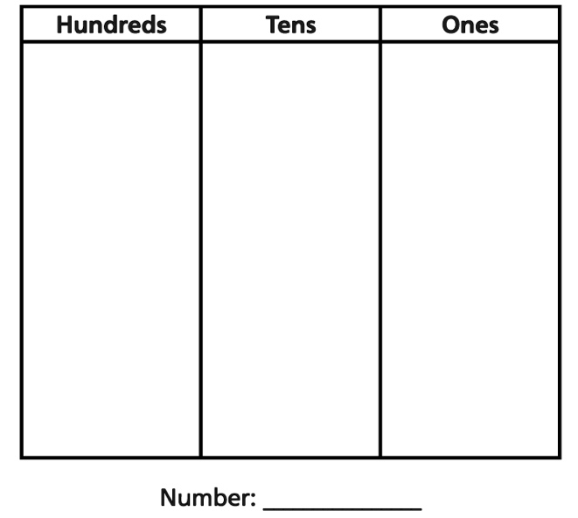

Riddle Recording Sheet Line Master 11
Name: _____________________________

Write up to 5 clues to help others identify your mystery number. Use the following wordings to build your clues:
• greater than
• less than
• between ____ and ____
• closer to ____ than to ____
• 100 greater (less) than ____
• has ____ in the hundreds place and ____ in the ones place
• 50 more (less) than ____
• you say it when counting by ____

1.
2.
3.
4.
5.

Guess my mystery number. _____________________

Solving Problems Line Master 12
– – – – – – – – – – – – – – – – – – – – – – – – – – – – – – – – – – – – – – – – – –
How many linking cubes do you think it would take
to cover the book Finding Buster? ______________
Cover the book, count, re-count, and record how many.
– – – – – – – – – – – – – – – – – – – – – – – – – – – – – – – – – – – – – – – – – –
How many linking cubes do you think it would take to cover your
desk? ___________
Cover the desk, count, re-count, and record how many.
– – – – – – – – – – – – – – – – – – – – – – – – – – – – – – – – – – – – – – – – – –
How many linking cubes do you think it would take
to measure the length of the meeting carpet? ___________
Line up the cubes, count, re-count, and record how many.
– – – – – – – – – – – – – – – – – – – – – – – – – – – – – – – – – – – – – – – – – –
Find the largest 3-digit number you can in the room.
Record the number and where you found it.
– – – – – – – – – – – – – – – – – – – – – – – – – – – – – – – – – – – – – – – – – –
Find the smallest 3-digit number you can in the room.
Record the number and where you found it.
– – – – – – – – – – – – – – – – – – – – – – – – – – – – – – – – – – – – – – – – – –
How many groups of 10 are in 1000?
Record what and how you found out using pictures, words, and numbers.
– – – – – – – – – – – – – – – – – – – – – – – – – – – – – – – – – – – – – – – – – –

