**Namir’s Marvellous** **Line Master 1  
Masterpieces**

(Assessment Master)

**Name:** _____________________________

|  |  |  |  |
| --- | --- | --- | --- |
| **Investigate Growing and Shrinking Patterns (Further Developed)** | **Not observed** | **Sometimes** | **Consistently** |
| Creates increasing/decreasing patterns |  |  |  |
| Describes increasing/decreasing pattern |  |  |  |
| Extends number patterns |  |  |  |
| Finds missing elements in number patterns |  |  |  |
| **Use Equations to Represent Growing and Shrinking Patterns** |  |  |  |
| Generalizes and explains the rule for arithmetic patterns (including the starting point and change) |  |  |  |
| Writes one-step addition and subtraction equations to match a pattern rule |  |  |  |

**Strengths:**

**Next Steps:**

**Connecting Home and School Line Master 2–1**

**NOTE TO THE TEACHER**

You may wish to send families a ***Namir’s Marvellous Masterpieces*** letter outlining a familiar activity or two they can do at home with their children.

Create a letter using this template and select one or two activities from the suggestions on the next page. Simply **delete these instructions and cut and paste the activities you have selected**, adapting them to fit your needs.

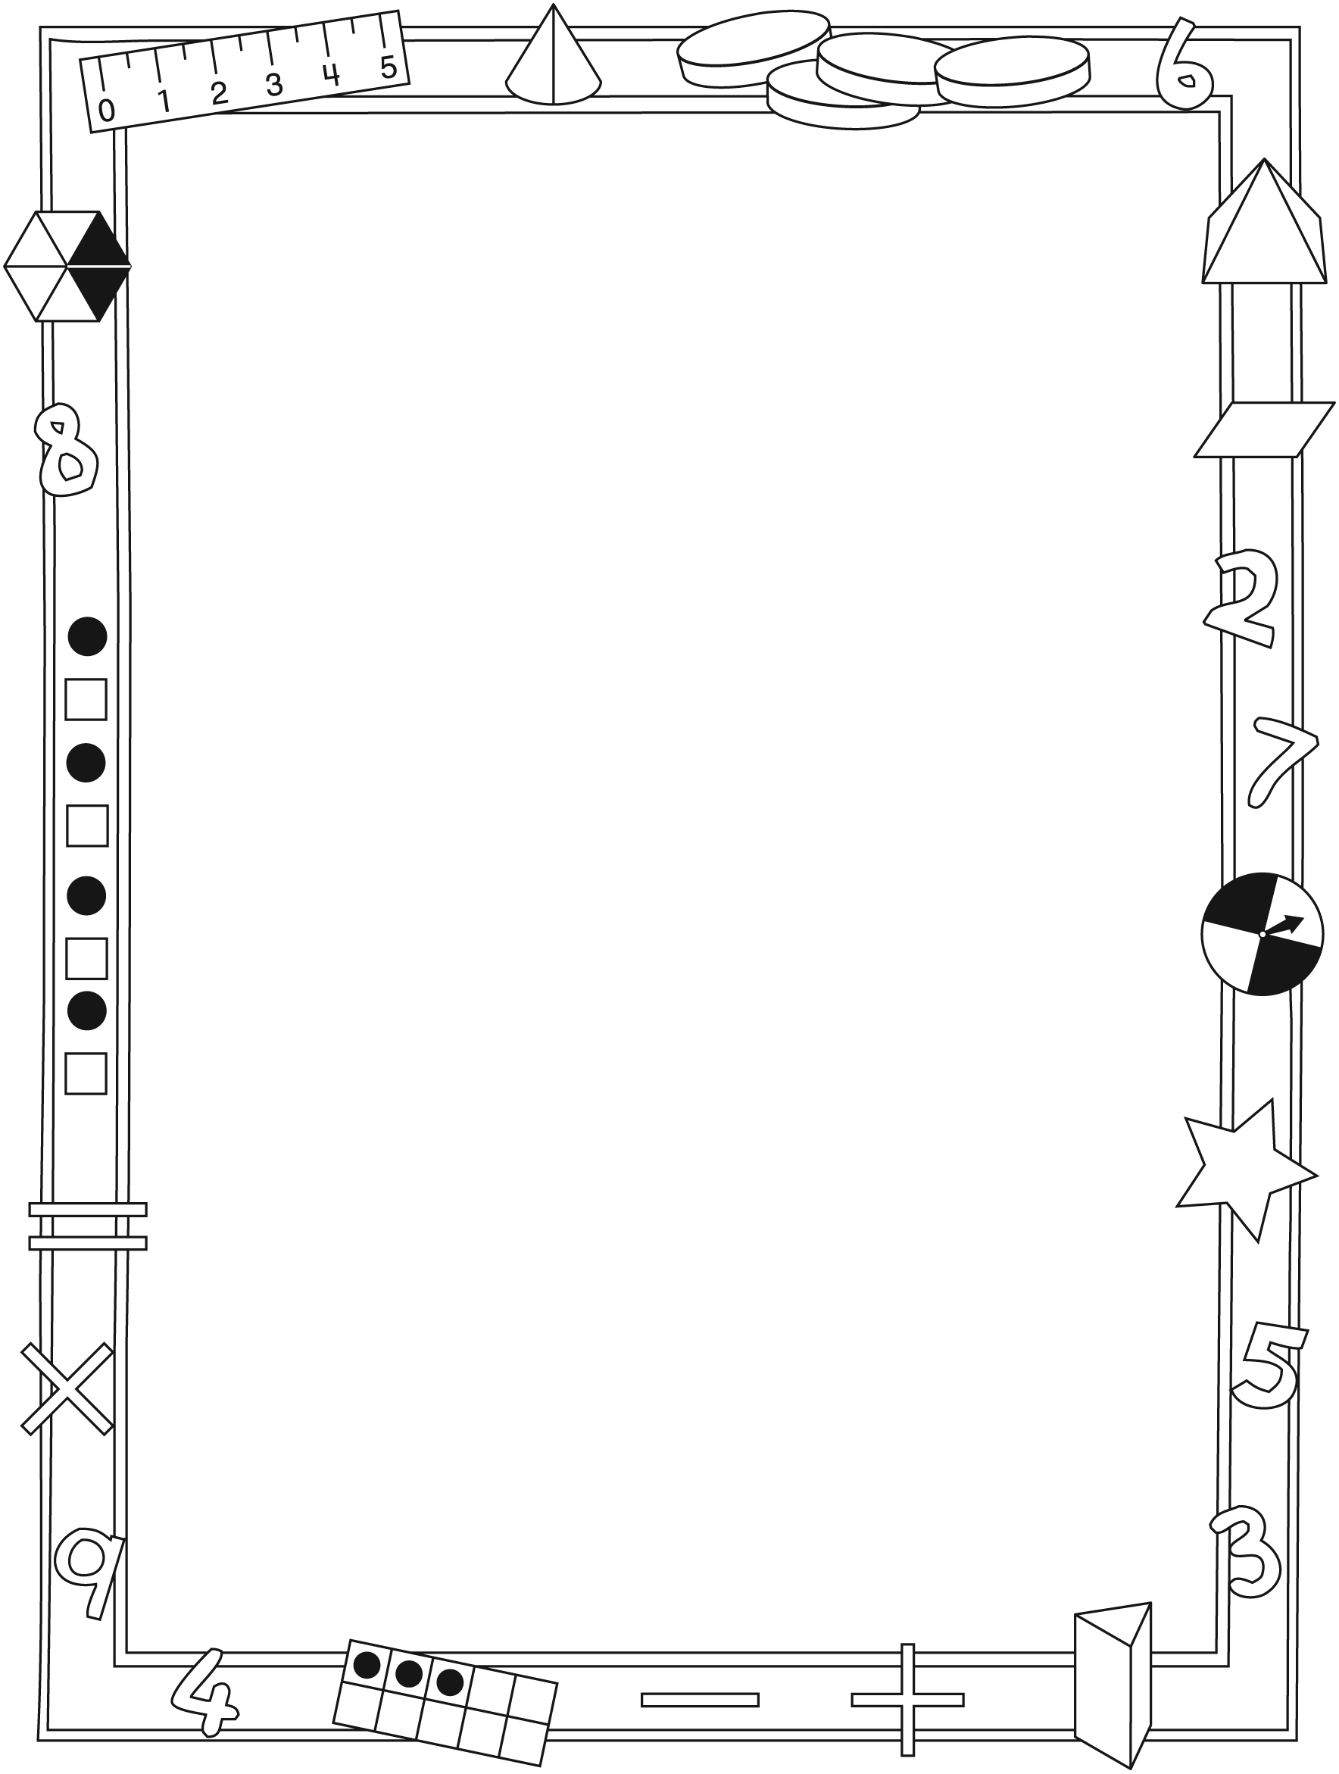

**Connecting Home and School Line Master 2–2**

Dear Family:

We have been working on ***Namir’s Marvellous Masterpieces***, which engages children in conversations, investigations, and activities that help to develop their understanding of the big math idea that “Patterns can be described mathematically.” Particular focus is placed on describing, extending, and creating growing and shrinking patterns, and on using equations to represent growing and shrinking patterns. Try this activity at home with your child.

✂ – – – – – – – – – – – – – – – – – – – – – – – – – – – – – – – – – – – – – – – – – –

**Reading the Story:** As you read the story, explore the patterns with your child and invite him/her to predict the next terms. After you read, you might gather some small objects, such as different coloured beans or buttons, and use the Math Mat (inside back cover of the book) to help you and your child create repeating, growing, and shrinking patterns.

✂ – – – – – – – – – – – – – – – – – – – – – – – – – – – – – – – – – – – – – – – – – –

**Pattern Walk:** Take a walk outside with a pencil and notepad, and record all the patterns you see. You could also look for patterns inside. Challenge your child to see who can find more patterns. Play again, but this time, look only for growing or shrinking patterns.

✂ – – – – – – – – – – – – – – – – – – – – – – – – – – – – – – – – – – – – – – – – – –

**Money Patterns:** Invite your child to use nickels and dimes to create growing and shrinking money patterns. For the first round, use only dimes or only nickels, so that the total goes up (or down) by only 10 or 5. Then, encourage your child to use both coins to create patterns. You can try to guess the pattern rule or keep extending the pattern. Repeat, but this time you create the pattern and have your child give the pattern rule or extend it.

✂ – – – – – – – – – – – – – – – – – – – – – – – – – – – – – – – – – – – – – – – – – –

**Toothpick Designs:** Create a growing or shrinking pattern with your child using toothpicks. When the pattern is finished, ask your child to state the pattern rule. For an additional challenge, create a pattern without showing it to your child and then remove part of it (a middle section). Challenge your child to fill in   
the missing part.

✂ – – – – – – – – – – – – – – – – – – – – – – – – – – – – – – – – – – – – – – – – – –

Sincerely,

___________________________

***Namir’s Marvellous* Line Master 3**

***Masterpieces* Math Mat**

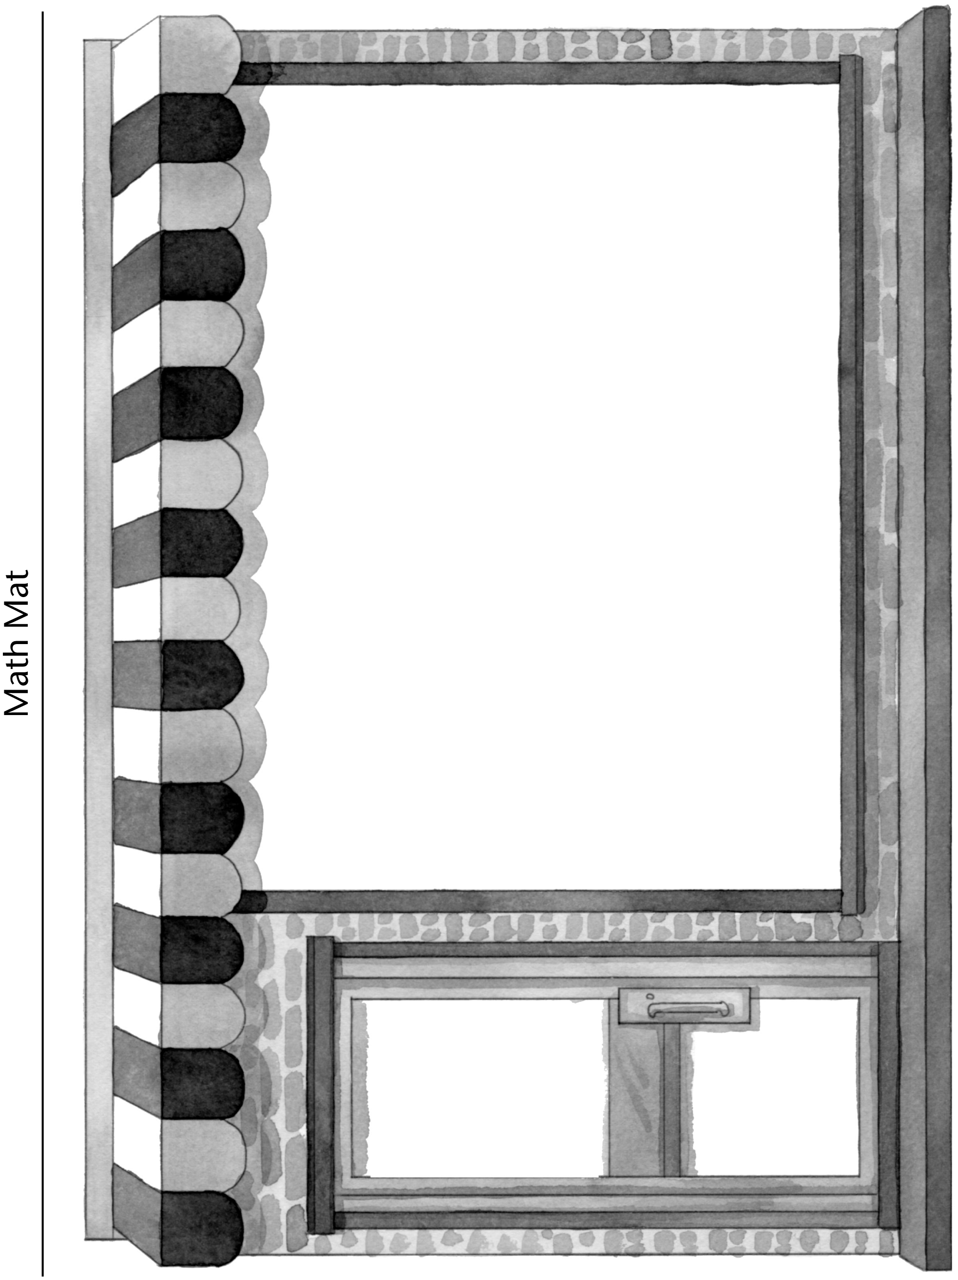

**Hundred Charts Line Master 4–1**

**Name:** _____________________________

|  |  |  |  |  |  |  |  |  |  |
| --- | --- | --- | --- | --- | --- | --- | --- | --- | --- |
| 1 | 2 | 3 | 4 | 5 | 6 | 7 | 8 | 9 | 10 |
| 11 | 12 | 13 | 14 | 15 | 16 | 17 | 18 | 19 | 20 |
| 21 | 22 | 23 | 24 | 25 | 26 | 27 | 28 | 29 | 30 |
| 31 | 32 | 33 | 34 | 35 | 36 | 37 | 38 | 39 | 40 |
| 41 | 42 | 43 | 44 | 45 | 46 | 47 | 48 | 49 | 50 |
| 51 | 52 | 53 | 54 | 55 | 56 | 57 | 58 | 59 | 60 |
| 61 | 62 | 63 | 64 | 65 | 66 | 67 | 68 | 69 | 70 |
| 71 | 72 | 73 | 74 | 75 | 76 | 77 | 78 | 79 | 80 |
| 81 | 82 | 83 | 84 | 85 | 86 | 87 | 88 | 89 | 90 |
| 91 | 92 | 93 | 94 | 95 | 96 | 97 | 98 | 99 | 100 |

**Hundred Charts Line Master 4–2**

**Name:** _____________________________

|  |  |  |  |  |  |  |  |  |  |
| --- | --- | --- | --- | --- | --- | --- | --- | --- | --- |
| 101 | 102 | 103 | 104 | 105 | 106 | 107 | 108 | 109 | 110 |
| 111 | 112 | 113 | 114 | 115 | 116 | 117 | 118 | 119 | 120 |
| 121 | 122 | 123 | 124 | 125 | 126 | 127 | 128 | 129 | 130 |
| 131 | 132 | 133 | 134 | 135 | 136 | 137 | 138 | 139 | 140 |
| 141 | 142 | 143 | 144 | 145 | 146 | 147 | 148 | 149 | 150 |
| 151 | 152 | 153 | 154 | 155 | 156 | 157 | 158 | 159 | 160 |
| 161 | 162 | 163 | 164 | 165 | 166 | 167 | 168 | 169 | 170 |
| 171 | 172 | 173 | 174 | 175 | 176 | 177 | 178 | 179 | 180 |
| 181 | 182 | 183 | 184 | 185 | 186 | 187 | 188 | 189 | 190 |
| 191 | 192 | 193 | 194 | 195 | 196 | 197 | 198 | 199 | 200 |

**Hundred Charts Line Master 4–3**

**Name:** _____________________________

|  |  |  |  |  |  |  |  |  |  |
| --- | --- | --- | --- | --- | --- | --- | --- | --- | --- |
| 201 | 202 | 203 | 204 | 205 | 206 | 207 | 208 | 209 | 210 |
| 211 | 212 | 213 | 214 | 215 | 216 | 217 | 218 | 219 | 220 |
| 221 | 222 | 223 | 224 | 225 | 226 | 227 | 228 | 229 | 230 |
| 231 | 232 | 233 | 234 | 235 | 236 | 237 | 238 | 239 | 240 |
| 241 | 242 | 243 | 244 | 245 | 246 | 247 | 248 | 249 | 250 |
| 251 | 252 | 253 | 254 | 255 | 256 | 257 | 258 | 259 | 260 |
| 261 | 262 | 263 | 264 | 265 | 266 | 267 | 268 | 269 | 270 |
| 271 | 272 | 273 | 274 | 275 | 276 | 277 | 278 | 279 | 280 |
| 281 | 282 | 283 | 284 | 285 | 286 | 287 | 288 | 289 | 290 |
| 291 | 292 | 293 | 294 | 295 | 296 | 297 | 298 | 299 | 300 |

**Hundred Charts Line Master 4–4**

**Name:** _____________________________

|  |  |  |  |  |  |  |  |  |  |
| --- | --- | --- | --- | --- | --- | --- | --- | --- | --- |
| 301 | 302 | 303 | 304 | 305 | 306 | 307 | 308 | 309 | 310 |
| 311 | 312 | 313 | 314 | 315 | 316 | 317 | 318 | 319 | 320 |
| 321 | 322 | 323 | 324 | 325 | 326 | 327 | 328 | 329 | 330 |
| 331 | 332 | 333 | 334 | 335 | 336 | 337 | 338 | 339 | 340 |
| 341 | 342 | 343 | 344 | 345 | 346 | 347 | 348 | 349 | 350 |
| 351 | 352 | 353 | 354 | 355 | 356 | 357 | 358 | 359 | 360 |
| 361 | 362 | 363 | 364 | 365 | 366 | 367 | 368 | 369 | 370 |
| 371 | 372 | 373 | 374 | 375 | 376 | 377 | 378 | 379 | 380 |
| 381 | 382 | 383 | 384 | 385 | 386 | 387 | 388 | 389 | 390 |
| 391 | 392 | 393 | 394 | 395 | 396 | 397 | 398 | 399 | 400 |

**Hundred Charts Line Master 4–5**

**Name:** _____________________________

|  |  |  |  |  |  |  |  |  |  |
| --- | --- | --- | --- | --- | --- | --- | --- | --- | --- |
| 401 | 402 | 403 | 404 | 405 | 406 | 407 | 408 | 409 | 410 |
| 411 | 412 | 413 | 414 | 415 | 416 | 417 | 418 | 419 | 420 |
| 421 | 422 | 423 | 424 | 425 | 426 | 427 | 428 | 429 | 430 |
| 431 | 432 | 433 | 434 | 435 | 436 | 437 | 438 | 439 | 440 |
| 441 | 442 | 443 | 444 | 445 | 446 | 447 | 448 | 449 | 450 |
| 451 | 452 | 453 | 454 | 455 | 456 | 457 | 458 | 459 | 460 |
| 461 | 462 | 463 | 464 | 465 | 466 | 467 | 468 | 469 | 470 |
| 471 | 472 | 473 | 474 | 475 | 476 | 477 | 478 | 479 | 480 |
| 481 | 482 | 483 | 484 | 485 | 486 | 487 | 488 | 489 | 490 |
| 491 | 492 | 493 | 494 | 495 | 496 | 497 | 498 | 499 | 500 |

**Hundred Charts Line Master 4–6**

**Name:** _____________________________

|  |  |  |  |  |  |  |  |  |  |
| --- | --- | --- | --- | --- | --- | --- | --- | --- | --- |
| 501 | 502 | 503 | 504 | 505 | 506 | 507 | 508 | 509 | 510 |
| 511 | 512 | 513 | 514 | 515 | 516 | 517 | 518 | 519 | 520 |
| 521 | 522 | 523 | 524 | 525 | 526 | 527 | 528 | 529 | 530 |
| 531 | 532 | 533 | 534 | 535 | 536 | 537 | 538 | 539 | 540 |
| 541 | 542 | 543 | 544 | 545 | 546 | 547 | 548 | 549 | 550 |
| 551 | 552 | 553 | 554 | 555 | 556 | 557 | 558 | 559 | 560 |
| 561 | 562 | 563 | 564 | 565 | 566 | 567 | 568 | 569 | 570 |
| 571 | 572 | 573 | 574 | 575 | 576 | 577 | 578 | 579 | 580 |
| 581 | 582 | 583 | 584 | 585 | 586 | 587 | 588 | 589 | 590 |
| 591 | 592 | 593 | 594 | 595 | 596 | 597 | 598 | 599 | 600 |

**Hundred Charts Line Master 4–7**

**Name:** _____________________________

|  |  |  |  |  |  |  |  |  |  |
| --- | --- | --- | --- | --- | --- | --- | --- | --- | --- |
| 601 | 602 | 603 | 604 | 605 | 606 | 607 | 608 | 609 | 610 |
| 611 | 612 | 613 | 614 | 615 | 616 | 617 | 618 | 619 | 620 |
| 621 | 622 | 623 | 624 | 625 | 626 | 627 | 628 | 629 | 630 |
| 631 | 632 | 633 | 634 | 635 | 636 | 637 | 638 | 639 | 640 |
| 641 | 642 | 643 | 644 | 645 | 646 | 647 | 648 | 649 | 650 |
| 651 | 652 | 653 | 654 | 655 | 656 | 657 | 658 | 659 | 660 |
| 661 | 662 | 663 | 664 | 665 | 666 | 667 | 668 | 669 | 670 |
| 671 | 672 | 673 | 674 | 675 | 676 | 677 | 678 | 679 | 680 |
| 681 | 682 | 683 | 684 | 685 | 686 | 687 | 688 | 689 | 690 |
| 691 | 692 | 693 | 694 | 695 | 696 | 697 | 698 | 699 | 700 |

**Hundred Charts Line Master 4–8**

**Name:** _____________________________

|  |  |  |  |  |  |  |  |  |  |
| --- | --- | --- | --- | --- | --- | --- | --- | --- | --- |
| 701 | 702 | 703 | 704 | 705 | 706 | 707 | 708 | 709 | 710 |
| 711 | 712 | 713 | 714 | 715 | 716 | 717 | 718 | 719 | 720 |
| 721 | 722 | 723 | 724 | 725 | 726 | 727 | 728 | 729 | 730 |
| 731 | 732 | 733 | 734 | 735 | 736 | 737 | 738 | 739 | 740 |
| 741 | 742 | 743 | 744 | 745 | 746 | 747 | 748 | 749 | 750 |
| 751 | 752 | 753 | 754 | 755 | 756 | 757 | 758 | 759 | 760 |
| 761 | 762 | 763 | 764 | 765 | 766 | 767 | 768 | 769 | 770 |
| 771 | 772 | 773 | 774 | 775 | 776 | 777 | 778 | 779 | 780 |
| 781 | 782 | 783 | 784 | 785 | 786 | 787 | 788 | 789 | 790 |
| 791 | 792 | 793 | 794 | 795 | 796 | 797 | 798 | 799 | 800 |

**Hundred Charts Line Master 4–9**

**Name:** _____________________________

|  |  |  |  |  |  |  |  |  |  |
| --- | --- | --- | --- | --- | --- | --- | --- | --- | --- |
| 801 | 802 | 803 | 804 | 805 | 806 | 807 | 808 | 809 | 810 |
| 811 | 812 | 813 | 814 | 815 | 816 | 817 | 818 | 819 | 820 |
| 821 | 822 | 823 | 824 | 825 | 826 | 827 | 828 | 829 | 830 |
| 831 | 832 | 833 | 834 | 835 | 836 | 837 | 838 | 839 | 840 |
| 841 | 842 | 843 | 844 | 845 | 846 | 847 | 848 | 849 | 850 |
| 851 | 852 | 853 | 854 | 855 | 856 | 857 | 858 | 859 | 860 |
| 861 | 862 | 863 | 864 | 865 | 866 | 867 | 868 | 869 | 870 |
| 871 | 872 | 873 | 874 | 875 | 876 | 877 | 878 | 879 | 880 |
| 881 | 882 | 883 | 884 | 885 | 886 | 887 | 888 | 889 | 890 |
| 891 | 892 | 893 | 894 | 895 | 896 | 897 | 898 | 899 | 900 |

**Hundred Charts Line Master 4–10**

**Name:** _____________________________

|  |  |  |  |  |  |  |  |  |  |
| --- | --- | --- | --- | --- | --- | --- | --- | --- | --- |
| 901 | 902 | 903 | 904 | 905 | 906 | 907 | 908 | 909 | 910 |
| 911 | 912 | 913 | 914 | 915 | 916 | 917 | 918 | 919 | 920 |
| 921 | 922 | 923 | 924 | 925 | 926 | 927 | 928 | 929 | 930 |
| 931 | 932 | 933 | 934 | 935 | 936 | 937 | 938 | 939 | 940 |
| 941 | 942 | 943 | 944 | 945 | 946 | 947 | 948 | 949 | 950 |
| 951 | 952 | 953 | 954 | 955 | 956 | 957 | 958 | 959 | 960 |
| 961 | 962 | 963 | 964 | 965 | 966 | 967 | 968 | 969 | 970 |
| 971 | 972 | 973 | 974 | 975 | 976 | 977 | 978 | 979 | 980 |
| 981 | 982 | 983 | 984 | 985 | 986 | 987 | 988 | 989 | 990 |
| 991 | 992 | 993 | 994 | 995 | 996 | 997 | 998 | 999 | 1000 |

**Pattern Scramble Line Master 5–1**

**Name:** _____________________________

Circle the pattern type: growing shrinking

Record your pattern. Then, add 3 more terms (craft sticks).

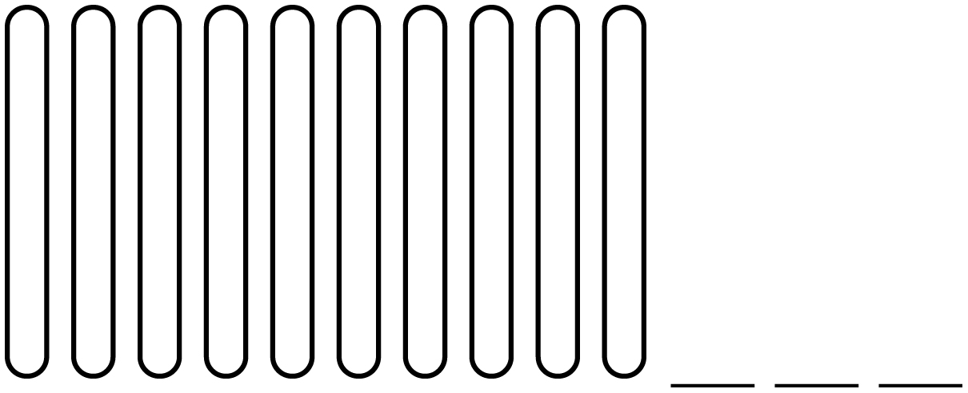

**Pattern Scramble Line Master 5–2**

**Name:** _____________________________

Write the pattern rule.

Write equations to represent your pattern.

**Pattern Hunt Line Master 6**

**Name:** _____________________________

Type of pattern: _____________________________

Sketch:

Pattern rule:

Equations:

**Tree Patterns Line Master 7**

**Name:** _____________________________

|  |  |  |  |
| --- | --- | --- | --- |
| **Tree Number** | **Number of Blocks I Added** | **Total Number of Blocks in My Tree** | **Equation** |
| 1 |  |  |  |
| 2 |  |  |  |
| 3 |  |  |  |
| 4 |  |  |  |
| 5 |  |  |  |
| 6 |  |  |  |
| 7 |  |  |  |
| 8 |  |  |  |

**Roll a Pattern Rule Line Master 8**

**Name:** _____________________________

1. Roll 2 number cubes to make a 2-digit number. This is your starting number.

2. Choose a Pattern Rule Card to find out if your pattern will be growing or shrinking.

3. Roll 1 number cube to tell you what number to use in your pattern rule.

4. Complete the table. The first row shows an example.

|  |  |  |  |  |  |  |  |
| --- | --- | --- | --- | --- | --- | --- | --- |
| **Starting Number (1st Term)** | **Growing or Shrinking** | **Pattern Rule** | **2nd Term** | **3rd Term** | **4th Term** | **5th Term** | **6th Term** |
| 26 | growing | add 4 | 30 | 34 | 38 | 42 | 46 |
|  |  |  |  |  |  |  |  |
|  |  |  |  |  |  |  |  |
|  |  |  |  |  |  |  |  |
|  |  |  |  |  |  |  |  |
|  |  |  |  |  |  |  |  |

**Pattern Rule Cards Line Master 9**



|  |  |  |
| --- | --- | --- |
| shrinking | shrinking | shrinking |
| growing | growing | growing |

**Mini-Book Template Line Master 10**

|  |  |
| --- | --- |
| People Patterns  by ____________________ | At the start of the day, 1 person comes in the store.  Altogether, there are  ________ _________________  ________ _________________  ________ _________________  in the store. |
| ________ more come in the store.  Now there are  ________ _________________  ________ _________________  ________ _________________  in the store. | ________ more come in the store.  Now there are  ________ _________________  ________ _________________  ________ _________________  in the store. |

**Pattern Problems Line Master 11–1**

✂ – – – – – – – – – – – – – – – – – – – – – – – – – – – – – – – – – – – – – – – – – –

Namir is biking to his family’s store, which is 5 blocks away. If it takes him 2 minutes to bike 1 block, how long will it take him to get to the store?

|  |  |
| --- | --- |
| Number of Blocks | Number of Minutes |
| 1 | 2 |
|  |  |
|  |  |
|  |  |
|  |  |

✂ – – – – – – – – – – – – – – – – – – – – – – – – – – – – – – – – – – – – – – – – – –

Naia saves 4 quarters each day she works at the store. If she works   
6 days, how many quarters will she have saved?

|  |  |
| --- | --- |
| Number of Days | Number of Quarters Saved |
| 1 | 4 |
|  |  |
|  |  |
|  |  |
|  |  |
|  |  |

✂ – – – – – – – – – – – – – – – – – – – – – – – – – – – – – – – – – – – – – – – – – –

**Pattern Problems Line Master 11–2**

✂ – – – – – – – – – – – – – – – – – – – – – – – – – – – – – – – – – – – – – – – – – –

Naia gives her brother these numbers: 150, 125, 100, 75.

What is the pattern rule?

What are the next 2 terms of this pattern?

✂ – – – – – – – – – – – – – – – – – – – – – – – – – – – – – – – – – – – – – – – – – –

A delivery truck brought 5 loaves of bread to the family store   
on Monday, 16 loaves of bread on Tuesday, and 27 loaves of bread on Wednesday. If this pattern continues, how many loaves of bread will be delivered on Thursday and Friday?

✂ – – – – – – – – – – – – – – – – – – – – – – – – – – – – – – – – – – – – – – – – – –

Namir sold 7 sandwiches on Thursday, 14 sandwiches on Friday, and 21 sandwiches on Saturday. If this pattern continues, how many sandwiches will Namir sell on Sunday and Monday?

✂ – – – – – – – – – – – – – – – – – – – – – – – – – – – – – – – – – – – – – – – – – –

Naia sold 15 boxes of dog treats during the first week of the month. She sold 25 boxes the next week and 35 the following week. If this pattern continues, how many boxes of dog treats will she sell in the next 2 weeks?

✂ – – – – – – – – – – – – – – – – – – – – – – – – – – – – – – – – – – – – – – – – – –

**Pattern Problems Line Master 11–3**

✂ – – – – – – – – – – – – – – – – – – – – – – – – – – – – – – – – – – – – – – – – – –

In the early winter, Namir’s family sells gingerbread cookies. The first week, they sell 10 cookies. The next week, the sales double. The third week, the sales double again. How many cookies do they sell during the second and third weeks?

✂ – – – – – – – – – – – – – – – – – – – – – – – – – – – – – – – – – – – – – – – – – –

Naia made this pattern out of cereal boxes at the store. What would be the next 2 terms of this pattern?

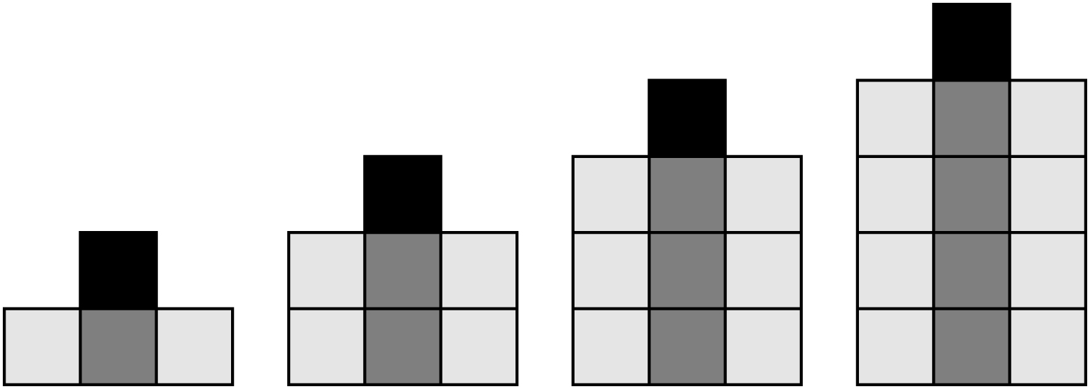

✂ – – – – – – – – – – – – – – – – – – – – – – – – – – – – – – – – – – – – – – – – – –

Naia decides to make another pattern. It looks like this:

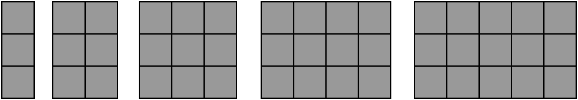

What would be the next 3 terms of this pattern?

✂ – – – – – – – – – – – – – – – – – – – – – – – – – – – – – – – – – – – – – – – – – –