**The Bunny Challenge** **Line Master 1** (Assessment Master)

**Name:** _____________________________

|  |  |  |  |
| --- | --- | --- | --- |
| **Estimate, Measure, and Compare Area** | **Not observed** | **Sometimes** | **Consistently** |
| Demonstrates ways to estimate area with non-standard units |  |  |  |
| Demonstrates ways to measure area with non-standard units |  |  |  |
| Demonstrates ways to compare and order objects by area with  non-standard units |  |  |  |
| Selects and uses appropriate  non-standard units to estimate, measure, and compare area |  |  |  |
| **Estimate, Measure, and Compare Perimeter** |  |  |  |
| Demonstrates ways to estimate perimeter with standard units |  |  |  |
| Demonstrates ways to measure perimeter with standard units |  |  |  |
| Demonstrates ways to compare and order objects by perimeter with standard units |  |  |  |
| Selects and uses appropriate standard units to estimate, measure, and compare perimeter |  |  |  |

**Strengths:**

**Next Steps:**

**Connecting Home and School Line Master 2–1**

**NOTE TO THE TEACHER**

You may wish to send families a ***The Bunny Challenge*** letter outlining a familiar activity or two they can do at home with their children.

Create a letter using this template and select one or two activities from the suggestions on the next page. Simply **delete these instructions and cut and paste the activities you have selected**, adapting them to fit your needs.

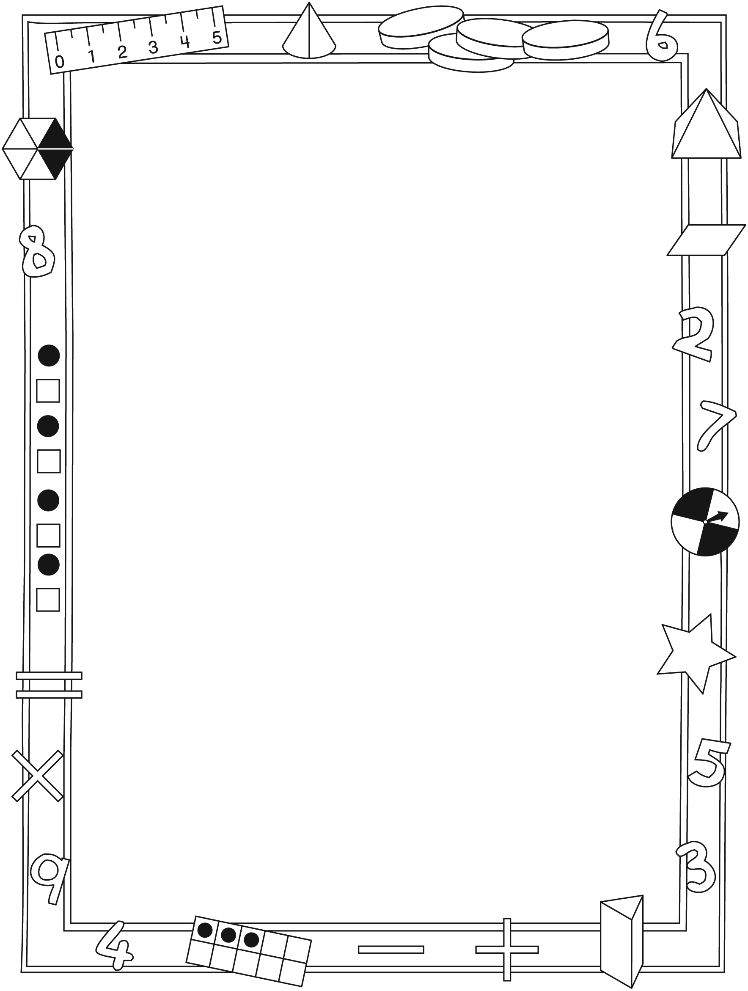

**Connecting Home and School Line Master 2–2**

Dear Family:

We have been working on ***The Bunny Challenge***, which engages children in conversations, investigations, and activities that help to develop their understanding of the big math idea that “Units can be used to measure and compare attributes.” Particular focus is placed on estimating, comparing, and measuring area and perimeter of objects. Try this activity at home with your child.

✂ – – – – – – – – – – – – – – – – – – – – – – – – – – – – – – – – – – – – – – – – – –

**Reading the Story:** As you read the story, enjoy predicting the perimeter and area of the various bunny home designs. Try to estimate which home will have the greatest area and the least area space.

✂ – – – – – – – – – – – – – – – – – – – – – – – – – – – – – – – – – – – – – – – – – –

**Bunny Homes:** Invite your child to predict whether the bunny homes on the Math Mat (inside back cover of the book) have the same or different perimeters. Then, work together to measure the perimeters of all the homes (the lengths of all the sides added together) in centimetres to check. Repeat, but for the areas of the homes. Fill the bunny homes with squares (e.g., with square sticky notes or by covering them with grid paper), and then count them to find the area.

✂ – – – – – – – – – – – – – – – – – – – – – – – – – – – – – – – – – – – – – – – – – –

**Missing Sides:** Draw a shape with straight sides and 1 side missing (e.g., draw only 3 sides of a rectangle). Measure the perimeter of the completed shape in centimetres. Tell your child the perimeter and ask her/him to tell you the length of the missing side. Complete the shape and encourage your child to measure to check his/her answer. For the next round, have your child draw a shape with a missing side, and then measure and tell you the perimeter of the completed shape.

✂ – – – – – – – – – – – – – – – – – – – – – – – – – – – – – – – – – – – – – – – – – –

**My Bunny Home:** Use square building blocks to build a bunny home with your child. Ask your child to show you how to use the blocks to find the perimeter and area of the home.

✂ – – – – – – – – – – – – – – – – – – – – – – – – – – – – – – – – – – – – – – – – – –

Sincerely,

___________________________

***The Bunny Challenge* Line Master 3**

**Math Mat**

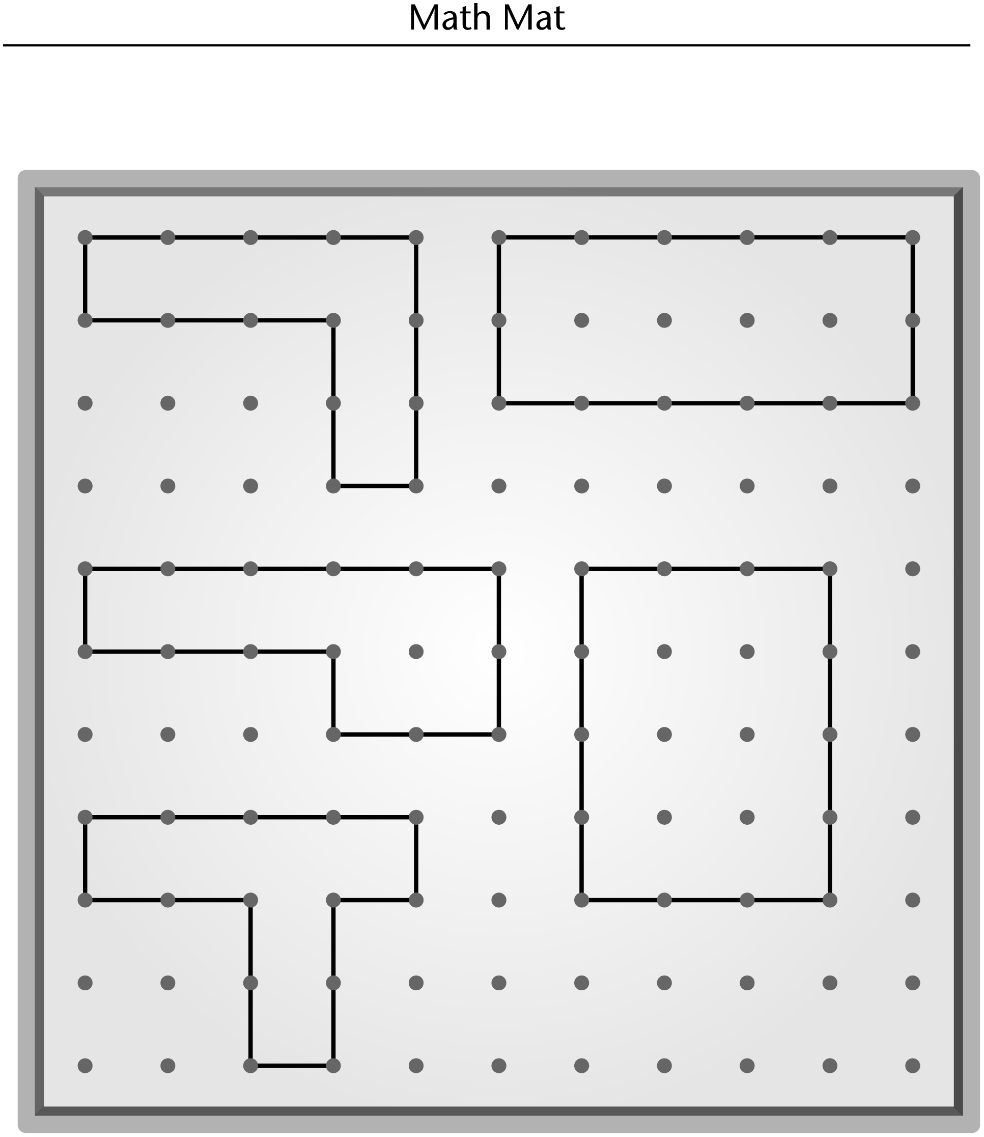

**Grid Paper Line Master 4–1**

**1 Centimetre**

**Name:** _____________________________

|  |  |  |  |  |  |  |  |  |  |  |  |  |  |  |  |
| --- | --- | --- | --- | --- | --- | --- | --- | --- | --- | --- | --- | --- | --- | --- | --- |
|  |  |  |  |  |  |  |  |  |  |  |  |  |  |  |  |
|  |  |  |  |  |  |  |  |  |  |  |  |  |  |  |  |
|  |  |  |  |  |  |  |  |  |  |  |  |  |  |  |  |
|  |  |  |  |  |  |  |  |  |  |  |  |  |  |  |  |
|  |  |  |  |  |  |  |  |  |  |  |  |  |  |  |  |
|  |  |  |  |  |  |  |  |  |  |  |  |  |  |  |  |
|  |  |  |  |  |  |  |  |  |  |  |  |  |  |  |  |
|  |  |  |  |  |  |  |  |  |  |  |  |  |  |  |  |
|  |  |  |  |  |  |  |  |  |  |  |  |  |  |  |  |
|  |  |  |  |  |  |  |  |  |  |  |  |  |  |  |  |
|  |  |  |  |  |  |  |  |  |  |  |  |  |  |  |  |
|  |  |  |  |  |  |  |  |  |  |  |  |  |  |  |  |
|  |  |  |  |  |  |  |  |  |  |  |  |  |  |  |  |
|  |  |  |  |  |  |  |  |  |  |  |  |  |  |  |  |
|  |  |  |  |  |  |  |  |  |  |  |  |  |  |  |  |
|  |  |  |  |  |  |  |  |  |  |  |  |  |  |  |  |
|  |  |  |  |  |  |  |  |  |  |  |  |  |  |  |  |
|  |  |  |  |  |  |  |  |  |  |  |  |  |  |  |  |
|  |  |  |  |  |  |  |  |  |  |  |  |  |  |  |  |

**Grid Paper Line Master 4–2**

**2 Centimetre**

**Name:** _____________________________

|  |  |  |  |  |  |  |  |
| --- | --- | --- | --- | --- | --- | --- | --- |
|  |  |  |  |  |  |  |  |
|  |  |  |  |  |  |  |  |
|  |  |  |  |  |  |  |  |
|  |  |  |  |  |  |  |  |
|  |  |  |  |  |  |  |  |
|  |  |  |  |  |  |  |  |
|  |  |  |  |  |  |  |  |
|  |  |  |  |  |  |  |  |
|  |  |  |  |  |  |  |  |
|  |  |  |  |  |  |  |  |

**Dot Paper Line Master 5–1**

**1 Centimetre**

**Name:** _____________________________



**Dot Paper Line Master 5–2**

**2 Centimetre**

**Name:** _____________________________



**Geoboard Challenge Line Master 6**

**Name:** _____________________________

|  |  |
| --- | --- |
|  | The perimeter measures  This shape has (circle)  the greatest perimeter.  the middle perimeter.  the least perimeter. |
|  | The perimeter measures  This shape has (circle)  the greatest perimeter.  the middle perimeter.  the least perimeter. |
|  | The perimeter measures  This shape has (circle)  the greatest perimeter.  the middle perimeter.  the least perimeter. |

**Rectangles Line Master 7**

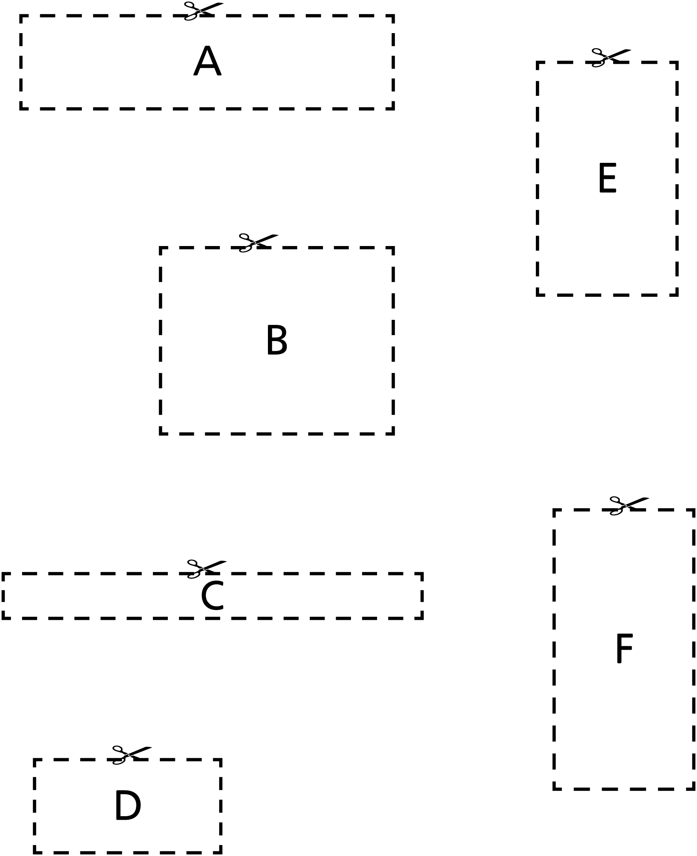

**Roll and Flip Cards Line Master 8**



|  |  |  |
| --- | --- | --- |
| **greatest perimeter** | **greatest perimeter** | **greatest perimeter** |
| **least  perimeter** | **least  perimeter** | **least  perimeter** |
| **greatest area** | **greatest area** | **greatest area** |
| **least  area** | **least  area** | **least  area** |

**Roll and Flip Score Sheet Line Master 9**

**Name:** _____________________________

|  |  |  |  |  |
| --- | --- | --- | --- | --- |
| **Round** | **Card (circle)** | | **My Measurement** | **My Friend’s Measurement** |
| **1** | least perimeter | least area |  |  |
| greatest perimeter | greatest area |
| **2** | least perimeter | least area |  |  |
| greatest perimeter | greatest area |
| **3** | least perimeter | least area |  |  |
| greatest perimeter | greatest area |
| **4** | least perimeter | least area |  |  |
| greatest perimeter | greatest area |
| **5** | least perimeter | least area |  |  |
| greatest perimeter | greatest area |

**20 Square Units Line Master 10**

**Name:** _____________________________

|  |  |  |
| --- | --- | --- |
| **Shape** | **Area** | **Perimeter** |
|  |  |  |
|  |  |  |
|  |  |  |
|  |  |  |

**Mini-Book Template Line Master 11**



|  |  |
| --- | --- |
| **My Pet’s Home**  **by** | My pet is a |
| The perimeter of my pet’s home is | The area of my pet’s  home is |

**Area and Perimeter Line Master 12–1**

**Problems**

✂ – – – – – – – – – – – – – – – – – – – – – – – – – – – – – – – – – – – – – – – – – –

Adam wants to put a rug in his room so the bunnies can be comfy when they come inside for a visit. The rug is a rectangle with a perimeter of 10 metres. The length of one side is 2 metres.

What are the lengths of the other sides?

Use words, numbers, and drawings in your answer.

✂ – – – – – – – – – – – – – – – – – – – – – – – – – – – – – – – – – – – – – – – – – –

Katie is going to help build a fence around the family’s garden so the bunnies don’t eat their vegetables! The garden is 5 metres wide and 6 metres long.

How much fencing will Katie need?

Use words, numbers, and drawings in your answer.

✂ – – – – – – – – – – – – – – – – – – – – – – – – – – – – – – – – – – – – – – – – – –

**Area and Perimeter Line Master 12–2**

**Problems**

✂ – – – – – – – – – – – – – – – – – – – – – – – – – – – – – – – – – – – – – – – – – –

Adam’s classroom is 7 metres long and 6 metres wide. Katie’s classroom is 8 metres long and 5 metres wide.

What is the perimeter of each classroom?

Which classroom has the greater area?

✂ – – – – – – – – – – – – – – – – – – – – – – – – – – – – – – – – – – – – – – – – – –

Uncle Matt is going to build a bunny home for some bunnies he is taking to his house. He has 30 metres of fencing.

Draw as many rectangles as you can that would have a perimeter of 30 metres. Label the lengths of all the sides.

Uncle Matt wants his bunny home to have the greatest area possible. Which of your rectangle designs should he use?

✂ – – – – – – – – – – – – – – – – – – – – – – – – – – – – – – – – – – – – – – – – – –