Welcome to The Nature Park Line Master 1
(Assessment Master)
Name: _____________________________

Interpret Charts, Tables, Pictographs, and Bar Graphs | Not observed | Sometimes | Consistently
Reads and interprets information from data displays
Explains and justifies whether a display used is appropriate for the data collected
Draw Conclusions from Data Displays
Poses questions about data collected and displayed
Answers questions about data collected and displayed
Makes simple inferences about a population based on sample data collected
Draws conclusions from charts, tables, and graphs
Strengths:

Next Steps:

Connecting Home and School Line Master 2–1

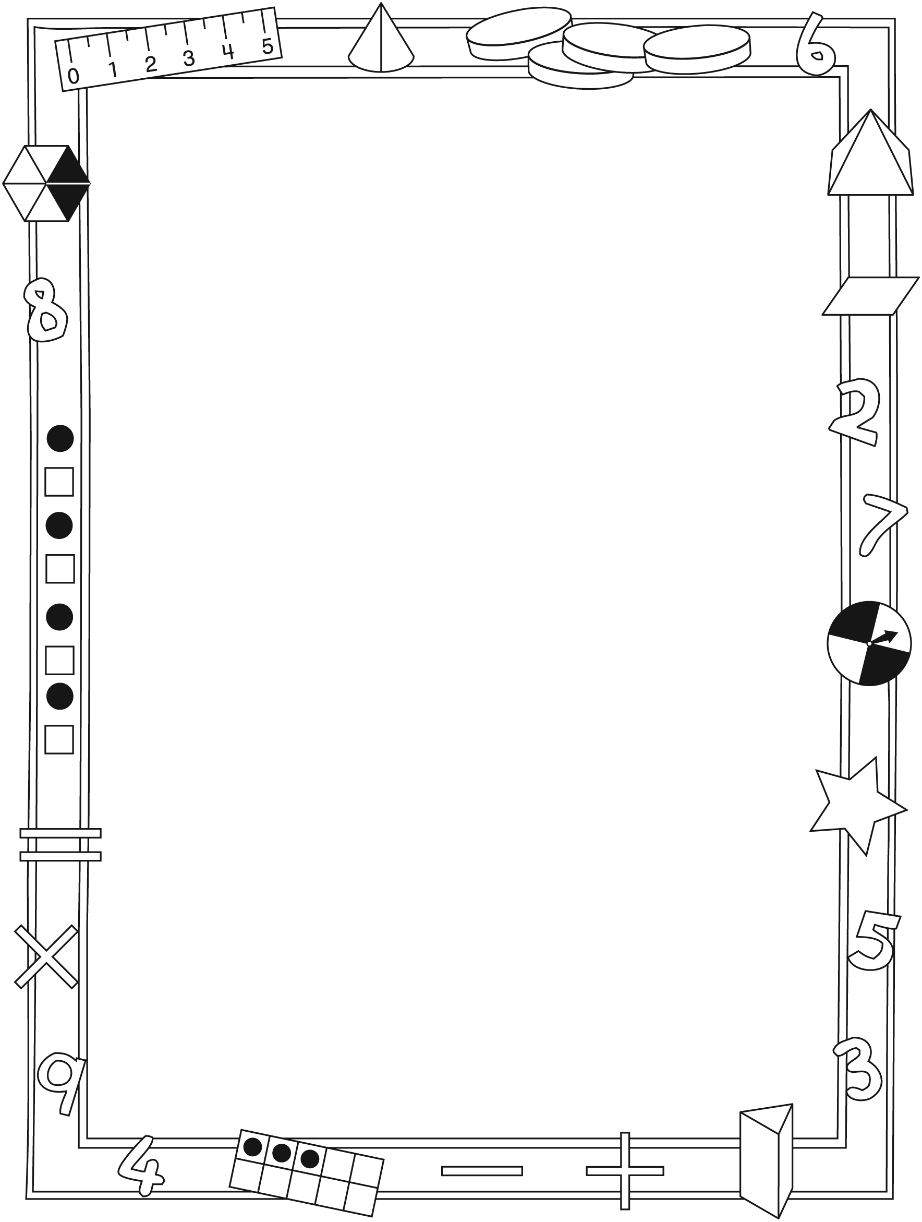

NOTE TO THE TEACHER

You may wish to send families a Welcome to The Nature Park letter outlining a familiar activity or two they can do at home with their children.

Create a letter using this template and select one or two activities from the suggestions on the next page. Simply delete these instructions and cut and paste the activities you have selected, adapting them to fit your needs.

Connecting Home and School Line Master 2–2

Dear Family:

We have been working on Welcome to The Nature Park, which engages children in conversations, investigations, and activities that help to develop their understanding of the big math idea that “Collecting and displaying data can help us predict and interpret situations.” Particular focus is placed on interpreting charts, tables, pictographs, and bar graphs, and drawing conclusions based on data displays. Try this activity at home with your child.
– – – – – – – – – – – – – – – – – – – – – – – – – – – – – – – – – – – – – – – – – –
Reading the Story: As you read the story, enjoy talking about the various ways information is displayed and what you learn from the graphs. After you read, you might ask some questions about objects in your home that could be shown on a graph (e.g., stuffed toys and toys with wheels; different genres of books).
– – – – – – – – – – – – – – – – – – – – – – – – – – – – – – – – – – – – – – – – – –
Say Something! With your child, decide on 4 categories for a graph (e.g.,
4 types of sports, 4 ice cream flavours) and assign a different symbol to each category. Roll a number cube to determine how many are in each category. Use a copy of the Math Mat (see the inside back cover of the book) to create your graph. Then, take turns saying something about the graph (e.g., “More people like soccer than swimming,” “9 people voted in this survey”) until you run out of things to say. The last person to be able to come up with something to say about the graph is the winner.
– – – – – – – – – – – – – – – – – – – – – – – – – – – – – – – – – – – – – – – – – –
Newsworthy: Look through newspapers and magazines to find simple graphs on an appropriate topic for your child. Read and discuss the content of these graphs with your child, drawing conclusions and making inferences based on the graphs.
– – – – – – – – – – – – – – – – – – – – – – – – – – – – – – – – – – – – – – – – – –
Sincerely,

___________________________

Welcome to The Nature Park Line Master 3
Math Mat

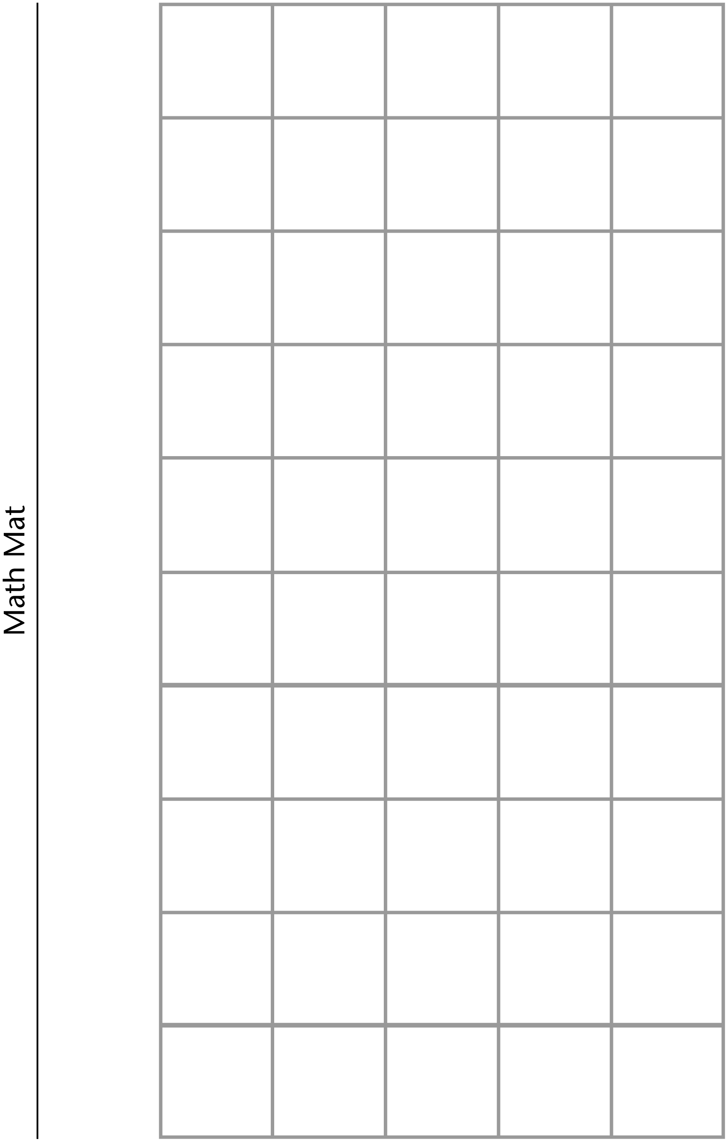

The Big Graphing Oops! Line Master 4
Name: _____________________________

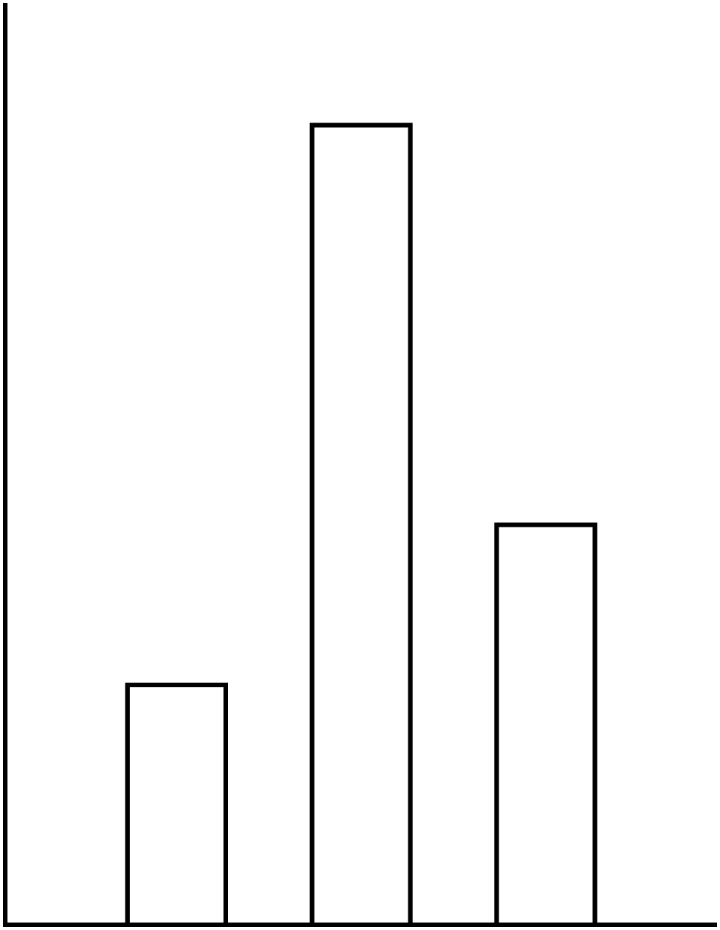

The Best Way Line Master 5–1

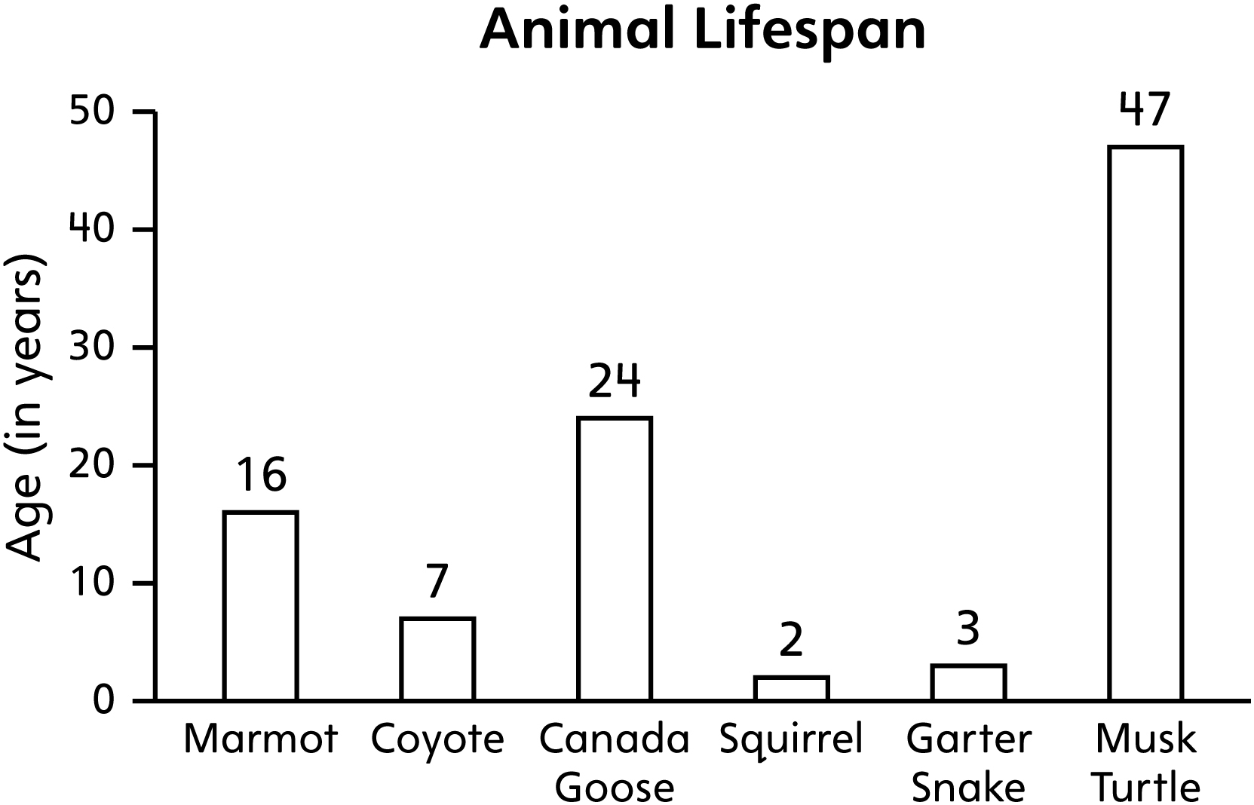

Animal Lifespan
Marmot | Coyote | Canada  Goose | Squirrel | Garter  Snake | Musk  Turtle
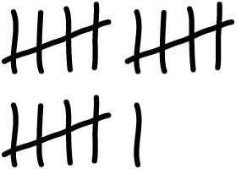 |  |  |  |  | 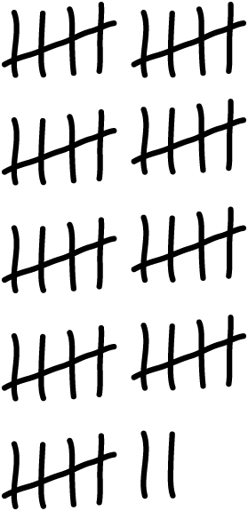

The Best Way Line Master 5–2

Animal Lifespan
Animal | Lifespan in Years
Marmot | 16
Coyote | 7
Canada Goose | 24
Squirrel | 2
Garter Snake | 3
Musk Turtle | 47

Animal Lifespan
Animal | Lifespan in Years
Marmot
Coyote
Canada Goose
Squirrel
Garter Snake
Musk Turtle

The Best Way Line Master 5–3
Name: _____________________________

How are the graphs, tables, and charts alike?

How are they different?

Which one is the easiest to read? Why?

Which ones are harder to make sense of? Explain your thinking.

Digging into Data Line Master 6–1

– – – – – – – – – – – – – – – – – – – – – – – – – – – – – – – – – – – – – – – – – –

Favourite Fruits for School Snack
Grapes | Orange | Apple

– – – – – – – – – – – – – – – – – – – – – – – – – – – – – – – – – – – – – – – – – –

What do we want to do at recess?
Skip rope
Play soccer
Play in playground

– – – – – – – – – – – – – – – – – – – – – – – – – – – – – – – – – – – – – – – – – –

Digging into Data Line Master 6–2

– – – – – – – – – – – – – – – – – – – – – – – – – – – – – – – – – – – – – – – – – –

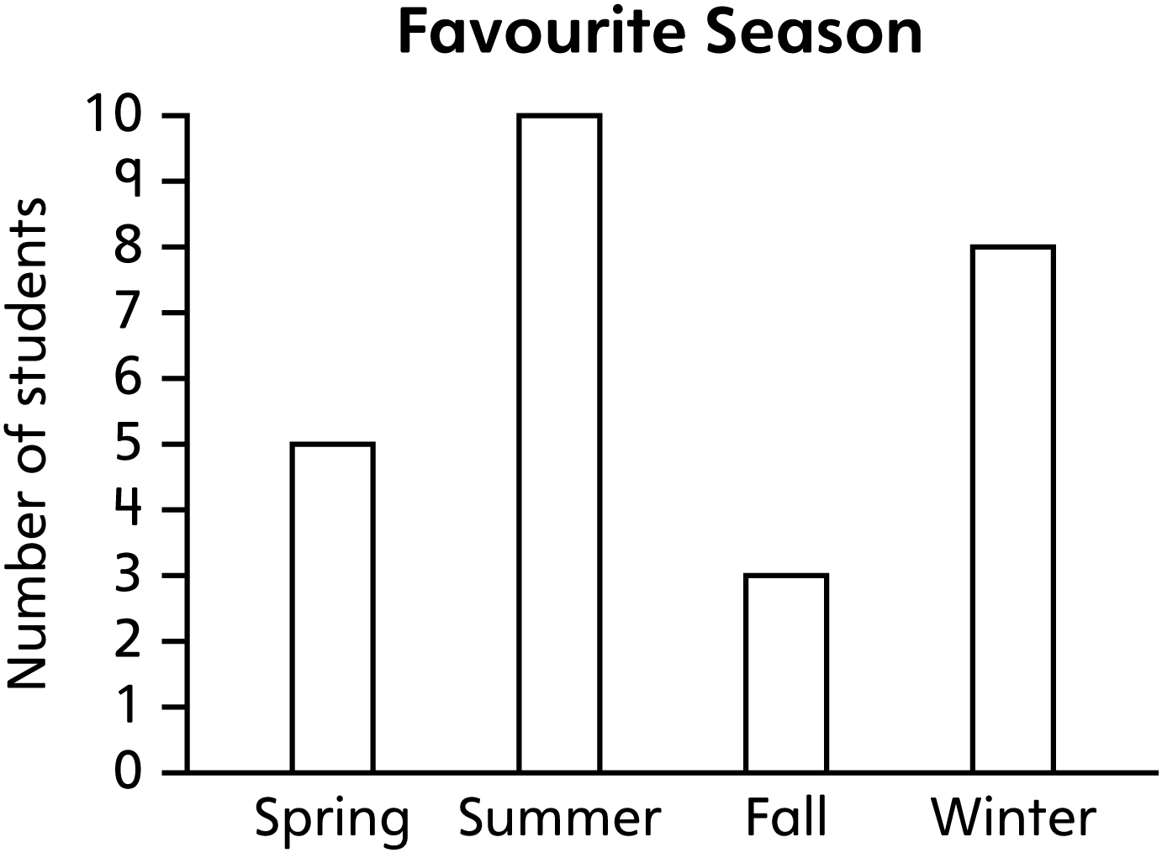

– – – – – – – – – – – – – – – – – – – – – – – – – – – – – – – – – – – – – – – – – –

Where do we want to go on a field trip?
Museum
Aquarium
Animal Shelter

– – – – – – – – – – – – – – – – – – – – – – – – – – – – – – – – – – – – – – – – – –

Digging into Data Line Master 6–3

– – – – – – – – – – – – – – – – – – – – – – – – – – – – – – – – – – – – – – – – – –
What type of information is in this data display?

– – – – – – – – – – – – – – – – – – – – – – – – – – – – – – – – – – – – – – – – – –
Which choice was most popular? _______________ How did you decide?

– – – – – – – – – – – – – – – – – – – – – – – – – – – – – – – – – – – – – – – – – –
What is another question you can ask about the information in this data display? What is the answer to your question? How did you decide?

– – – – – – – – – – – – – – – – – – – – – – – – – – – – – – – – – – – – – – – – – –
How can you use the information from this data display?

– – – – – – – – – – – – – – – – – – – – – – – – – – – – – – – – – – – – – – – – – –

Nature Park Problems Line Master 7–1

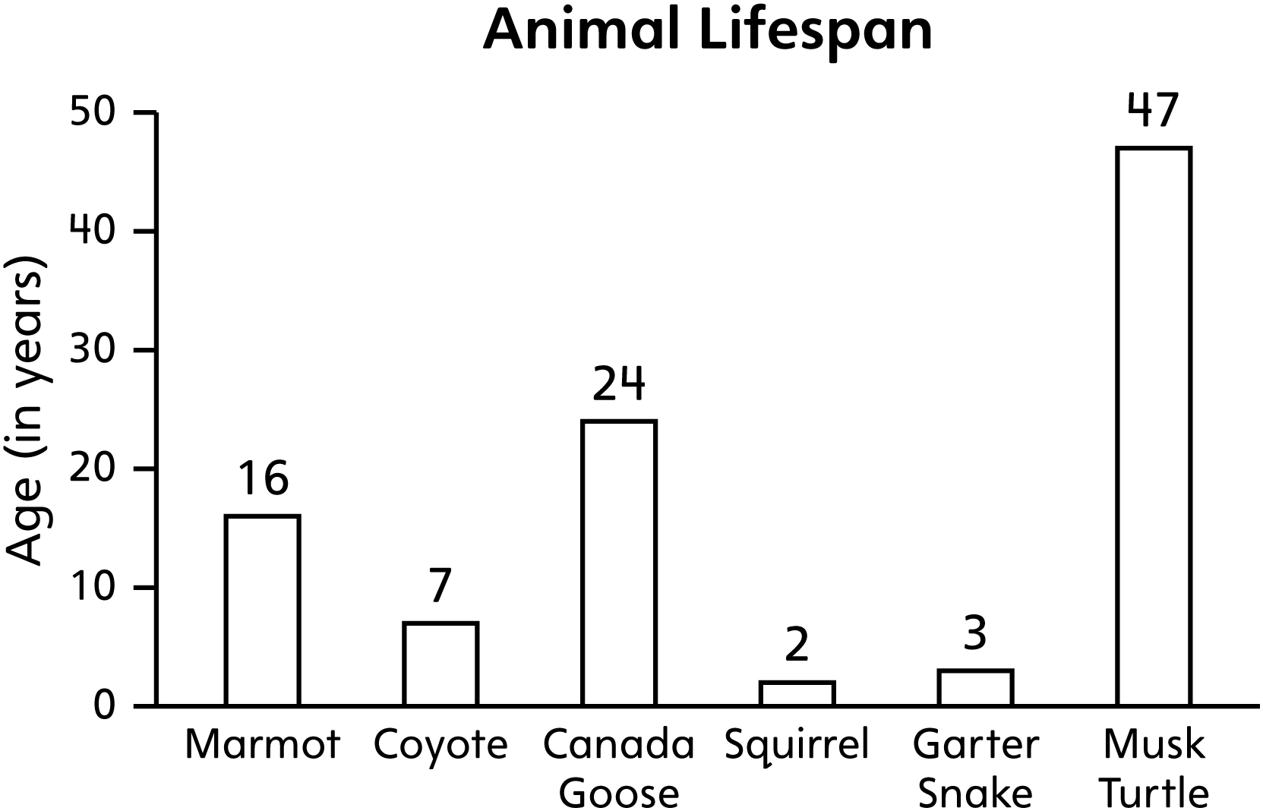

1. How much longer does a marmot live than a coyote?

2. How many years older are you than an old garter snake?

3. Which animal lives about 3 times longer than a squirrel?

4. What question can you ask using this bar graph?

Nature Park Problems Line Master 7–2

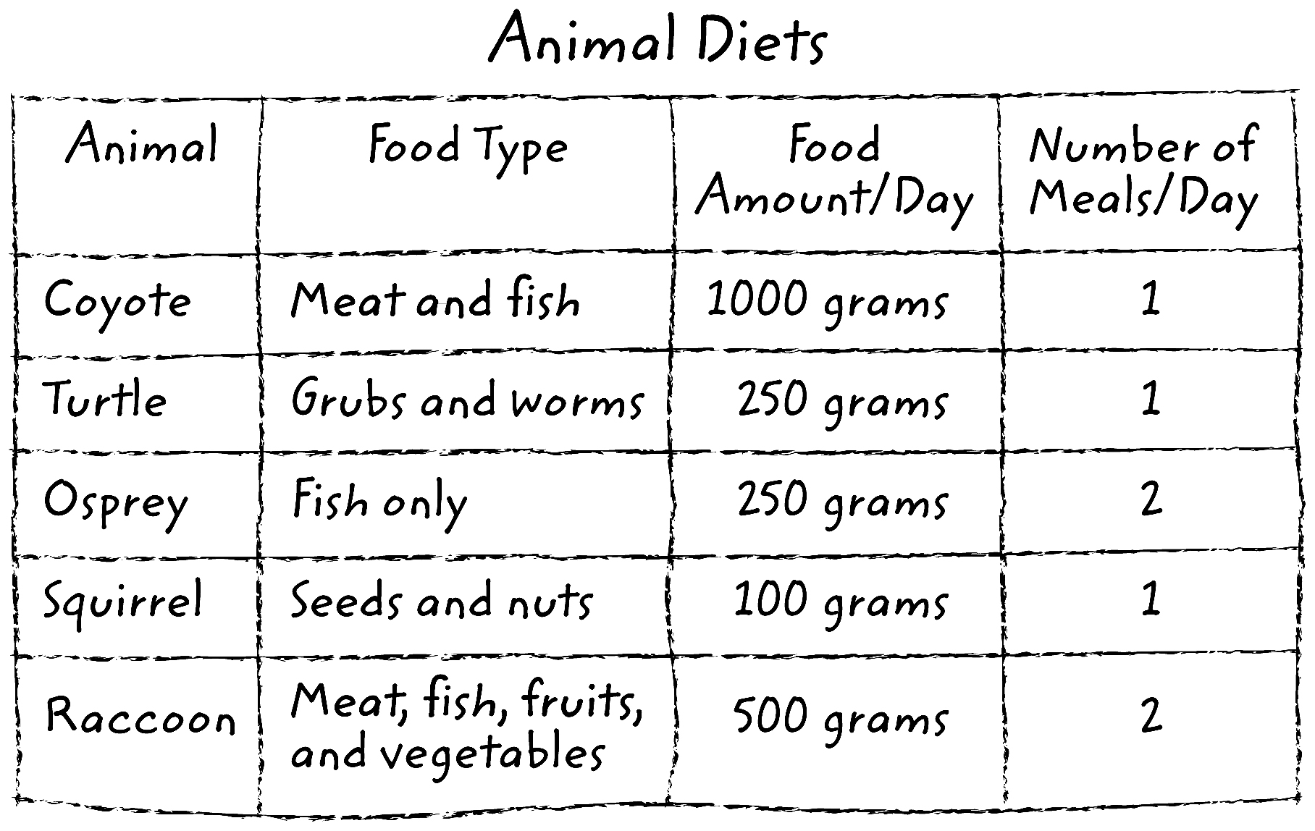

1. How much food does a raccoon eat in 1 day? 3 days?

2. How much food is needed to feed an osprey for 1 week?

3. You have 750 grams of grubs and worms. How many turtles can you feed in 1 day?

4. Which eats more: 10 squirrels or 2 raccoons?

5. Make up a problem of your own using this chart.

Nature Park Problems Line Master 7–3

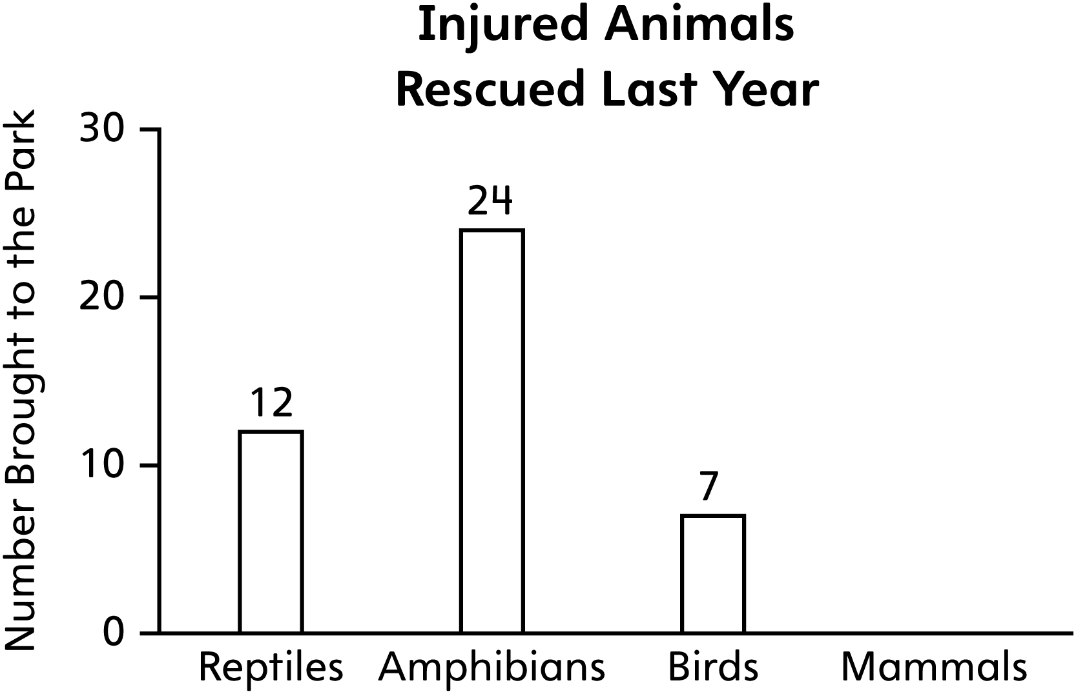
1. 61 injured animals were brought to the park last year. How many were mammals? How did you figure it out?

2. Suppose 71 injured animals were brought to the park and the number of reptiles, amphibians, and birds did not change. How many mammals would there be?

3. Suppose 51 injured animals were brought to the park and the number of reptiles, amphibians, and birds did not change. How many mammals would there be?

4. Suppose 100 injured animals were brought to the park and the number of reptiles, amphibians, and birds did not change. How many mammals would there be?

5. Suppose there were twice as many injured mammals as birds brought to the park. How many injured mammals would there be?

