Representing Outcomes using Fractions
Uses likelihood terms to describe probability of events and make predictions.  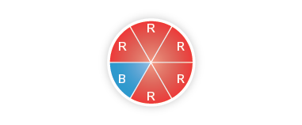  “The spinner is likely to land on red because all but 1 sector is red.” | Makes predictions benchmark fractions on a probability line.  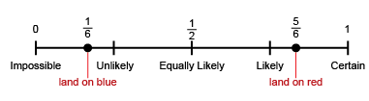  “I can see from the line that it is much more likely for the pointer to land on red. In 60 spins, I predict the pointer will land on blue 50 times.” | Makes predictions for combined outcomes on a probability line.  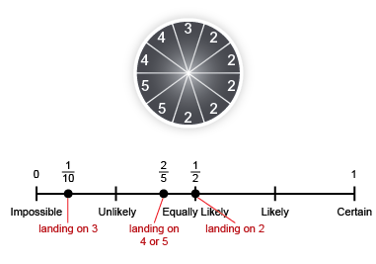  “The probability of landing on 4 or 5 is less than the probability of landing on 2. I would predict that the pointer is more likely to land on 2  than on 4 or 5.” | Uses fractions to express probability using benchmarks and make informed decisions.  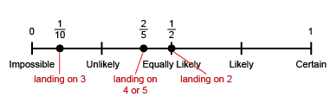  “If this spinner was at a carnival game, I would always choose the pointer landing on 2 because it is the most likely outcome. I would never choose the pointer landing on 3.”
Observations/Documentation

