Making Predictions and Conducting Experiments
Makes predictions and  performs experiments.  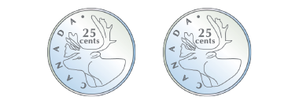  “The probability of getting 2 tails when tossing 2 coins is $\frac{1}{4}$. That isn’t what happened in the experiment. I’m not sure why.” | Performs experiment, records results, and compares predictions  to results.  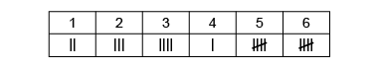  “If I roll a number cube 20 times, I expect to roll each number about 3 times. The results weren’t close to my predictions because I only rolled a 4 once.” | Knows that with more trials, the closer the actual results may be to predicted results.  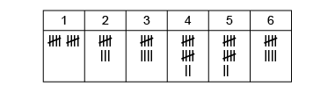  “When I conducted more trials (100), I noticed that the results got closer to my predictions. But they still didn’t match exactly.” | Performs experiments, analyzes results, and compares and justifies predictions.  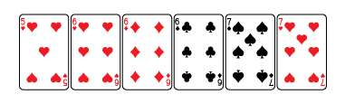  “The probability of drawing a 6 or a 7 is $\frac{5}{6}$. So, when I conduct the experiment 60 times, I would expect to get a 6 or 7 about 50 times. I got 6 or 7 forty-four times. I have to do more trials.”
Observations/Documentation

Theoretical Probability of Independent Events
Predicts likelihood of favored outcomes based on personal preferences or experiences.  “I think I will get the blue marble because last time I got  a blue marble.” | Represents probability using words/fractions and predicts the likelihood of future events.  “I think I will get a blue marble because $\frac{6}{12}$ or $\frac{1}{2}$of the marbles  are blue.” | Represents probability using ‘odds in favour’ and predicts likelihood of future events.  “The probability of getting a red marble is $\frac{1}{4}$. The probability of not getting a red marble is $\frac{3}{4}$.  The ‘odds in favour’ of a red marble are 1:3. It is not likely that I will get a red marble.” | Fluently makes and justifies predictions about the likelihood of future events.  “Knowing the likelihood of events can help me make decisions in real life. For example, weather forecasts are created by comparing the likelihood of different weather conditions.”
Observations/Documentation

