Properties of 2-D Shapes and 3-D Objects
Recognizes that 2-D shapes and 3-D objects have different attributes.  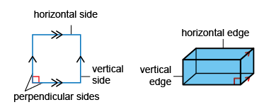  “Square:  - opposite sides parallel  - adjacent sides perpendicular  Rectangular prism:  - opposite edges and faces parallel  - adjacent faces and edges perpendicular.” | Identifies and describes 2-D shapes and 3-D objects by their attributes.  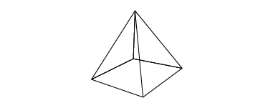  “Square pyramid:  - 1 horizontal face, which is its base  - base intersects each triangular face  - adjacent edges of base are perpendicular.” | Compares and describes pairs of  2-D shapes and 3-D objects.  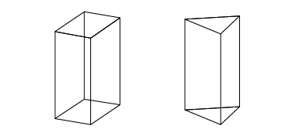  “Both objects have:  - vertical faces and edges perpendicular to 2 horizontal faces and edges  - horizontal faces that are parallel  - intersecting faces and edges  Rectangular prism has parallel vertical faces.” | Flexibly identifies, sketches, and describes a 2-D shape or 3-D object from its attributes.  Sketch and name a shape with:  - 5 sides  - 2 pairs of perpendicular sides  - 1 pair of parallel and horizontal sides  “I drew a pentagon that has all of the attributes.”
Observations/Documentation

