Identifying and Constructing Congruent 2-D Shapes
Recognizes that congruent shapes have matching sides and equal angles.  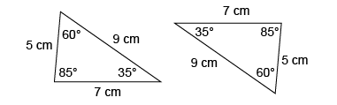  “Matching sides and angles are equal. When I place one shape on top of the other,  they match exactly.” | Applies properties of shapes and conditions of congruence to identify congruent shapes.  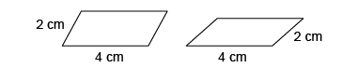  “These parallelograms have the same side lengths but different angles, so they are not congruent.” | Constructs congruent 2-D shapes and explains why they are congruent.  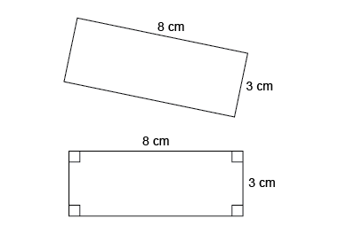  “I used the side lengths given and the fact that rectangles have right angles to construct  a congruent rectangle.” | Flexibly identifies, constructs, and describes congruent 2-D shapes.  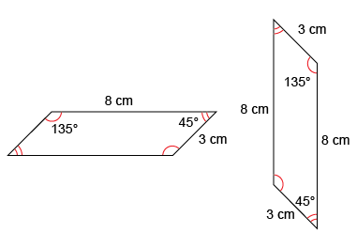  “I constructed a congruent parallelogram using a ruler and a protractor. For two parallelograms to be congruent, matching sides and angles must be equal.”
Observations/Documentation

