Applying and Visualizing Translations and Reflections
Identifies translations and reflections of 2-D shapes on a grid.  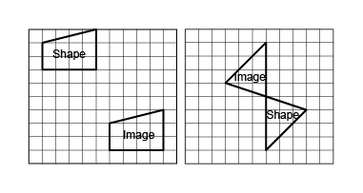  “The first image shows a translation, and the second grid shows a reflection.” | Identifies the translation/reflection used to move a shape and the line of reflection.  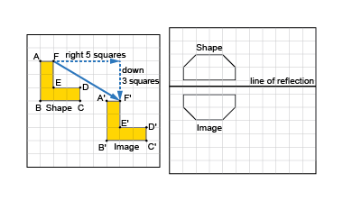  “The shape has been translated 5 squares right and down 3 squares. The hexagon was reflected because the shape and the image are the same distance from the line of reflection.” | Describes and performs translations and reflections on a grid using labelled vertices.  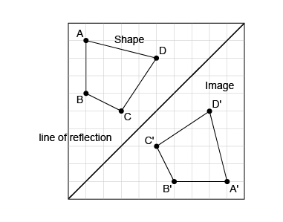  “The image is a reflection of the shape because matching vertices on the shape and its image are the same distance from the line of reflection. The vertices on the image are labelled in the  opposite direction.” | Visualizes, predicts, and describes image of a shape after a translation or reflection.  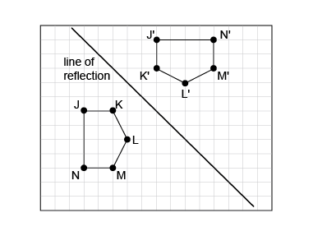  “The hexagons are congruent and matching vertices are the same distance from the line of reflection. The line of reflection is the diagonal line halfway between the  two hexagons.”
Observations/Documentation

