Measuring Area of Parallelograms and Triangles
Determines the area of a rectangle.  “A rectangle is an array of squares. To find the area, I multiply the number of rows by the number of columns or use the formula A = b × h.  This rectangle has area  5 cm × 3 cm = 15 cm².”  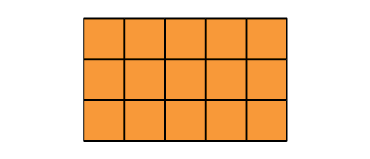 | Partitions and rearranges a parallelogram to form a rectangle with the same base and height.  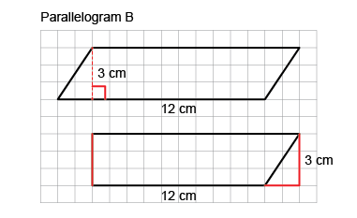  “I partitioned the parallelogram  and moved the triangle to  create a rectangle.  I then found the area of the rectangle: A = b × h = 12 cm × 3 cm= 36 cm². The area of the parallelogram is also 36 cm².” | Doubles a triangle to create a parallelogram (area of triangle is one-half that of parallelogram).  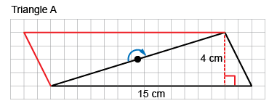  “I rotated the triangle to make a parallelogram with the same base  and height. The area of the triangle  is one-half the area  of the parallelogram.  Area of parallelogram:  15 cm × 4 cm = 60 cm²  Area of triangle: 60 cm² ÷ 2 = 30 cm²  So, the formula for the area of a triangle is: A = b × h ÷ 2.” | Flexibly solves problems involving the areas of rectangles, parallelograms, and triangles.  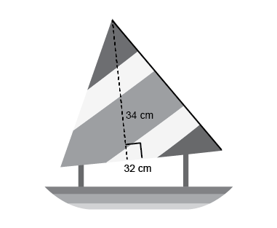  What is the area of the sail on the toy boat?  “I doubled the triangular sail to make a parallelogram with the same base and height. I found the area of the parallelogram: 34 cm × 32 cm = 1088 cm², then divided the area in half to find the area of the triangle: 1088 cm² ÷ 2 = 544 cm².”
Observations/Documentation

