Understanding Relationships Among Metric Units
Understands some metric relationships: 1 kg = 1000 g,  1 L = 1000 mL, and 1 km = 1000 m.  1.88 kg of flour  ”I know that 1 kg = 1000 g, so 1.88 kg = 1000 g × 1.88 = 1880 g.” | Uses metric relationships to convert between units (calculates in steps).  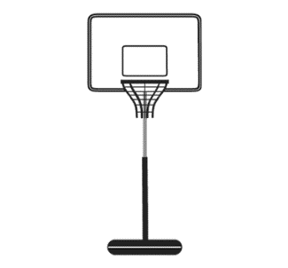  Write the height of the basketball net, 2.60 m, in millimetres.  “I multiplied by 10 three times: 2.60 × 10 = 26; 26 × 10 = 260;  260 × 10 = 2600;  2.60 m = 2600 mm.” | Uses metric relationships to convert between units efficiently.  Write the height of the basketball net, 2.60 m, in millimetres.  “To convert from metres to millimetres, I multiplied by 1000: 2.60 × 1000 = 2600;  2.60 m = 2600 mm.” | Flexibly and efficiently converts between metric units and  solves problems.  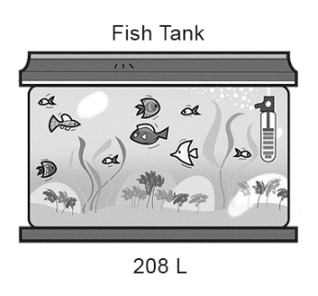  Rewrite the measure using 3 different units.  “208 × 10 = 2080; 2080 dL  208 × 1000 = 208 000; 208 000 mL  208 ÷ 1000 = 0.208; 0.208 kL  I think 208 L is most reasonable as it is a unit that people can easily relate to. A number such as 208 000 mL is difficult to visualize.”
Observations/Documentation

