Representing Numbers Using Place Value
Models 4-digit number using Base Ten Blocks (decomposes in one way).  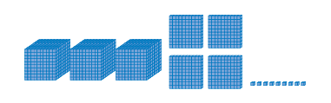  “2375: I used the digits of the number to tell me how many of each block I needed.” | Represents 4-digit number on place-value chart (decomposes in one way).  “2375 has 2 thousands, 3 hundreds,  7 tens, and 5 ones.” | Represents 5-digit number on place-value chart (decomposes in one way).  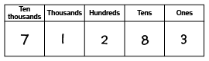  “71 283: I used the digits of the number to tell me the number to write in each column.”
Observations/Documentation

Representing Numbers Using Place Value (cont’d)
Uses relationships among place-value positions to read a number in more than one way.  “7 ten-thousands, 1 thousand, 2 hundreds,  8 tens, and 3 ones can also be 71 thousands,  2 hundreds, and 83 ones.” | Represents numbers using expanded form.  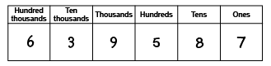  “639 587 =  600 000 + 30 000 + 9000 + 500 + 80 + 7” | Represents numbers flexibly using place-value relationships.  “639 587 =  600 000 + 30 000 + 9000 + 500 + 80 + 7  Or 600 000 + 39 000 + 400 + 180 + 7  Or 639 000 + 587”
Observations/Documentation

