Developing Fluency of Whole Number Addition and Subtraction
Uses known sums and differences to fluently solve addition and subtraction problems to 1000.  435 + 578 = ?  “I know 430 + 570 = 1000.  Since 435 is 5 more than 430 and 578 is 8 more than 570, and 8 + 5 = 13, the answer is 1013.” | Purposefully uses properties and/or relationships to solve addition and subtraction problems.  226 + 435 + 574 + 375 = ?  “I can rearrange the numbers  to make it easier to add.”  226 + 574 + 435 + 375 = ?  226 + 574 = 800  435 + 375 = 810  800 + 810 = 1610 | Understands the inverse relationship between addition and subtraction and uses it to solve problems.  1619 – 815 = ?  “I can think addition: 815 + ? = 1619.  I added on: 815 + 200 = 1015,  1015 + 600 = 1615,  1615 + 4 = 1619  The missing part is 200 + 600 + 4 = 804.”
Observations/Documentation

Developing Fluency of Whole Number Addition and Subtraction (cont’d)
Uses mental math strategies and algorithms (e.g. using benchmark numbers, known facts, partial sums).  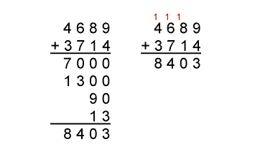  “I could used partial sums  or the standard algorithm.” | Uses estimation to check the reasonableness of solutions.  There are 648 French Immersion students. 174 more students plan to enroll in the Fall. The program can have 835 students. Is there enough space?  “648 is close to 650 and 174 is close to 175.  650 + 175 = 825. 835 – 825 = 10;  about 10 spaces.  I overestimated because we want to make sure we have enough spaces for the students.” | Flexibly creates and solves multi-operational problems and checks reasonableness of solutions.  7350 – 326 = ?  7350 – 300 = 7050  7050 – 26 = 7024 books in library.  7050 is close to 7024, so the solution is reasonable.
Observations/Documentation

