Fluency with Multiplication and Division Facts
Recalls multiplication and division facts to demonstrate and fluently recall facts to 100.  8 × 7 = 56  “I know my facts up to 10 × 10.” | Uses inverse operation to find multiplication and division facts.  56 ÷ 8 = ?  8 × ? = 56  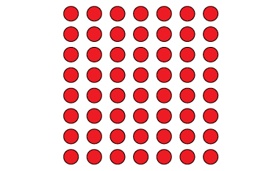  “I can use multiplication  to solve division problems.” | Applies estimation strategies to multiply and divide larger numbers.  Gardeners planted 236 plants in rows of 5.  Estimate how many rows were planted.  236 ÷ 5 = ?  “I know 100 ÷ 5 = 20, so 200 ÷ 5 = 40.  Because 236 is close to 200,  I estimate about 40 rows.”
Observations/Documentation

Fluency with Multiplication and Division Facts (cont’d)
Uses mental math strategies and properties of operations to multiply and divide larger numbers.  5 × 47 = ?  “I can decompose the numbers  to make it easier to multiply:  5 × 40 = 200, 5 × 7 = 35,  and 200 + 35 = 235.” | Applies properties of operations and partial products and connects to algorithms.  16 × 12 = ?  16 × 12 = (10 × 10) + (10 × 2) + (6 × 10) + (6 × 2)  = 100 + 20 + 60 + 12  = 192 | Flexibly and fluently selects strategies and properties of operations to solve problems involving larger numbers.  375 students are going on a field trip. Each bus holds 25 students. How many buses are needed?  “I subtracted multiples of 25, then added.”
Observations/Documentation

Representing Equivalent Ratios and Rates
Uses multiplicative relationships to represent and create ratios and rates (ratio table).  It takes 6 cups of blueberries to make a pie.  How many cups of blueberries  will I need to make 5 pies?  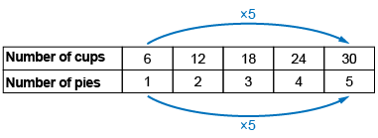  “I use a ratio table to see patterns to help me solve problems.” | Represents and records ratios and rates symbolically.  6:1, 12:2, 18:3, 24:4, 30:5 | Represents and creates equivalent ratios and rates.  The ratio of cups  of blueberries to pies is 30:5.  Identify equivalent ratios.  “I multiply or divide each term by the same number. Equivalent ratios: | Flexibly represents and creates equivalent ratios and rates.  A baker sells 2 pies for $15. How much did the baker make  if 7 pies were sold?  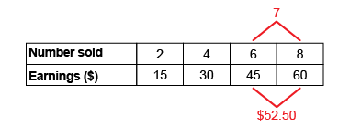  “7 is halfway between 6 and 8, so I find the number halfway between  45 and 60, which is $52.50.”
Observations/Documentation

