Adding and Subtracting Fractions with Like Denominators
Concretely solves problems.  $\frac{3}{4}$ + $\frac{2}{4}$ = ?  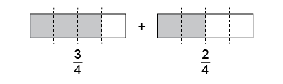  “Because each whole is divided into fourths, I can add the parts.  3 fourths + 2 fourths = 5 fourths.  5 fourths make 1 whole and $\frac{1}{4}$.” | Models pictorially to solve problems.  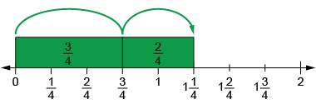  $\frac{3}{4}$ + $\frac{2}{4}$ = $\frac{5}{4}$ = 1$\frac{1}{4}$  “I modelled on the number line,  then counted on from $\frac{3}{4}$:  4 fourths, 5 fourths.” | Models symbolically to solve problems.  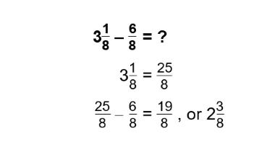  “I converted 3$\frac{1}{8}$ to $\frac{25}{8}$,  then subtracted. I checked my answer using addition.” | Fluently and flexibly solves addition and subtraction problems.  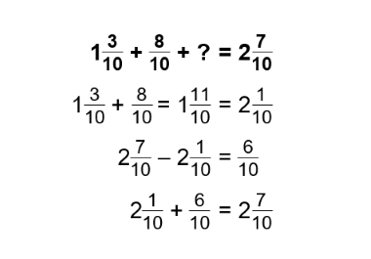  “$\frac{6}{10}$ needs to be added to the other fractions to equal 2$\frac{7}{10}$.”
Observations/Documentation

