Problem Solving with Money (Without Sales Tax)
Recognizes prices involving dollars and cents.  “The price of a bag of apples  is $3.85.”  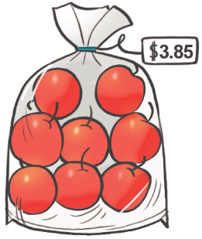 | Estimates the cost of transactions involving several items.  “I made friendly numbers to estimate the total cost:  $10 + $10 + $46 = $66.  The total cost is about $66.”  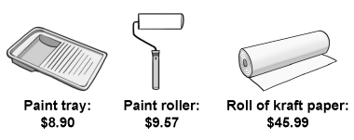 | Calculates the cost of several items with prices in dollars and cents.  “I made friendly numbers:  $8.90 + $9.57 + $45.99  = $8.90 + $9.56 + $46  = $9 + $9.46 + $46  = $9 + $9 + $46 + $0.46  = $64.46.” | Uses mental math strategies to estimate, calculate total cost, and determine change  “To find the change from a $100 bill, I would add on from $64.45 as the amount would be rounded to the nearest 5¢.  $64.45 + $0.05 =$64.50  $64.50 + $0.50 = $65  $65 + $5 = $70  $70 + $30 = $100.  $0.05 + $0.50 + $5 + $30 = $35.55.”
Observations/Documentation

