Generalizing and Representing Patterns
Identifies how a pattern repeats, increases, or decreases and describes pattern rule.  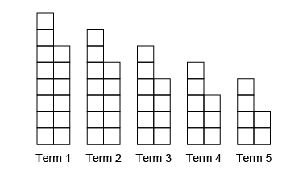  “This is a decreasing pattern. The pattern rule is: Start with 14 red tiles and take away 2 tiles each time.” | Represents patterns using tables or charts and describes the pattern rule.  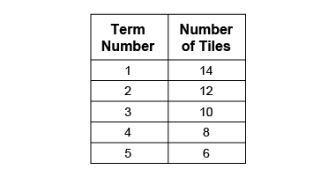  “The table shows the number of tiles decreases by 2 each time.”  Term Number Number of Blocks  1 8  2 16  3 24 | Represents patterns using graphs and describes the pattern rule.  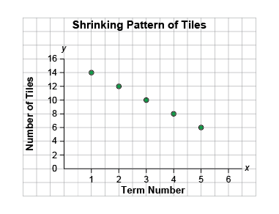  “By looking at the graph, I see that the number of tiles starts at 14 and decreases by 2 with each term.” | Represents patterns symbolically and writes the pattern rule.  18, 17, 15, 12, 8, …  “Pattern rule: Start at 18 and take away 1. Increase the number taken away by 1 each time.”
Observations/Documentation

Generalizing and Representing Patterns (cont’d)
Extends patterns using repeated addition/subtraction, multiplication, and division.  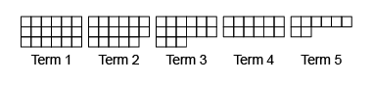  18, 17, 15, 12, 8, …  “The next term would have 8 – 5 = 3 squares. It would be the last term because I cannot take 6 away from 3. Decreasing patterns end but repeating and increasing  patterns don’t.” | Creates patterns and explains the pattern rule.  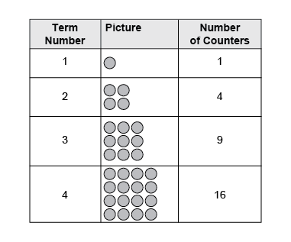  “I created an increasing pattern with the pattern rule: Start at 1. Multiply the term number by itself.” | Uses patterns to solve problems.  How many counters are  in Term 8?  “64 counters; I used the rule and multiplied the term number by itself: 8 × 8 = 64.” | Fluently identifies, creates, and extends various patterns to solve real-life problems.  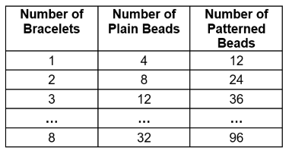  Naomi beaded bracelets using 4 plain and 12 patterned beads.  “Plain beads: Multiply the number of bracelets by 4: 4n  Patterned beads: Multiply the number of bracelets by 8: 8b.”
Observations/Documentation
 |  | .

