Solving for Unknowns in Equations
Uses ‘guess and check.’  3n = 72  “I know 3 times 20 is 60.  So, n must be more than 20.  3 × 30 = 90 (too high)  3 × 25 = 75 (too high, but close)  3 × 24 = 72  So, n = 24 because 3 × 24 =72.” | Uses the balance model.  3n = 72  72 ÷ 3 = n  or  27 + n = 45  45 − 27 = n  “I used a balance model. I moved the numbers and variable around until the equations were equivalent and I could find the solution.” | Uses relationships among operations (inverse operations, associative property).  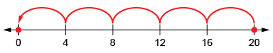  “I rewrote the equation as a division equation:  20 ÷ 4 = $∎$.”
Observations/Documentation

Solving for Unknowns in Equations (con’t)
Uses a flow chart to solve by decomposing and recomposing numbers.  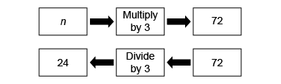  “I can decompose the equation into parts using the flow chart, then reverse the flow using the inverse operation to solve for the unknown.” | Interprets and writes a statement for a given equation and solves for the unknown.  n ÷ 5 = 8  “I collected a jar full of shells. I shared the shells with 5 of my friends. Each person got 8 shells. How many shells did I collect for my friends? | Flexibly uses multiple strategies to solve equations.  54 ÷ n − 6 = 3  “54 ÷ n = 3 + 6 so, 54 ÷ n = 9.  I then rearranged the equation:  n × 9 = 54, so n = 6 because 6 × 9 = 54.”
Observations/Documentation

Solving and Graphing for Inequalities
Recognizes inequality symbols and their meanings in various inequality equations.  3m > 18  3m ≥ 18  “Each time, the unknown can be any number greater than 6. In the second equation, it could also be 6. There are many quantities that would work.” | Represents solutions by graphing on a number line and tests values to check solutions.  25 > 5m  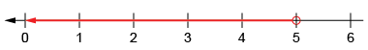  “The unknown multiplied by 5 must be less than 25. I can count by groups of 5 to get to 25. So, the unknown is 1, 2, 3, or 4.” | Verifies the solution by thinking of related equality and testing numbers.  3m ≥ 18  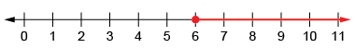  “I can use the number line to graph the solution. I know 3 × 6 = 18. So, the unknown can be any number equal to or greater than 6.” | Flexibly solves inequalities, then verifies and graphs the solutions.  5 > $\frac{n}{4}$  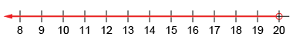  “What number can I divide by 4 so that the answer is less than 5?  I can rearrange the equation to find the unknown: 5 × 4 > n”
Observations/Documentation

