Spin and Compare

Number
Unit 1 Line Master 7a

Play with a partner.
Materials:
● Open paperclip as pointer
What to Do
Each of you spins the pointer to create a 5-digit or a 6-digit number.

or

Spin once for each digit.
You decide on its place-value position.
Try to create the greatest number you can.
Compare numbers with your partner.
The player with the greater number scores 1 point.
Play until one of you reaches 10 points.

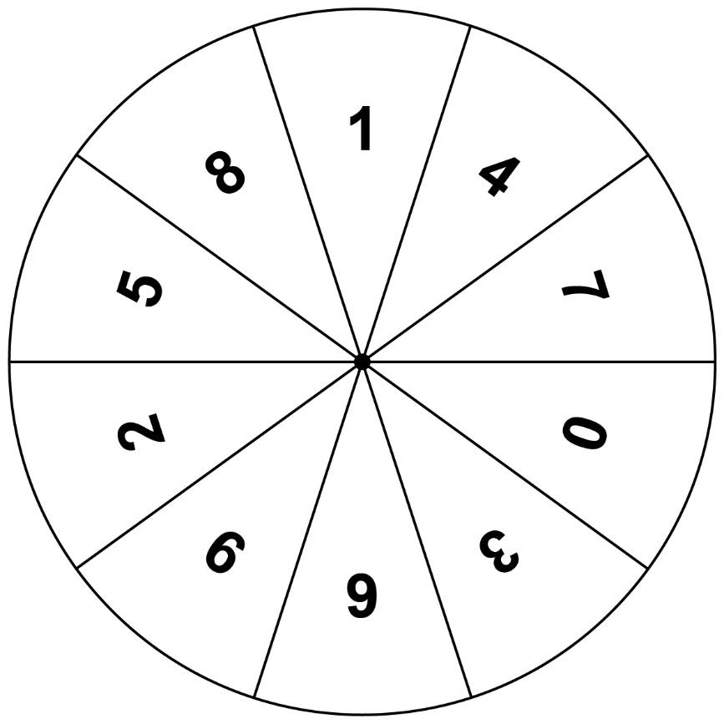
Spin and Compare (cont’d)

Number
Unit 1 Line Master 7b

Player 1 | or | Player 2

Variation:
Score a point when you make a smaller number
than your partner.

