Filling Three

Number
Unit 3 Line Master 1a

Goal: Counting by one-fifths to be the first to reach 3.

How to Play:
● Player A: Start at 0. Count 1, 2, or 3 one-fifths.
Draw jumps on the line and write a fraction to label
where you land.
● Player B: Start where Player A ended.
Count on 1, 2, or 3 one-fifths.
● Draw the jumps and label where you land.
If you land beyond 1, record the fraction as a mixed number.
● Continue to take turns until one player reaches 3.
● Play again.
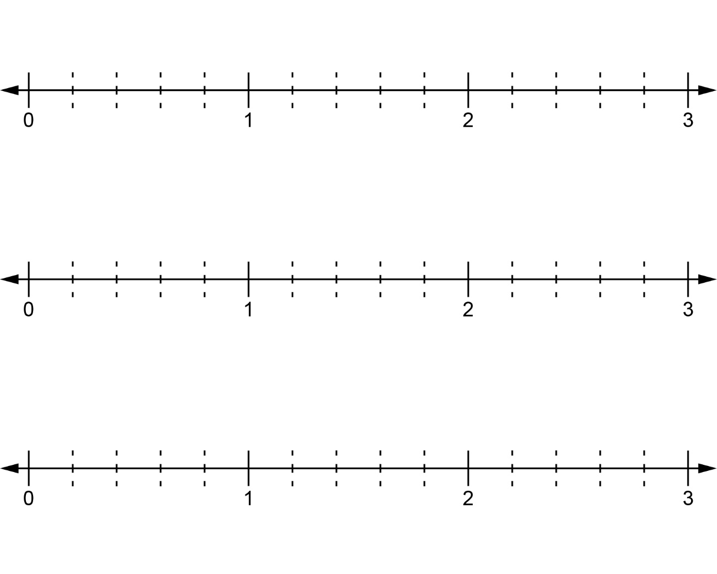
Filling Four

Number
Unit 3 Line Master 1b
ounting by one-fourths to be the first to reach 4.
How to Play:
● Player A: Start at 0. Count 1, 2, or 3 one-fourths.
Draw jumps on the line and write a fraction to label
where you land.
● Player B: Start where Player A ended.
Count on 1, 2, or 3 one-fourths. Draw the jumps and label
where you land. If you land beyond 1, record the fraction
as a mixed number.
● Continue to take turns until one player reaches 4.
● Play again.
