How Many Pears?

Number
Unit 4 Line Master 5

Jonah is making a large fruit salad for the class.
The recipe uses apples and pears in this ratio:
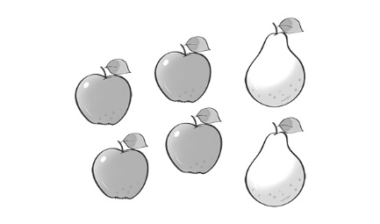

Jonah uses 12 apples.
How many pears does Jonah need?

Number of apples | 4
Number of pears | 2

