Complete the Chase!
Gameboard

Number
Unit 5 Line Master 5a

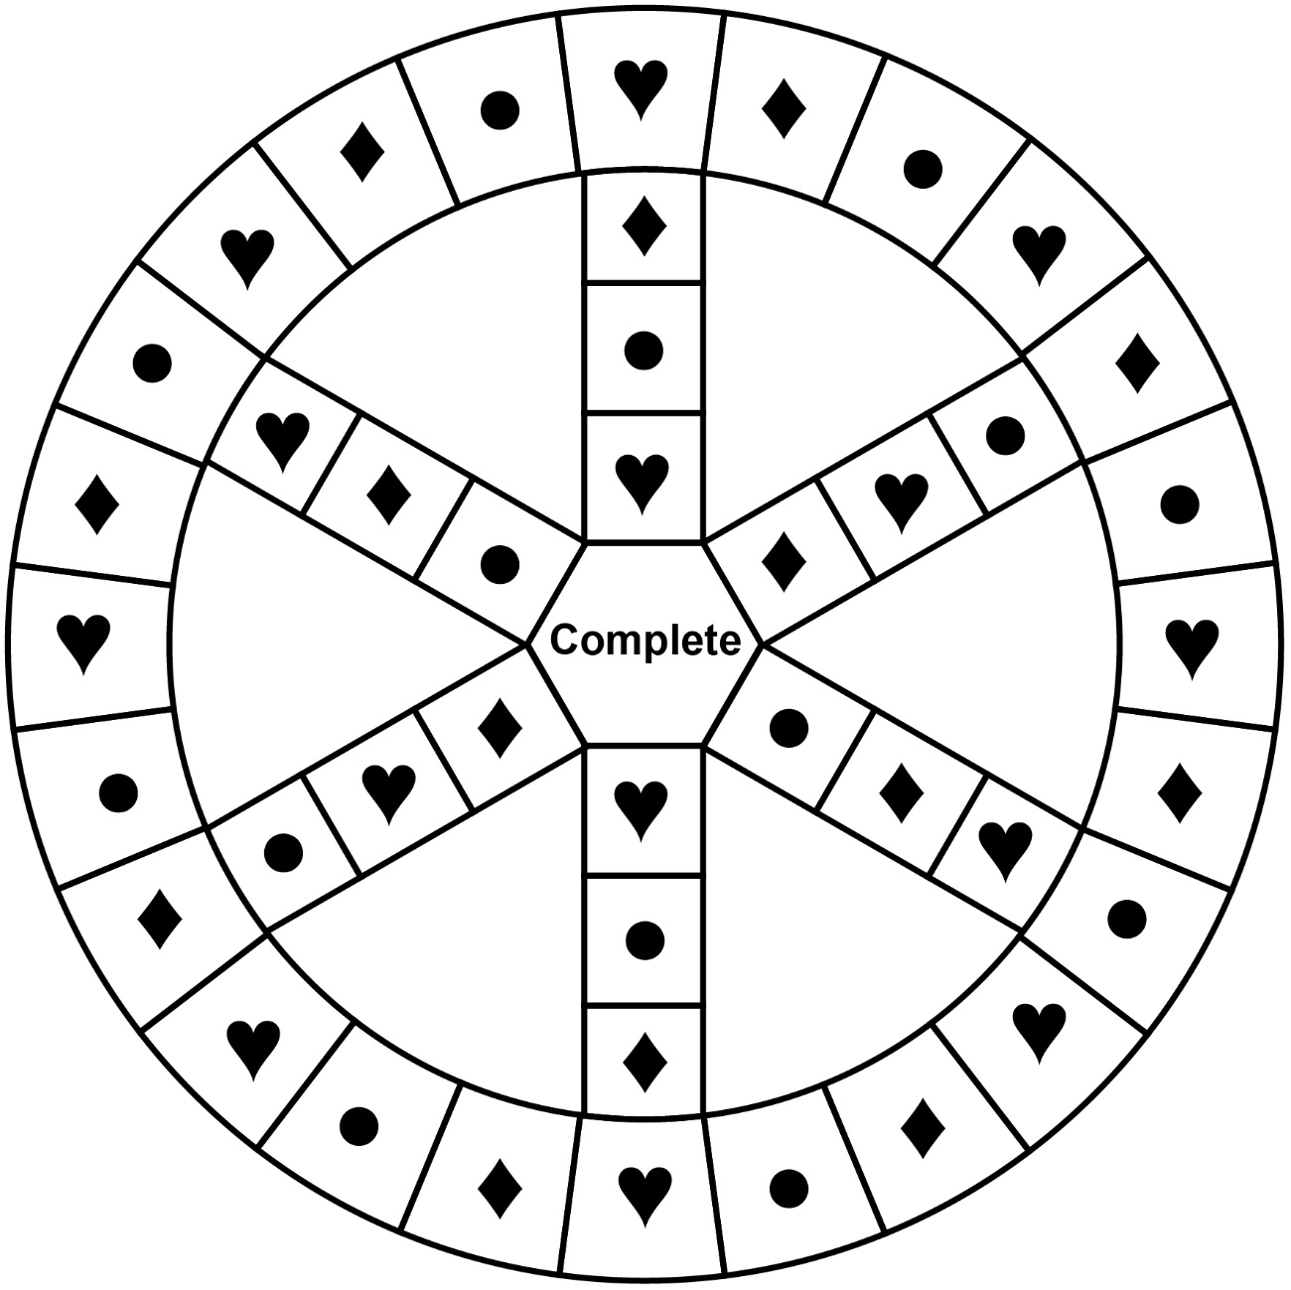
Legend
♥ Estimating | ♦ Adding decimals | • Subtracting decimals

Complete the Chase!
Gameboard (ON only)

Number
Unit 5 Line Master 5b

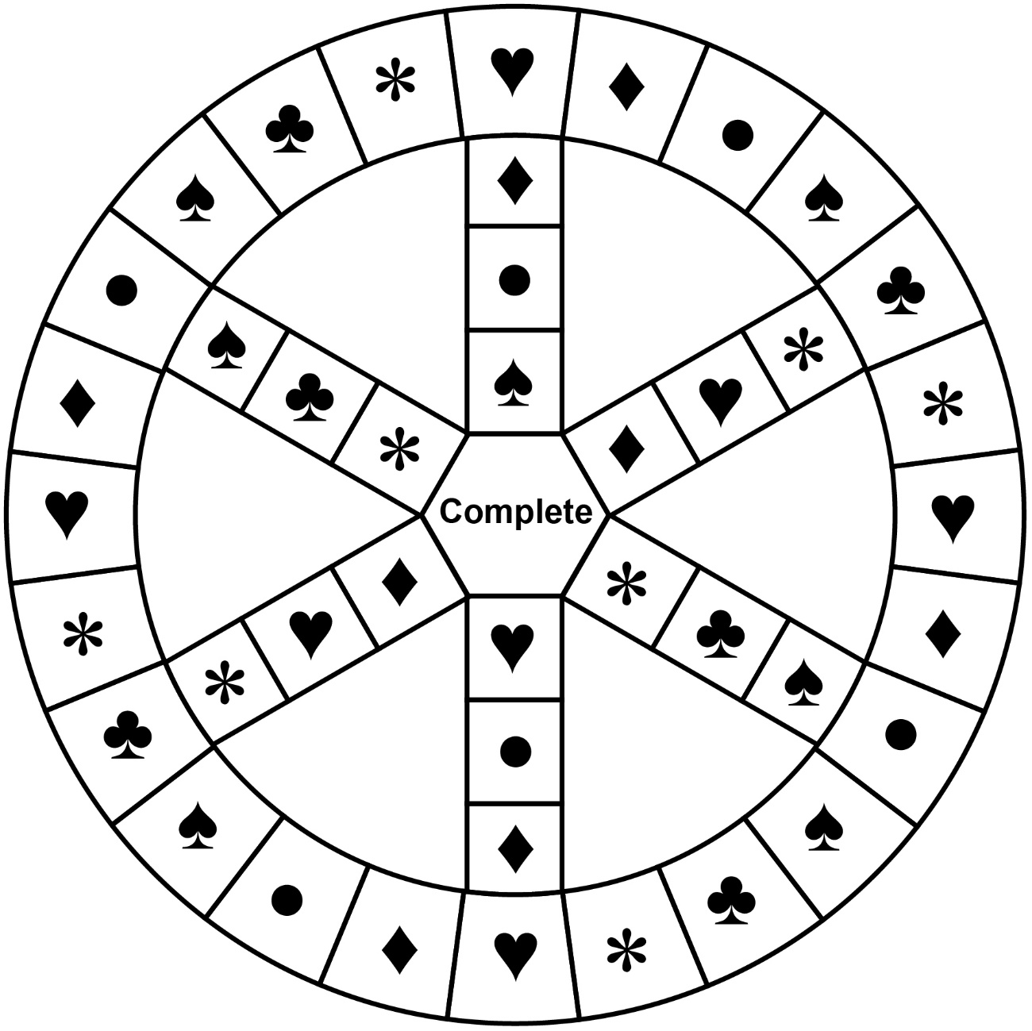
Legend
♥ Estimating | ♦ Adding decimals
• Subtracting decimals | ♠ Adding/subtracting fractions
♣ Multiplying unit fractions | ∗ Multiplying by 0.1 and 0.01

