Healthy Snacks

Number
Unit 6 Line Master 7a

Cheese Strings
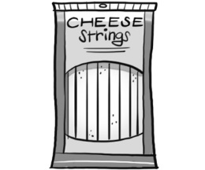 | 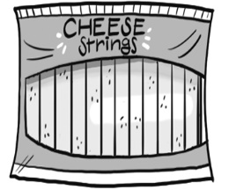 | 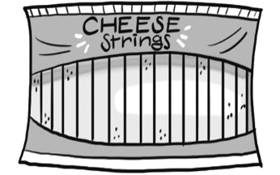
A: 8 for $4.47 | B: 12 for $5.97 | C: 16 for $6.27
Granola Bars
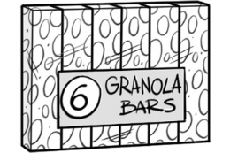 | 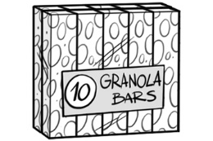 | 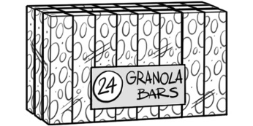
A: 6 for $2.98 | B: 10 for $4.47 | C: 24 for $10.49
Orange Juice
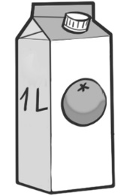 | 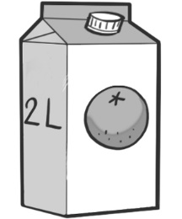 | 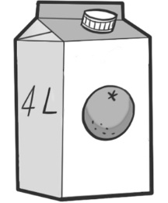
A: 1 L for $2.57 | B: 2 L for $2.87 | C: 4 L for $5.99
Single Serving of Yogurt
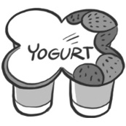 | 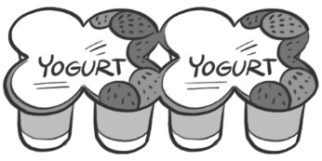 | 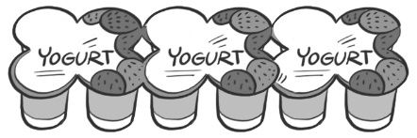
A: 4 for $3.97 | B: 8 for $4.78 | C: 12 for $5.97

Healthy Snacks (cont’d)
Answers

Number
Unit 6 Line Master 7b

Cheese Strings
A: 8 for $4.47 $0.56 per string
B: 12 for $5.97 $0.50 per string
C: 16 for $6.27 $0.39 per string; option C is the best value.

Granola Bars
A: 6 for $2.98 $0.50 per bar
B: 10 for $4.47 $0.45 per bar
C: 24 for $10.49 $0.44 per bar; option C is the best value.

Orange Juice
A: 1 L for $2.57 $2.57 per litre
B: 2 L for $2.87 $1.44 per litre
C: 4 L for $5.99 $1.50 per litre; option B is the best value.

Single Serving of Yogurt
A: 4 for $3.97 $0.99 per serving
B: 8 for $4.78 $0.60 per serving
C: 12 for $5.97 $0.50 per serving; option C is the best value.

