Expenses for the Car Wash

Number
Unit 6 Line Master 9

Cleaning Supplies
Plastic bucket  $4.99 | Package of 4 cloths  $2.47
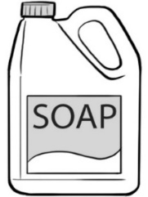 | 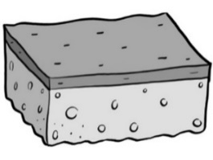
3 L of soap  $9.97 | Sponge  $2.97
Advertising
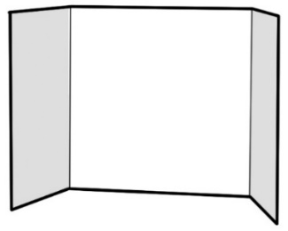 | 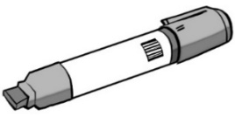
Poster board  $4.98 | Marker  $1.49
Other Expenses

