Dance Code Sequences
Master 2a

Dance 1: Whole Class
Face upward on the grid. For example, Dancer A will start facing towards location (2,6).
Repeat 2  Glide 1 step forward.  Glide 1 step to the left.  Dance your way 2 steps back.  Glide 2 steps to the right.  Repeat 2  Dance your way 1 step forward.  Dance your way 1 step back.  End Repeat  Glide 1 step to the left.  End Repeat  Crisscross.  Jump a half turn. | 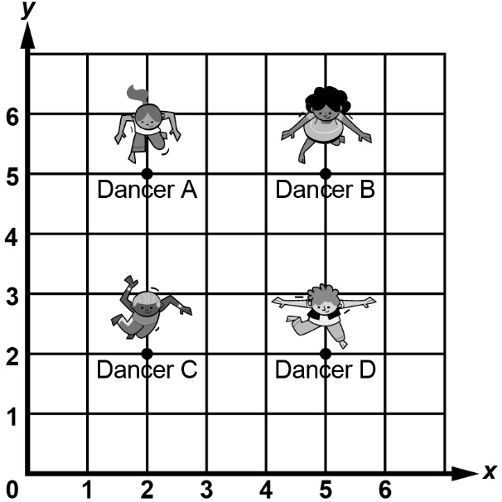

Visualize and dance the code.
Will Dancer A ever be on (3,3) on the coordinate grid?

Where will Dancer D be after “Dance your way 2 steps back”?

Will Dancer C ever be where Dancer B started?

Dance Code Sequences (cont’d)
Master 2b

How is each coding event incorporated into the dance routine?
Sequential events: the dance is a sequence.

Concurrent events: all dancers are doing the same moves, so they’ll always be the same distance away from each other.

Repeats: the sequence repeats 2 times, which gets the dancers back to the beginning and has them doing the dance 3 times in total

Nested events: the step forward and back within the repeat of the whole dance sequence is a nested repeating event.

Dance Code Sequences (cont’d)
Master 2c

Dance 2: Whole Class or Groups of Four
Code: Dancer A | Code: Dancer B | Code: Dancer C | Code: Dancer D
Face forward  (as if you are  moving higher  on the y-axis). | Face forward  (as if you are  moving higher  on the y-axis). | Face forward  (as if you are  moving higher  on the y-axis). | Face forward  (as if you are  moving higher  on the y-axis).
Dance 1 step back. | Move 1 step forward. | Dance 1 step back. | Move 1 step forward.
Glide 1 step left. | Glide 1 step right. | Glide 1 step left. | Glide 1 step right.
Move 1 step forward. | Dance 1 step back. | Move 1 step forward. | Dance 1 step back.
Glide 2 steps right. | Glide 2 steps left. | Glide 2 steps right. | Glide 2 steps left.
Jump a half turn. | Jump a half turn. | Crisscross. | Crisscross.
Crisscross. | Crisscross. | Jump up. | Jump up.
Dance 1 step forward. | Dance 1 step forward. | Dance 1 step forward. | Dance 1 step forward.

Visualize the dance. Talk about how the dancers are moving
in relation to one another. What visualizing and tracking strategies
are you using?

In groups of four, dance the code sequence.
Talk about what you notice.

Dance Code Sequences (cont’d)
Master 2d

Dance 3: Whole Class or Groups of Four
Code: Dancer A | Code: Dancer B | Code: Dancer C | Code: Dancer D
Face forward  (as if you are  moving higher  on the y-axis). | Face forward  (as if you are  moving higher  on the y-axis). | Face forward  (as if you are  moving higher  on the y-axis). | Face forward  (as if you are  moving higher  on the y-axis).
Dance 1 step back. | Dance 1 step back. | Move 1 step forward. | Move 1 step forward.
Glide 1 step right. | Glide 1 step right. | Glide 1 step left. | Glide 1 step left.
Dance 1 step back. | Dance 1 step back. | Crisscross. | Crisscross.
Glide 2 steps right. | Glide 2 steps left. | Glide 2 steps right. | Glide 2 steps left.
Dance 1 step forward. | Dance 1 step forward. | Dance 1 step forward. | Dance 1 step forward.

Predict the dancers’ movements.
Will the dance work? Will any dancers be in the same location
on the coordinate grid at the same time? Explain.

Dance the code to check.

Dance Code Sequences (cont’d)
Master 2e

Alter the Code: Groups of Four
Alter the code for Dance 3 to make it your own.
Make sure that dancers don’t bump into each other on
the “dance floor!”
At some point in your dance, all the dancers should:
● all be doing different moves
● all be doing the same move

You might:
● adjust the sequence
● add new blocks
● change the numbers of the existing blocks
● add repeats
● alter the starting location of the dancers.

Talk about the changes you are considering and what impact they
will have on your dance.
It is important to work back and forth between the code sequence
and the outcome of the code (the dance itself).

Dance Code Sequences (cont’d)
Master 2f

Code: Dancer A | Code: Dancer B | Code: Dancer C | Code: Dancer D
Face forward  (as if you are  moving higher  on the y-axis). | Face forward  (as if you are  moving higher  on the y-axis). | Face forward  (as if you are  moving higher  on the y-axis). | Face forward  (as if you are  moving higher  on the y-axis).
Dance 1 step back. | Dance 1 step back. | Move 1 step forward. | Move 1 step forward.
Glide 1 step right. | Glide 1 step right. | Glide 1 step left. | Glide 1 step left.
Dance 1 step back. | Dance 1 step back. | Crisscross. | Crisscross.
Glide 2 steps right. | Glide 2 steps left. | Glide 2 steps right. | Glide 2 steps left.
Dance 1 step forward. | Dance 1 step forward. | Dance 1 step forward. | Dance 1 step forward.

